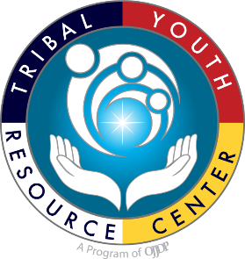
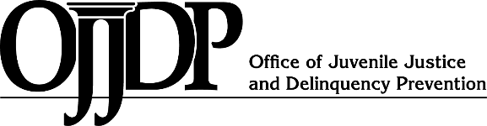
FY 2021
CTAS Purpose Area 9: Tribal Youth Programs Resource Guide with Planning Templates
FY 2021
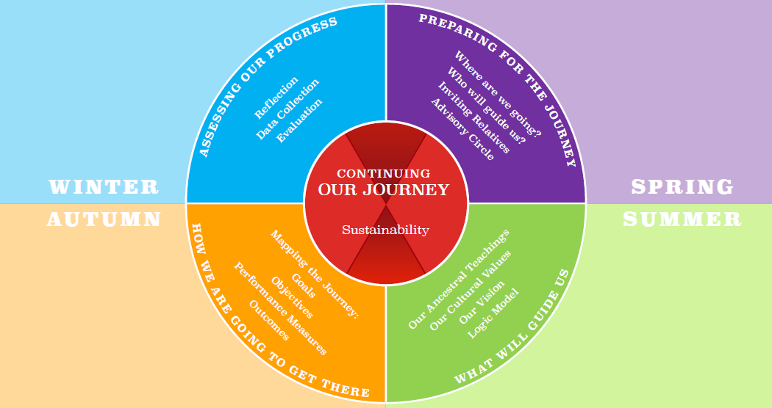
MAPPING THE JOURNEY A Strategic Planning Resource Guide
Tribal Youth Resource Center
This project was supported by Grant #15PJDP-21-GK-04048-MUMawarded by the Office of Juvenile Justice and Delinquency Prevention, Office of Justice Programs, U.S. Department of Justice. The opinions, findings, and conclusions or recommendations expressed in this publication/program/exhibition are those of the author(s) and do not necessarily reflect those of the Department of Justice.
Introduction to the Mapping the Journey Tool (A strategic planning resource guide)

Greetings from the Tribal Youth Resource Center (TYRC)!

There’s a Hopi proverb that says, “One finger cannot lift a pebble.” Picking up even the smallest stone requires teamwork, a forefinger joined by a thumb, in a simple effort of cooperation. The action speaks to community in much the same as the broadly recognized tenet of tribal people- we are all related.

And so it is with the Tribal Youth Resource Center’s training and technical assistance delivery – we work diligently with American Indian Tribes and Alaska Native Villages, Tribal Youth Program grantees, Tribal Juvenile Healing to Wellness Court grantees, and tribal youth to indigenize successful approaches and evidence-based practices, while innovating and encouraging culturally grounded responses that can contribute to addressing challenges Tribal youth face. We are honored and humbled to serve tribal youth, their families, and communities.
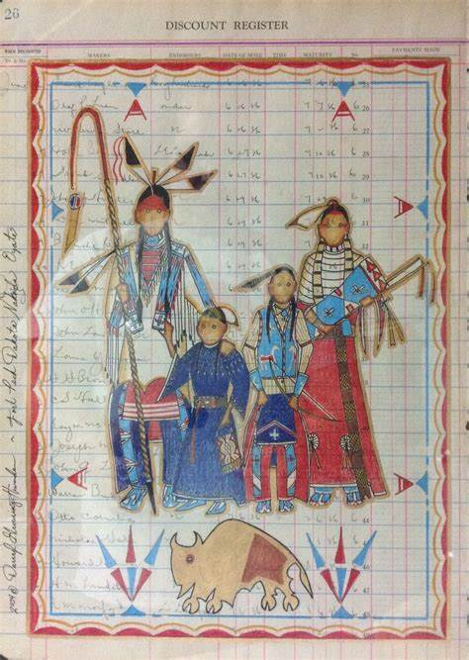
We welcome the opportunity to work with your Tribe and community to assist in the development of a strategic plan to implement your OJJDP Tribal Youth Program (TYP) grant. The Tribal Youth Training and Technical Assistance Specialist (TTAS) team provides online learning events, both individual and group learning opportunities, and when requested, onsite training to complete the strategic planning process by September 30, 2022.

Mapping the Journey is a process our people engaged in for thousands of years as they strategized where to go, when to go and what tools they needed to ensure reaching their destination. This guide includes examples of tools that are intended as resources for Tribal Youth Program grantees to develop a strategic plan, with the help of your respective stakeholders and partners. Ultimately, the strategic plan can serve as a road map for the journey your Tribal Youth Program is taking to support Native youth, families, and community.

Each Tribal Youth grantee will have an assigned TTA Specialist who will work with the TYP Coordinator and advisory circle through each step of your Journey, the first step being development of a strategic action plan. Please visit www.TribalYouth.org to learn more about the Tribal Youth Resource Center.

As a training and technical assistance provider for the Office of Juvenile Justice and Delinquency Prevention, the Tribal Youth Resource Center, administered by the Tribal Law and Policy Institute and in partnership with the National Native Children’s Trauma Center, we bring an in-depth understanding and appreciation of American Indian and Alaska Native history, customs, and Indigenous justice systems.
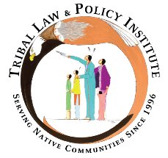
Native youth benefit from our value that:
Our Children are Sacred.

Tribal Youth Resource Center
Email: TribalYouth@TLPI.org
Website: www.TribalYouth.org

Table of Contents
Section | Page
I. OJJDP FY 2021 Tribal Youth Program Grant Program Mapping the Journey Timeline | 4
II. Program Contact Information | 5
III. Strategic Plan Core Components | 6
- Community Advisory Circle | 7
- Vision and Purpose Statement | 9
- Communication Plan | 10
- Engaging Youth and Community Voice | 13
- Specific Measurable Achievable Realistic Time-bound (S.M.A.R.T.) Goals | 15
- Program Logic Model | 19
- Documenting Our Journey: Data Collection Planning | 24
- Telling Our Story: Evaluation Planning and Implementation | 26
- Continuing Our Journey: Sustainability Plan | 30
Appendix
- Community Engagement Planning Tools and Resources | 32
- Youth Engagement and Empowerment | 34
- Developing the Community Advisory Committee Guidance | 35
- Memorandums of Understanding | 38
- Resource Mapping Resources | 39
- Strategic Planning Tools | 40
- Program Reporting Overview | 41
- Sustainability Planning Tools and Resources: Continuing Our Journey | 42
- Tribal Youth Program Guiding Priorities | 44
- Resource Websites for Tribal Youth Program Planning | 45

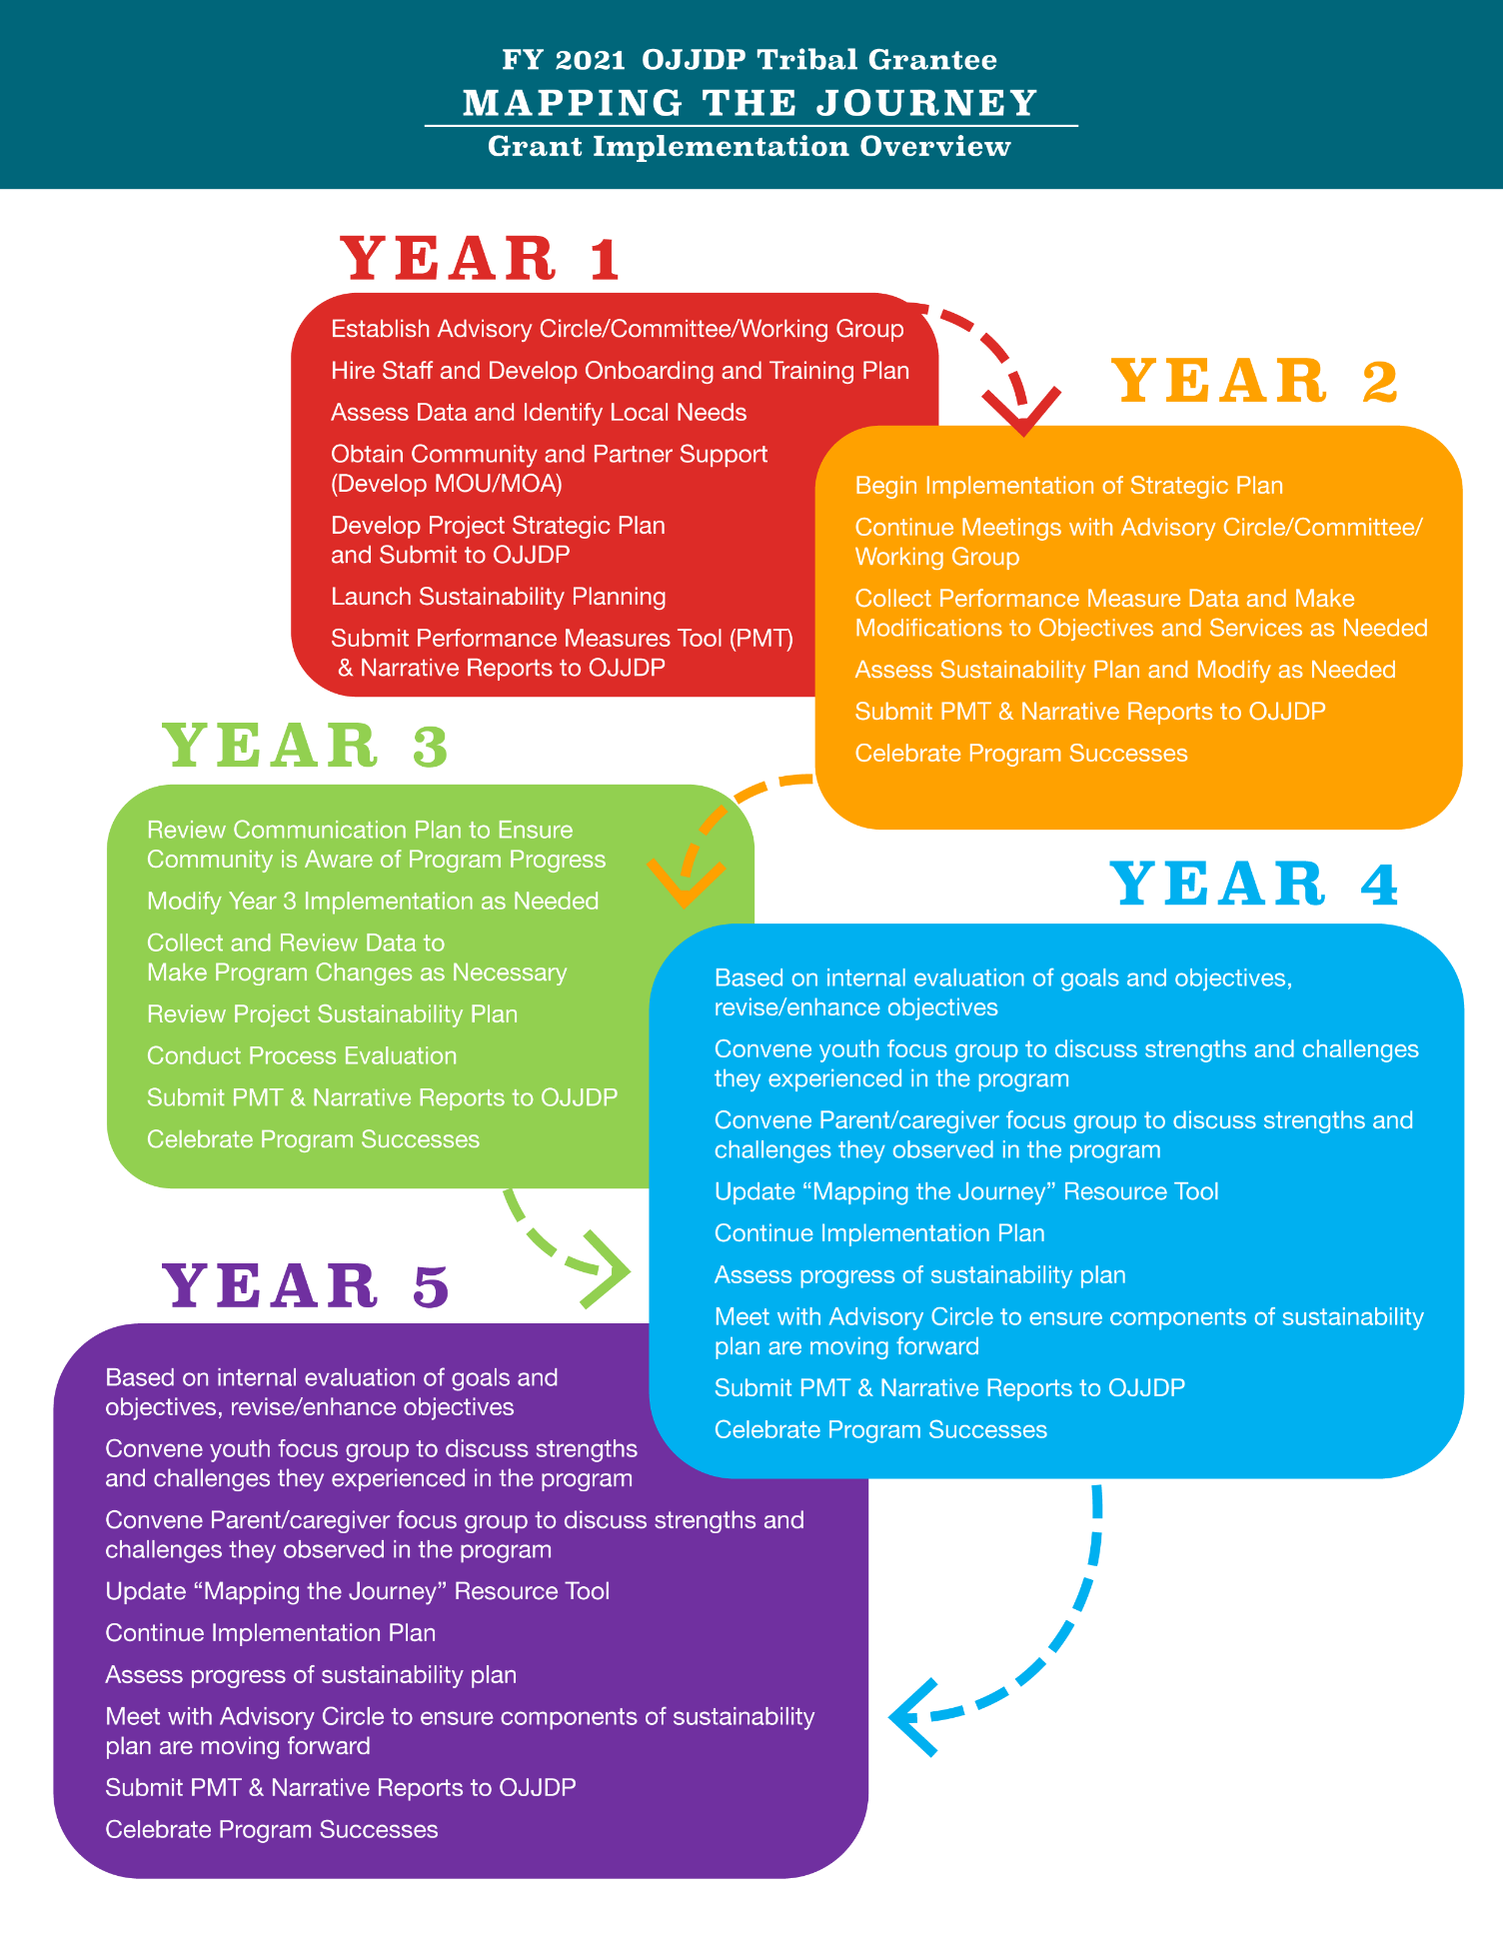
FY 2021 CTAS Purpose Area 9: Tribal Youth Program


Strategic Planning Resource Guide

Tribe Name: | Click or tap here to enter text.
Grant Award Number: | Click or tap here to enter text.
Grantee Point of Contact (Name, Phone, Email): | Click or tap here to enter text.
Grantee Secondary  Point of Contact (Name, Phone, Email): | Click or tap here to enter text.
OJJDP Grants Management Specialist: | Click or tap here to enter text.
TYRC Training and Technical Assistance Specialist: | Click or tap here to enter text.

This Strategic Plan Guide Addresses the Following Core Components:

☐ Community Advisory Circle
☐ Vision & Purpose Statement
☐ Communication Plan
☐ Engaging Youth and Community Voice
☐ Specific Measurable Achievable Realistic Time-bound (S.M.A.R.T.) Goals
☐ Program Logic Model
☐ Data Collection Planning: Documenting Our Journey
☐ Evaluation Planning: Telling Our Story
☐ Sustainability Planning: Continuing Our Journey

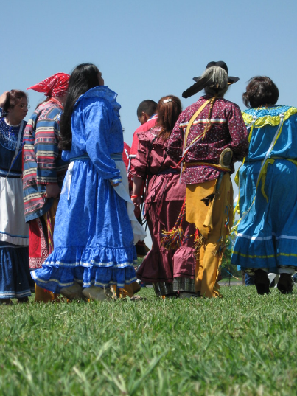
Community Advisory Circle

Engaging a Community Advisory Circle is considered a best practice for strategic planning, implementation, and sustainability. The purpose of a Community Advisory Circle is to contribute to the development of the overarching framework and program design from planning to sustainability. Community Advisory Circles are comprised of 6-12 members representing all facets of the community ranging from elders, youth, formal and informal leaders in the community, to health, education, justice, treatment/healing and youth serving providers.

Partner Name  & Title |  | Role on Team | MOA/MOU  Yes or No* | Gifts/  Expertise
 | Click or tap here to enter text. | Click or tap here to enter text. | Click or tap here to enter text. | Click or tap here to enter text.
 | Click or tap here to enter text. | Click or tap here to enter text. | Click or tap here to enter text. | Click or tap here to enter text.
 | Click or tap here to enter text. | Click or tap here to enter text. | Click or tap here to enter text. | Click or tap here to enter text.
 | Click or tap here to enter text. | Click or tap here to enter text. | Click or tap here to enter text. | Click or tap here to enter text.
 | Click or tap here to enter text. | Click or tap here to enter text. | Click or tap here to enter text. | Click or tap here to enter text.
 | Click or tap here to enter text. | Click or tap here to enter text. | Click or tap here to enter text. | Click or tap here to enter text.
 | Click or tap here to enter text. | Click or tap here to enter text. | Click or tap here to enter text. | Click or tap here to enter text.
*Sample MOUs are included in the appendix.
Add rows as needed. While your cursor is in the last row, right click and then click “insert rows below.”

Community Advisory Circle Role and Agreements

Please provide a brief overview of the role, responsibilities and agreements of your advisory circle. The role and responsibilities can include providing input in program planning, support, implementation and guidance to the program and the agreements can include how often the Community Advisory Circle meets.

Example Language: The Community Advisory Circle (CAC) fulfills a role of support and guidance to the program and agrees to meet bi-weekly in the planning year of the grant to assist in the development of the Strategic Plan and thereafter monthly to advise on implementation of the strategic plan. Additionally, the Community Advisory Circle outreaches to community members to inform them of the progress of the project.
Click or tap here to enter text.


Vision and Purpose Statements

Developing effective vision (your collective inspired dream) and purpose (why your program exists) statements are important first steps in your strategic planning process. These written declarations provide the foundation for the program while communicating the purpose and direction of work that will be launched during the life of the project.

VISION STATEMENT
Your dream/the desired end state, where you would like to be. Statement is generally inspirational, memorable and concise. For example: Restoration of our families and our communities to be strong and healthy.
Click or tap here to enter text.

PURPOSE STATEMENT
A statement of the purpose of your strategic initiative/program and how your vision will be realized. For example: Our purpose is to revitalize and reconnect our Tribal youth to their Culture through activities and support that strengthens their cultural identity.
Click or tap here to enter text.

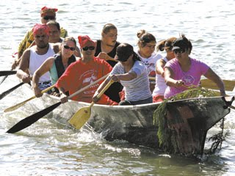
Communication Plan

A communication plan among core team members that includes partners, youth, families, Tribal and community leadership and other stakeholders can strengthen collaboration and support for the program. It can also serve as a social marketing tool to share your program activities, milestones and success stories. The more informed your stakeholders are about your program, the more likely they are to lend support and invest in your program.

Enhancing your Communication Plan through social marketing to build and strengthen Community Engagement & Support
Core Service Provider and Partners | Team Member Name | Role | Description of Services for youth/community
Core Service Provider and Partners | Example: Mr. and Mrs. Sees Above | Example: Community Elders | Example: Guidance and ancestral teachings
Core Service Provider and Partners | Click or tap here to enter text. | Click or tap here to enter text. | Click or tap here to enter text.
Core Service Provider and Partners | Click or tap here to enter text. | Click or tap here to enter text. | Click or tap here to enter text.
Core Service Provider and Partners | Click or tap here to enter text. | Click or tap here to enter text. | Click or tap here to enter text.
Core Service Provider and Partners | Click or tap here to enter text. | Click or tap here to enter text. | Click or tap here to enter text.
Core Service Provider and Partners | Click or tap here to enter text. | Click or tap here to enter text. | Click or tap here to enter text.
Core Service Provider and Partners | Click or tap here to enter text. | Click or tap here to enter text. | Click or tap here to enter text.
Please list the materials you will be developing for your Tribal Youth Program:
Print | Broadcast | Social Media | Digital Content Management
Example:  Program Brochures  Template for community flyer | Example:  Pre-recorded PSAs for local radio stations | Example:  YouTube account  Instagram account | Example:  *Scheduling posts  *Coordinating different platforms  *Storing content online
Click or tap here to enter text. | Click or tap here to enter text. | Click or tap here to enter text. | Click or tap here to enter text.
Click or tap here to enter text. | Click or tap here to enter text. | Click or tap here to enter text. | Click or tap here to enter text.
Click or tap here to enter text. | Click or tap here to enter text. | Click or tap here to enter text. | Click or tap here to enter text.
Click or tap here to enter text. | Click or tap here to enter text. | Click or tap here to enter text. | Click or tap here to enter text.

Administrative Activities to Support Communication

Develop record keeping process and communicate with full team. | Example: program logs of activities, communications, in-kind support, meeting notes, calendar of events.
Develop necessary MOU/MOA to engage program partners. | Example: Sharing of resources, e.g. meeting space, facilitation/hosting of meetings, schedule of meetings, collaborative events.
Develop necessary consents/waivers/  confidentiality agreements to address privacy and protected communications. | Example: Risk and benefits of program activities, statements of confidentiality, information on how information will be used, who will see it and where it will be stored.
Create processes for ongoing quality improvement. | Example: Regular schedule to review implementation and progress of strategic plan; and review feedback from youth and families.
Identify modes of communication and venues to outreach to broader community (e.g., radio, television, tribal newsletter, social media). | Example: Meet with youth bi-monthly to gather input for best strategies to engage peers; radio show schedule; partners sharing submission of program related articles for tribal newsletter and posting on social media.
Develop Tribal Youth marketing materials | Example: Meet with staff and advisory circle to identify primary audience and design key messages. Develop work plan that is inclusive of 1) selecting two-way communication method with primary audience, 2) establishing time frame, and 3) tracking outcomes with an eye towards improvements.

Engaging Youth and Community Voice

Incorporating youth and community voice in the development and implementation of the Tribal Youth Program provide youth and community an opportunity to learn about power dynamics, consensus making, planning and organizing, data collection and resource mapping. Most importantly, providing a “voice, place and space” for youth and community in the strategic planning process can provide a sense of investment in the success of the program and supports the philosophy of “nothing about us without us.” The Tribal youth programs’ focus is tribal youth, so they should be included and involved every step of the way. Examples of inclusion and involvement are youth representation on the TYP Community Advisory Circle – and/or creating a Youth Steering Committee. Other suggested activities for youth and community engagement are listed below.

*Add rows as needed. While your cursor is in the last row, right click and then click “insert rows below.”
Activities/  Tasks (examples) | Person Responsible | Anticipated  Completion Date | Progress and Comments | Indigenous Value
Host open community meeting and invite youth | Program Coordinator,  TYP Community Advisory Circle | August 2022 | Not Started. Requested Resources from TTA Specialist | Inclusion
Set up booth at Community Youth Event | Program Coordinator,  TYP Community Advisory Circle | September 2022 | Requested booth from event organizer | Empowerment
Volunteer at Community Youth Events | Program Coordinator,  TYP Community Advisory Circle | Ongoing | Review community event calendars and outreach to key contacts | Generosity
Meet with other youth serving agencies | Program Coordinator,  TYP Community Advisory Circle | October 2022 | Schedule meetings with the directors of other youth serving agencies in the community | Respect
Create Youth Steering Committee inclusive of justice involved youth | Program Coordinator,  TYP Community Advisory Circle | September 2022, Ongoing | Started outreaching to youth in the community to gauge interest | Humility
Conduct an interest assessment within community, talking to young people about what they want to see in their community | Program Coordinator, TYP Community Advisory Circle | August 2022 | Not Started. Requested Resources from TTA Specialist | Learning
Click or tap here to enter text. | Click or tap here to enter text. | Click or tap here to enter text. | Click or tap here to enter text. | Click or tap here to enter text.
Click or tap here to enter text. | Click or tap here to enter text. | Click or tap here to enter text. | Click or tap here to enter text. | Click or tap here to enter text.
Click or tap here to enter text. | Click or tap here to enter text. | Click or tap here to enter text. | Click or tap here to enter text. | Click or tap here to enter text.
Click or tap here to enter text. | Click or tap here to enter text. | Click or tap here to enter text. | Click or tap here to enter text. | Click or tap here to enter text.


Setting Indigenous S.M.A.R.T. (I-SMART) Goals

Research shows that establishing specific and challenging goals can lead to better performance. In this section, you will be creating SMART goals to help you obtain your desired results. Utilizing the SMART goals process will aid in establishing clear goals and objectives that will benefit the Tribal Youth Program and ultimately the entire tribal community.
I-SMART is keeping the Indigenous lens and perspective at the forefront of everything we do. When using the SMART goal and SMART objective process, continuously revisit whether these goals and objectives are aligned with tribal culture and community values.

A SMART goal is defined as one that is specific, measurable, achievable, realistic and time-bound. Below is a definition of each of the SMART goal criteria.

S.M.A.R.T. Goal Guidance
Example
GOAL: Increase partnerships within the Tribal Youth Program.
SMART GOAL: Increase Tribal and local county partnerships from 4 to 7 (75% Increase) within two years of program implementation to support youth referral and services within the Tribal Youth Program.
The following steps will assist you in creating SMART goals. Conduct this activity with your planning team and/or Community Advisory Circle. If your team/circle is already using the SMART or a similar process, great! Should you have any questions or require assistance, please contact your TTA Specialist.

For each goal in your grant:
- List your goal as it is currently written.
- Assess whether your current goals are crafted in a way that is specific, measurable, achievable, realistic and time bound. If they are, please fill them in below.
- If you would like to refine your goals, feel free to use the SMART goals guidance to enhance the goal.
- Use a separate sheet of paper for brainstorming as needed.
- Conclude by revising your goal in the space allotted.
Review your work. Does your revised goal meet the SMART criteria and align with the Vison and Purpose?

Current goal: Click or tap here to enter text.

Revised goal: Click or tap here to enter text.

Current goal: Click or tap here to enter text.

Revised goal: Click or tap here to enter text.

Current goal: Click or tap here to enter text.

Revised goal: Click or tap here to enter text.

Current goal: Click or tap here to enter text.

Revised goal: Click or tap here to enter text.

*Add additional tables as needed. Click the + at the top left of the table, right click and select “copy” and then right click again and select “paste” to add a new table below.

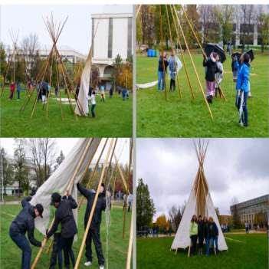
Developing Supportive Objectives

Objectives are focused, measurable, concrete and support the broader or long-range goals that your team has set forth. It is important to set out clear objectives to support your goals and desired outcomes.
An example goal with supporting objectives is included below to help you get started.

Example Project Goal 1: Increase Tribal and local county partnerships from 4 to 7 (75% Increase) within two years of program implementation to support youth referral and services within the Tribal Youth Program.
Objectives to support reaching project goal.
Objective a | Within 60-90 days the team will work with the advisory circle to identify a list of potential Tribal and local county partners.
Objective b | Within 6 months the program coordinator will arrange meetings with at least 5 local county/Tribal partners and discuss potential MOU development.
Objective c | Within 12 months, partnership agreements with at least 1 partner will be established to support youth referral to services. Two additional partnerships will be secured by the end of implementation year two.

Project Goal 1: Click or tap here to enter text.
Objectives to support reaching project goal.
Objective 1a | Click or tap here to enter text.
Objective 1b | Click or tap here to enter text.
Objective 1c | Click or tap here to enter text.

Project Goal 2: Click or tap here to enter text.
Objectives to support reaching project goal.
Objective 2a | Click or tap here to enter text.
Objective 2b | Click or tap here to enter text.
Objective 2c | Click or tap here to enter text.

Project Goal 3: Click or tap here to enter text.
Objectives to support reaching project goal.
Objective 3a | Click or tap here to enter text.
Objective 3b | Click or tap here to enter text.
Objective 3c | Click or tap here to enter text.

Project Goal 4: Click or tap here to enter text.
Objectives to support reaching project goal.
Objective 4a | Click or tap here to enter text.
Objective 4b | Click or tap here to enter text.
Objective 4c | Click or tap here to enter text.


Program Logic Model

A logic model is a one-page depiction (road map) that outlines the shared relationships among the resources, activities, outputs, outcomes, and impact for your program. It depicts the relationship between your program’s activities and its intended effects. https://www.cdc.gov/eval/logicmodels/index.htm
How are we going to work toward realizing our Vision and honoring our purpose? Let’s start with developing a logic model, which is a depiction of your project – where you have been, where you are going, how you are going to get there and how you will know when you have arrived. For example, if we were to tell the story of our project in a one-page graphic, what would that look like? Below are a couple of examples, which are also available as blank templates.
Example One (below): In this example, note that the logic model starts with indicating the changes that we want to see, then it works to the right highlighting how those changes are going to happen and how they will be measured. Finally, the far right column shows how the resources invested and the activities engaged in have impacted the desired outcome. Click here to view a larger version of the logic model.

Example of a Logic Model to Increase Cultural Pride and Identity
What are the changes we want to see? | What are the issues that impact making the changes? | What are the activities/resources/inputs we  will employ to meet each goal? | What will be the outputs for each specific activity? | What will you do to measure the outcomes and outputs of the  program? | What is our hope for the future?
Our Story Wellbeing  - Historically our Tribe had a strong Cultural foundation that contributed to the well-being of the entire Tribe. | Our story of resilience  - Historical impacts contributed to the lack of access to Cultural traditions and ceremonies and denies our youth their Cultural identity  - Connecting with Tribe youth to actively support their development of a strong Cultural identity | What we can do today, Supporting our relatives  - Cultural skill building/Cultural pride*  - Establish Community Advisory Committee (CAC)  - Talking Circles as process for guiding principles, Cultural identity survey, and designing process for Cultural identity  - Develop a communication plan: parents, tribal leadership, youth, community | There is healing in our culture  - CAC Guide Tribal Name of Program, formalize guiding principles  - CAC assist in design of Cultural identity survey  - CAC assist in design of a process for Cultural identity (ex: naming, coming of age, healing, gender roles)  - Administer surveys, engage youth in ceremonies, interviews  - Materials used for communication to stakeholders  - Performance Measure: Cultural Skill building/cultural pride | Honoring our youth today  - 30 Youth receive their Tribe name, participate in coming of age ceremony and a healing ceremony, gender roles  - Youth understand and are able to use ceremonial elements for prayer  - Number of program youth served during the reporting period with the noted behavioral change*  - Total number of youth receiving services for the target behavior during the reporting period*  - Percent (A/B)* | Honoring our youth tomorrow  - Increase in Cultural skill-building and Cultural pride  - The youth Cultural identity enhances their wellbeing  - Growth in Cultural Identity as a result of participating in ceremony and healing activities, evidenced by 30 completed pre/post Cultural Identity surveys
What are the changes we want to see? | Our Hope  - Promote Tribe youth Cultural identity by creating opportunities and access to tribal Cultural values, traditions and ceremonies.
Healing is our future: | What are the Cultural values and principles that will guide our work?  Strong Hearts:  - Wellbeing of youth will remain focus of program.  - Establishing an approach of being a good relative and mutual regard with the youth and among all partners.  - Honoring of Culture will be the foundation of the program.  - Cultural Identity supports the wellbeing of our tribe.
The Foundation for Our Work:
Vision: Restoration of our families and our communities.
Purpose: The revitalization and reconnection of Tribal Youth to their Culture. Tribal Youth will have a strong cultural identity as a foundation for healing, skill building and pride.
*Denotes OJJDP Performance Measure
Let us look at another example below. In this example, where we have been is highlighted at the top, then the logic model proceeds to the right showing where we would like to be, then how we are going to get there and finally the outcome.
Example Two:
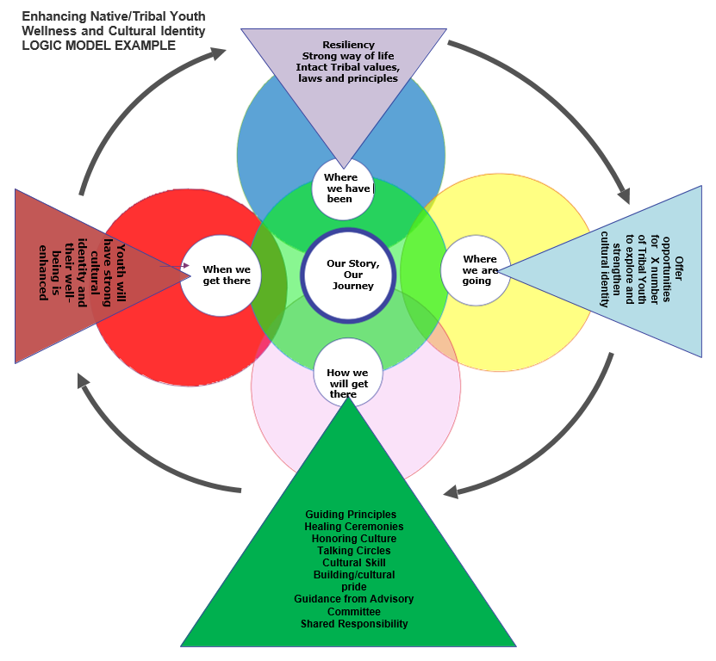
These two examples contain the same information but are depicted in different formats. There is no one “right” format, and you and your Community Advisory Circle can decide on what format to use; perhaps you’ll decide to design your own logic model or use a different format. The intent of the logic model is to provide a graphic depiction of your project that includes the issues or needs, the available resources and activities to address the needs, and what you are going to measure to determine if you are headed in the direction you want to go. Finally, the graphic shows the hoped for impact or outcome of your project.
Example Three:
This is another example of a format for a logic model that comes from OJJDP. As stated before, logic models can look different but they all have a central purpose: provide a one-page depiction of your program’s goals, objectives, activities and hoped for outcomes.
[Applicant/Program Name] Logic Model]
The italicized text in each logic model section describes the information to include and should be replaced with your responses. Enter the applicant or program name in the header, replacing the brackets.
Date | MM/DD/YY
Desired Result |  | State precisely what the program or initiative hopes to achieve. The result statement should reflect the purpose of the federal award and the Office of Juvenile Justice and Delinquency Prevention’s vision to support a nation where children are free from crime and violence and encounter a just and beneficial juvenile justice system.
Goals |  | Goal 1: Goals define how you know you have achieved your desired outcomes or the future condition your program or initiative hopes to achieve. The goals should align with your stated desired result and demonstrate how you intend to meet the purpose of the federal award. You may include an unlimited number of goals.

Inputs | Activities | Outputs | Outcomes
Inputs | Activities | Outputs | Short-term | Intermediate | Long-term
- Inputs describe the resources needed to implement a program’s activities successfully. | - Activities describe the actions needed to achieve a program’s goals and objectives. | - Outputs identify what happens from a program’s intended activity. Outputs are generally represented as a number, such as the number of people trained. | - Outcomes describe the results of an activity, program, or initiative.  - Short-term outcomes reflect the immediate result of an activity, such as a change in knowledge, or change in practice. | - Intermediate outcomes reflect the result that occurs after achieving the short-term outcome, such as a change in behavior or implementation of a new system. | - Long-term outcomes demonstrate the ultimate change in a population or system the activity, program, or initiative hopes to achieve, such as decreased youth recidivism or decreased child victimization.

Let’s jump to measurement which is an aspect of evaluation planning and is part of your data collection plan. For sure, the OJJDP performance indicators are data that you want to collect and in fact are required to collect as part of your grant. For example, if strengthening cultural identity is one of the performance measures/indicators, you would plan and implement activities designed to strengthen cultural identity and measure the outcomes of those activities.

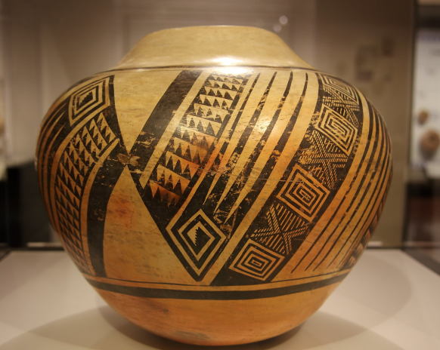
Documenting Our Journey:
Data Collection Planning
Local community members are excellent resources for gathering and interpreting data for your Tribal Youth Program because they know and live in the community. Focus on collecting data that are relevant to your program’s goals, e.g. improving the lives of youth to prevent or reduce at risk behaviors. Taking a strengths-based approach in gathering and interpreting data can highlight the resilience and positive things happening in your tribal community. This data can show what is working in your community and allows for enhancing interventions/approaches that are linked to positive outcomes for youth. The link below is a great resource for further understanding and approaching data collection. Resource: https://nij.ojp.gov/topics/articles/collecting-and-analyzing-tribal-data

Local Level Data: Work with the team to identify local level data. Data collection will support program goals, activities, quality improvement, and future sustainability planning. Developing a resource map may assist you with identifying key points for which data can be collected.
Key Questions: What methods will you use to collect the data? Where is the data? How often will the data be collected? Who will assist the program coordinator in collecting the data? How will you organize, manage, and store the data?
Data to Collect | Where is data and  how will it be collected | Who is Responsible for collecting data | Target Date(s) for Data Collection and review | Why would we collect this data
Example: school attendance records | Example: School can share information through an MOU | Example: Local County School. | Example: Monthly Review | Example: To celebrate youth attending school regularly and provide support for those youth not attending school on regular basis.

Data to Collect | Where is data and how will it be collected | Who is responsible for collecting data? | Target date(s) for data collection | Why would we collect this data
Example: # youth in different age groups, e.g., 12-17, 18-24 | Example: tribal census; school census will be requested. | Program Coordinator or designated partners | Annual basis | To build or adjust program capacity for services
Example: feedback from youth and families on program services. | Example: create questionnaire and distribute to youth and families | Example: Program Coordinator or Youth Advocate | Example: Quarterly | To ensure youth and family voice is included in planning
Example: # youth served | Example: activity sign in sheets, collected for each activity | Example: Activity Facilitator | Example: Compile number of participants on monthly basis | Example: to report to community and funding agency
Click or tap here to enter text. | Click or tap here to enter text. | Click or tap here to enter text. | Click or tap here to enter text. | Click or tap here to enter text.
Click or tap here to enter text. | Click or tap here to enter text. | Click or tap here to enter text. | Click or tap here to enter text. | Click or tap here to enter text.
*Add rows as needed. While your cursor is in the last row, right click and then click “insert rows below.

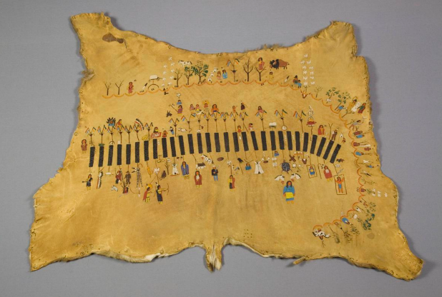
Telling Our Story: Evaluation Planning and Implementation
Evaluation is not a judgement of your program, it’s about telling your program’s story – where you have been, where you are going and how you are going to get there. Indigenous and Tribal people have always used evaluation. They needed to evaluate where the best hunting and fishing places were, where the best and safest place to camp and how they were going to ensure their teachings were passed on. Here is an opportunity to share your program’s story and ensure the teachings get passed on.
“Evaluation should be tailored to the cultural context of the community and responsive to cultural ways of life, including cultural values for parenting and child well-being” (see pg. 23 in #4 “A Roadmap” in the resource list below). With this in mind, here are some resources that may help with your evaluation planning:
RESOURCES FOR EVALUATION PLANNING AND IMPLEMENTATION
- Indigenous Evaluation Toolkit, https://gptec.gptchb.org/indigenous-evaluation-toolkit/
- Indigenous Evaluation Framework: Telling Our Story in Our Place and Time. LaFrance, J., & Nichols, R. (2008). Alexandria, VA: American Indian Higher Education Consortium (AIHEC), http://indigeval.aihec.org/Pages/Documents.aspx
- Using your logic model to plan for evaluation, Evaluation Planning, Chapter 4, W.K. Kellogg Foundation, https://azprc.arizona.edu/sites/default/files/CHWtoolkit/PDFs/LOGICMOD/CHAPTER4.PDF
- A Roadmap for Collaborative and Effective Evaluation in Tribal Communities, https://www.acf.hhs.gov/sites/default/files/cb/tribal_roadmap.pdf
- W.K. Kellogg Foundation Evaluation Handbook, https://www.wkkf.org/resource-directory/resource/2010/w-k-kellogg-foundation-evaluation-handbook
- Evaluating Indigenous programs: a toolkit for change, S. Hudson, 2017, https://www.cis.org.au/app/uploads/2017/06/rr28.pdf

Key questions for evaluation planning include: What is the culture of the community? What is the purpose of our evaluation? Who needs to know what, when and why? What outcome in our logic model do we want to focus on in our evaluation? How will we engage stakeholders in our evaluation plan? What resources do we have to commit to evaluation planning and implementation? After considering these questions, your first step is to establish goals for your evaluation. Here’s a table to help guide your work:

Establish Goal(s) for evaluation:
Example: Team strives to consistently evaluate project progress through an agreed upon data collection plan, in order to determine needed improvements.
Evaluation Goal(s)
Goal 1 | Click or tap here to enter text.
Goal 2 | Click or tap here to enter text.
Goal 3 | Click or tap here to enter text.
*Add rows as needed. While your cursor is in the last row, right click and then click “insert rows below.”

Evaluation Working Group
Establish Working Group  Team Lead | Program Name | Role/Responsibilities
Evaluation Team Member(s) | Name(s) | Role(s)
Click or tap here to enter text. | Click or tap here to enter text. | Click or tap here to enter text.
Click or tap here to enter text. | Click or tap here to enter text. | Click or tap here to enter text.
Click or tap here to enter text. | Click or tap here to enter text. | Click or tap here to enter text.
*Add rows as needed. While your cursor is in the last row, right click and then click “insert rows below.”

Stakeholders: How will the team engage stakeholders in the evaluation process?
Stakeholders to Engage | Stakeholder Interests/Perspectives | Stakeholder Engagement (When/How)
Example (Truancy Program): Engage local school partners | Example: Knowledge and awareness of population, program strengths, needs, and impacts | Example: Ongoing, but at least yearly, for program quality improvement. Survey will be generated and coordinator will host in-person meeting to review results.
Click or tap here to enter text. | Click or tap here to enter text. | Click or tap here to enter text.
Click or tap here to enter text. | Click or tap here to enter text. | Click or tap here to enter text.
Click or tap here to enter text. | Click or tap here to enter text. | Click or tap here to enter text.
*Add rows as needed. While your cursor is in the last row, right click and then click “insert rows below.”

Evaluation Activities (Examples) | Timing | Progress
Review data collected from data collection plan. | Example: Every 6 months through life of project  Click or tap here to enter text. | Click or tap here to enter text.
Review logic model to track projected short-term and long-term outcomes. | Click or tap here to enter text. | Click or tap here to enter text.
Engage stakeholders/partners/team in planning evaluation activities. | Click or tap here to enter text. | Click or tap here to enter text.
Team development of evaluation method and processes. (Will team engage in internal evaluation or engage external evaluation supports? What types of evaluation will team engage in — process evaluation, outcome evaluation, or both?) | Click or tap here to enter text. | Click or tap here to enter text.
Develop evaluation outcome dissemination plan; How will you share the evaluation results? How will results improve program design/implementation? | Click or tap here to enter text. | Click or tap here to enter text.
Engage supportive TTA assistance when needed for analysis and interpretation. | Click or tap here to enter text. | Click or tap here to enter text.
Click or tap here to enter text. | Click or tap here to enter text. | Click or tap here to enter text.
Click or tap here to enter text. | Click or tap here to enter text. | Click or tap here to enter text.
Click or tap here to enter text. | Click or tap here to enter text. | Click or tap here to enter text.
Click or tap here to enter text. | Click or tap here to enter text. | Click or tap here to enter text.
*Add rows as needed. While your cursor is in the last row, right click and then click “insert rows below.”
Logic models are tied directly to development of evaluation plans. The following is an example of how to use your logic model to plan for evaluation.
Evaluation Planning Using Your Logic Model
Identifying what area to focus on for evaluation, identifying the key audiences, identifying potential questions for evaluation and how to use the responses from those questions can all be helpful in evaluation planning. See below for examples.

- Evaluation Focus Area - What is going to be evaluated? List those components from your logic model that you think are the most important aspects of your program. These areas will become the focus of your evaluation.
- Audience – Who are the key audiences will have questions about your focus areas? For each focus area you have identified, list the audiences that are likely to be the most interested in that area.
Example of a Key Audience: Parents of youth who have challenges attending school regularly.
- Question – What questions will your key audience have about your program? For each focus area and audience you have identified, list the questions they might have about your program.
Example question from key audience of parent community: “How is this program going to help my child stay in school?”
- Information Use – for responses to any given questions, what will that information be used for? For each audience question you have identified, list the ways and extent to which you are going to make use of the evaluation information.
Example: If we ask the school about availability of truancy prevention activities and the response is they don’t have any, then we use that information to engage the school and partners to develop truancy prevention activities.
The following is an example of how evaluation can be designed using information from your logic model:
Logic Model Statements | Key evaluation questions | Indicators | Potential data sources
Ultimate outcome: Having a strong cultural identity enhances the overall wellbeing of Tribal youth | To what extent has the program contributed to Tribal youth well-being? | Number and percentage of program participants surveyed who report improvements in the quality of their life due to enhanced cultural identity | • Interviews with youth, their families and program staff  • Quality of life assessment/surveys
Longer term outcomes: Tribal youth have a foundation to establish and strengthen their cultural identity | To what extent has the program contributed to youth identifying and establishing their cultural identity? | Level of improvement in youth’s confidence in cultural identity as reported by youth, their families and staff | • Interviews with youth, their families and program staff  • Quality of life assessment/survey
Short term or Intermediate outcomes:  Growth in cultural identity | To what extent has the youth participated in cultural teachings and ceremonies? | Number of Youth who receive their tribal/spirit name; participated in coming of age ceremony; participated in a healing ceremony | • Program data  • Population data
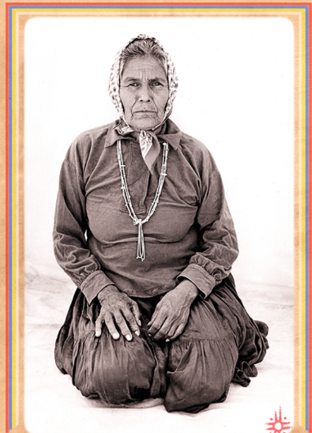
Continuing Our Journey: Sustainability Planning
Native Americans, Alaska Natives, and other Indigenous peoples have a long tradition of living sustainably with the natural world by understanding the importance of preserving natural resources and respecting the interdependence of all living things.” — Native American Rights Fund (NARF)

Maintaining and continuing the program’s vision for the future will provide a base for a strong sustainability plan. Review and assess other portions of the strategic plan as you work through sustainability planning processes. To begin sustainability planning, work with your Community Advisory Circle to establish a shared vision for sustainability.

Team Sustainability Vision

Type your shared vision for sustainability below.

Click or tap here to enter text.

Sustainability Activities

Activities/Tasks | Person Responsible | By When
Develop team processes to discuss program outcomes and data collected to make data-driven decisions. | Example: Coordinator  Click or tap here to enter text. | Year/Quarter  Click or tap here to enter text.
Identify resources and activities to build the capacity of youth, staff, volunteers to enhance skill sets and leadership opportunities
Review sustainability resources and tools to support project sustainability planning. Visit TribalYouth.org to engage in current and archived learning events to support project sustainability planning. Tools and resources for sustainability planning are also available on the “Planning Tools and Resources” supplement page. | Click or tap here to enter text. | Click or tap here to enter text.
Develop asset map with advisory circle to identify current project partnerships, resources, and program supports to support sustainability. | Click or tap here to enter text. | Click or tap here to enter text.
Develop team process to support identification of available funding sources. Engage with leadership to discuss application for available funding sources. | Click or tap here to enter text. | Click or tap here to enter text.
Click or tap here to enter text. | Click or tap here to enter text. | Click or tap here to enter text.
Click or tap here to enter text. | Click or tap here to enter text. | Click or tap here to enter text.
Click or tap here to enter text. | Click or tap here to enter text. | Click or tap here to enter text.
Click or tap here to enter text. | Click or tap here to enter text. | Click or tap here to enter text.
*Add rows as needed. While your cursor is in the last row, right click and then click “insert rows below.”

APPENDIX

Community Engagement Planning Tools and Resources
*Note: it is critical that local tribal knowledge, traditions, and lifeways guide the adaptation and/or utilization of any community engagement tools and resources.
Gathering of Native Americans

Gathering of Native Americans (GONA) is a culture-based planning process where community members gather to address community-identified issues. It uses an interactive approach that empowers and supports AI/AN tribes. The GONA approach reflects AI/AN cultural values, traditions, and spiritual practices.

GONA TOOLKIT
https://www.samhsa.gov/sites/default/files/gona-goan-toolkit.pdf

GONA Curriculum and Facilitator Guide
https://www.samhsa.gov/sites/default/files/gona-goan-curriculum-facilitator-guide.pdf

Fresno Indian Health Board- youth GONA Example
https://www.youtube.com/watch?v=blHMHWaSpmA&feature=youtu.be

Community Readiness Model
The Community Readiness Model (CRM) was developed at Colorado State University to aid in assessing the readiness of a community to address specific problems (e.g., youth substance misuse). The CRM identifies dimensions including leadership involvement, knowledge of the problem, levels of community readiness and can be easily scored by the community. The National Center for Community and Organizational Readiness at CSU was formed to assist communities and tribes in using the model.
National Center for Community and Organizational Readiness
https://nccr.colostate.edu
Community Tool Box
https://ctb.ku.edu/en/table-of-contents/overview/models-for-community-health-and-development/community-readiness/main
Community Readiness: A Handbook for Change
https://www.ndhealth.gov/injury/ND_Prevention_Tool_Kit/docs/Community_Readiness_Handbook.pdf
Community Workshops, Meetings, Assessments
There are other avenues that can be utilized in working toward community engagement. Formal workshops, meetings and assessments can be very beneficial to the process. Also, utilizing community-specific traditional gatherings may provide an organic structure for community engagement activities. Please engage your Technical Assistance Specialist as a resource to further explore and brainstorm community engagement processes and formats.

Youth Engagement and Empowerment
- Healthy & Empowered Youth: A Positive Youth Development Program for Native Youth, Journal of Preventative Medicine (2017): https://www.tribalyouthprogram.org/media/virtual_library/2018/06/26/1-s2.0-S0749379716305499-main.pdf

- Youth Power: a Guide to Community Organizing: https://www.tribalyouthprogram.org/media/virtual_library/2018/06/26/youth_power_complete.pdf

- Core Principles for Engaging Young People in Community Change: https://www.tribalyouthprogram.org/media/virtual_library/2018/06/26/FINALYouth_Engagment_8.15pdf.pdf

- Our Identities as Civic Power: 2017 State of Native Youth Report: https://www.tribalyouthprogram.org/media/virtual_library/2018/06/26/CNAY_State_of_Native_Youth_Report_2017_web.pdf

- Native American Youth 101: https://www.tribalyouthprogram.org/media/virtual_library/2018/06/26/Native-American-Youth-101.pdf

- Strengthening Indian Country Through Tribal Youth Programs: https://www.tribalyouthprogram.org/media/virtual_library/2018/05/15/TYPReportfinal_000.pdf

- A Sweetgrass Method of Bullying Prevention for Native American Youth: A Sweetgrass Method of Bullying Prevention for Native American Youth (usu.edu)

- UNITY Report, Healing Indigenous Lives Native Youth Town Halls: https://ojjdp.ojp.gov/library/publications/healing-indigenous-lives-native-youth-town-halls?utm_source=govdelivery&utm_medium=email&utm_campaign=publications

Tribal Youth Program Community Advisory Circle/Committee Development Guidance
What is the Community Advisory Circle/Committee (CAC) and what is their Role?
An advisory circle/committee is a group of collaborative key stakeholders who provide critical voice, input and support for programmatic activities to enhance the delivery of services to the community. The development of an advisory circle/committee is a recommended core component of the Mapping the Journey Strategic Plan (to be submitted to the Office of Juvenile Justice and Delinquency Prevention).
What are the primary roles and responsibilities of the Community Advisory Circle/Committee members?
- A primary role is to provide helpful guidance and support throughout the life of the project.
- Model and commit to being an impartial and objective group in support of the TYP program coordinator and the Indigenous youth and their families that will be served by the grant.
- Willing to contribute to the development of the overarching framework/program design from planning to sustainability.
- Willing to work together to develop necessary infrastructural supports for the planning and operational components of the TYP.
- Knowledgeable about the TYP’s place in the community (willingness to engage in training that can assist with increasing knowledge) and/or trends in the community affecting the field of services, and a focused commitment to the long-range issues that impact Indigenous youth and their families.
- Commitment to contribute to developing asset/strengths-based solutions.
- Willing to build relationships and work together as a Community Advisory Circle/Committee to accomplish the goals and objectives of the TYP.
- Attend/Participate in Community Advisory Circle/Committee meetings.
- Support ongoing evaluation and processes improvement

Planners can use six basic questions to assist with the development of the operations of the Community Advisory Circle/Committee. See: Center for Court Innovation, “How can Community Advisory Boards Assist the Work of the Justice System,” (Malangone and Facciolo, 2014)
1. Will meetings be open to the public?
2. Where will meetings occur?
3. When and how often will the board/circle meet?
4. Who will lead the meetings?
5. How will meetings be conducted?
6. How will the board meetings be publicized?
Establishing answers to these questions can assist with the format and contributions of the committee to the TYP. Development of the committee should also consider any existing administrative rules within the respective Tribal community, as some Tribes may have established or existing administrative policies related to the development of advisory or local community boards.

Who should be on the Community Advisory Circle/Committee?
Individuals who are identified as key stakeholders may then become members of your steering or tribal community advisory committee. “An effective steering committee is made up of key leaders in the community- people who are in the position to leverage resources, enlist the cooperation of other agencies, influence policy making, and build community awareness of your work” (Gurnell, 2014). It is imperative that the TYP coordinators identify key leaders to ensure support and participation within the TYP planning and implementation activities.
A Community Advisory Circle/Committee should be comprised of key stakeholders. Who are key stakeholders? Here are some examples:
Restorative Justice Practitioners | Tribal Leadership/Elders
Cultural/Spiritual Leadership | Education Providers
Social Services Providers | Program/Tribal Evaluator
Tribal/County/State Law Enforcement | Primary Care/Medical Providers
Tribal Juvenile Court Staff | Probation/Law Enforcement
Behavioral Health Providers | Tribal Families
Local Non-Profit Partners | Tribal Youth

*In the grant goals and objectives, staff representation from those key programs and services listed in the narrative should be recruited for membership in the Community Advisory Circle/Committee.
How many members should be on the Community Advisory Circle/Committee?
The Tribal Youth Program incorporates an interdisciplinary approach from a range of service areas. The advisory circle/committee should reflect these areas in diversity of membership and size of the committee should be determined by the community. Usually, a CAC may consist of at least five or up to a dozen members. Consideration for the quality of interaction and contribution as opposed to the number of members may be helpful in determining total advisory circle/committee membership.

What are the possible challenges involved with implementing a Community Advisory Circle/Committee (CAC)?
Here are some common challenges in maintaining a strong CAC, and steps that can help:
- Advisory Committee lacks purpose or direction.
o Tip: Define the committee with a charter and set out a clear purpose statement and goals of the committee.
- Having no previous working relationship with potential members can be difficult for recruitment.
o Tip: Request and invite potential members to an open discussion of the program, the vision for the program and how their expertise can contribute to the program.
- Potential members can be very busy people and may not be able to commit extensive time to the advisory board/circle.
  - Tip: Encourage buy-in for committee roles by expressing the value of the program and the long-term benefit derived by individual youth and community. Set clear timelines so that members can anticipate the amount of time that may be contributed as part of the advisory committee.
  - Tip: Define roles and responsibilities within the committee to assist with communication and effective planning/meeting processes.
  - Tip: Consider how reciprocity can help with keeping members engaged, e.g., what is their program doing that your project can support, offer that support.

Memorandum of Understanding (MOU) Resources
Sample Memorandum of Understandings are included below:
- Tribal Youth Program Memorandum of Understanding Template
- Tribal Youth Program Memorandum of Understanding Regarding Information Sharing Template
- Developing Agreements between Local Education Agencies and American Indian Nations and Tribal Communities: A WISCONSIN PERSPECTIVE
- MOU Example: Ho Chunk Nation and Black River Falls School District

Resource Mapping
National Center on Secondary Education and Transition: Essential Tools-Community Resource Mapping
This resource provides essential tools and steps to effective resource mapping. Mapping of youth services, supports, and programs within a community can have essentially three outcomes: 1) the identification of resources available to individual youth in a particular community—often referred to as “youth mapping,” 2) the identification of new or additional resources to sustain existing specific youth activities or initiatives within a community, and/or 3) the identification of resources to assist in creating and building capacity to support a more comprehensive community system for serving youth. The first outcome typically occurs at the local level while the second and third outcome can happen at any level—local, state, or federal.
Link to resource: http://www.ncset.org/publications/essentialtools/mapping/overview.asp

NCAI First Kids-Every Child is Sacred, Tribal Tool Kit: Community Asset Mapping for Tribal Youth Well-being
This resource provides a broad overview of the community asset mapping process. It addresses the overall purpose of gathering information, organizing and developing resources using a strength-based approach through identifying, collecting, and analyzing community assets.
Link to resource: http://www.ncai.org/policy-research-center/initiatives/NCAI_CAM_presentation_2019_Mid-Year_Conference.pdf

Wellness Resources for your Team
Your team and partners are key resources of the community and team wellness and strengthening are critical to effectively addressing needs of the youth, families and community. There are tools and support that can help including the Native Wellness Institute (nativewellness.com) and the Professional Quality of Life (ProQOL) websites. These websites (and there are many other resources) have information and tools related to self-care and wellness. Feel free to reach out to your assigned Technical Assistance Specialist for more information.

Strategic Planning Tools

- Strategic Planning Tool Example: National Minority AIDs Council: https://www.dropbox.com/s/8ue607ea3yqb7km/Strategic-Planning%20example%20tool%20compressed.pdf?dl=0

- BJA Tribal Strategic Planning Fact Sheet: https://www.tribalyouthprogram.org/media/virtual_library/2018/06/27/ctas_pa2_factsheet.pdf

- Strategic Planning- A Ten Step Guide: https://www.tribalyouthprogram.org/media/virtual_library/2018/06/27/mosaica_10_steps.pdf

- Developing an Effective Approach to Strategic Planning for Native American Indian Reservations, Space and Polity, Nicholas Christos Zaferatos (2004): https://www.tribalyouthprogram.org/media/virtual_library/2018/06/27/Zaferatos_-_Space_and_Policy.pdf.pdf

Program Reporting Overview
Please confer with your assigned OJJDP Grants Management Specialist regarding questions about project reporting.

A narrative report about the progress of your program is due two times per year in JustGrants. Due dates are January 30 and July 30 of each year.

JustGrants training is available through a series of self-guided eLearning videos, job aid reference guides, and infographics. The training resources provide users with an overview of the JustGrants processes, as well as detailed instructions on how to navigate through the various features and functionalities of the system. Visit https://justicegrants.usdoj.gov/training-resources to learn more.
Required Performance Measures for Tribal Youth Programs can be found at: https://ojjdp.ojp.gov/funding/performance-measures/performance-measures-tribal-youth-program.pdf

Grant Management Support
- For assistance with JustGrants: JustGrants.Support@usdoj.gov or 833–872–5175, Monday through Friday, between the hours of 5:00 a.m. and 9:00 p.m. Eastern Time (ET); and Saturday, Sunday, and federal holidays from 9:00 a.m. to 5:00 p.m. ET. Self-service support is available at: https://justicegrants.usdoj.gov/user-support

- For assistance with Program Reports: contact the OJJDP PMT Helpdesk 866–487–0512 or ojjdppmt@ojp.usdoj.gov. The Helpdesk is available Monday – Friday, 8:30 A.M. – 5:00 P.M. Eastern Time, excluding federal holidays.

Financial Reporting
Please confer with your assigned OJJDP Grants Management Specialist regarding questions about financial reporting.

SF425 (Financial Status Report and Office Management & Budget
Standard Form) reports are due Quarterly: January 30/April 30/July 30/October 30

Notes:
- Report actual expenditures for the period, not drawdowns or expected expenditures.
- Can be revised up until the end of the next quarter.
Review Financial Reporting Guidance by visiting https://justicegrants.usdoj.gov/training-resources/justgrants-training/financial-reporting

The Office of the Chief Financial Officer (OCFO) Customer Service Center provides assistance on the financial aspects of OJP awards. For help with drawing down funds or other issues related to finances contact the Office of the Chief Financial Officer (OCFO) Customer Service Center by email at ASK.OCFO@USDOJ.GOV or by phone at 800-458-0786.

Sustainability Planning Tools and Resources

Planning for sustainability should take place early in the planning process. Your team should formulate a workgroup to design and plan for future sustainability and engage with program partners and stakeholders to identify opportunities for supportive funding and resources. Create a shared vision to sustain program services and meet regularly to discuss plans and activities. Remember, “sustainability is not synonymous with securing more funds, rather it refers to the capacity of a program to sustain the benefits that it provides” (Mancini and Marek, 2004). Here are examples of resources to support team sustainability planning:
OJJDP Tribal Youth Online Learning Resources:
Strategic Action Planning Talking Circle 1: Sustainability
https://www.youtube.com/watch?v=9nofME2bjqs&list=PLEYl_nJGyPlF23t4QVc2EnWb75qAouWCX&index=2
Strategic Planning Toolkit Session 9: Planning for Sustainability https://www.youtube.com/watch?v=iQWUqhnz88g&list=PLEYl_nJGyPlH6TQxvxbGW6QzKVt71xSjt&index=11
Community Toolbox, University of Kansas
A free online toolkit to support sustaining work and initiatives with an outline and examples. https://ctb.ku.edu/en/sustaining-work-or-initiative

Program Sustainability Assessment Tool, Washington University in St. Louis
An online tool and resource to understand, assess, plan, and review resources to support program sustainability.
https://sustaintool.org/

Creating Sustainable and Effective Tribal Criminal Justice Systems
National Institutes of Justice
https://www.nij.gov/topics/tribal-justice/Pages/criminal-justice-system.aspx

Sources:
- Mancini et al., Sustaining Community Based Programs for Families: Conceptualization and Measurement, Family Relations Interdisciplinary Journal of Applied Family Science, 2004.

Tribal Youth Program Guiding Priorities
These Guiding Priorities and others can be used to inform the development of your strategic plan and provide resources for program goals.

- Prevention
  - “The term "prevention" is typically used to represent activities that stop an action or behavior. It can also be used to represent activities that promote a positive action or behavior. Research has found that successful interventions must both reduce risk factors and promote protective factors to ensure the well-being of youth and families.” (See What Is Prevention and Why Is It Important? - Child Welfare Information Gateway)

  - Prevention services to impact risk factors for delinquency and promote protective factors. Which may include:

- Mentoring
- Youth Development
- Gang Education
- Truancy and Dropout Prevention
- After School Programs
- Bullying Education
- Parenting Education
- Healing Informed Practices

  - Prevention, intervention, and treatment for children exposed to violence.

- Development and Implementation of trauma-informed/healing informed practices in programs and services that address child abuse, neglect and the effects and issues of childhood trauma or exposure to violence

  - Development and implementation of tribal best practices and traditional healing methods to support tribal youth.

- Intervention
  - Interventions for youth not experiencing success in schools, family, and community or may be justice -involved youth. Which may include:

- Cultural Practices
- Strengths Identification
- Natural community supports
- Therapeutic services
- Mentoring
- Restorative Practices
- Diversion
- Other alternatives to detention

  - Intervention and treatment services for children exposed to sex trafficking and/or child exploitation may include development and implementation of programs and services including healing-informed practices and services, as well as Restorative Practices.

- Healing/Treatment
  - Healing/Treatment services for at-risk and high-risk youth may include:

- Substance misuse/abuse treatment and prevention programs
- Healing Informed practices and services, e.g., equine assisted therapeutic activities
- Mental health treatment and healing
- Use of culturally grounded comprehensive screening tools
- Intake assessments
- Wraparound Model of Care
- Therapeutic services for co-occurring mental health and substance abuse disorders

- Effective Use of Data
  - Development, establishment and/or improvement of data collection system. This may include efforts to create or improve abilities to track youth in detention, placement, or community-based programs with the goal of strengthening responses to youth and understanding community needs. (See Resource Packet compiled by the Tribal Youth Resource Center for suggested resources to support effective use of data.)

Resource Websites for Tribal Youth Program Planning
The programs/organizations have a specific Native/Tribal youth focus and may be helpful to your project development and implementation.
- OJJDP Tribal Youth Resource Center: www.TribalYouth.org
- National Native Children’s Trauma Center: www.NNCTC.org

- Center for Native American Youth: www.CNAY.org

- Native Wellness Institute: www.NativeWellness.com

- Rural Alaska Community Action Program (RurAL CAP) - The Resource Basket: www.ResourceBasket.org

- Northwest Portland Area Indian Health Board: www.NPAIHB.org

- We R Native: www.WeRNative.org

- National Congress of American Indians: www.NCAI.org

Locke, E. A. (1968). Toward a theory of task motivation and incentives. Organizational Behavior and Human Performance,3(2), 157-189. doi:10.1016/0030-5073(68)90004-4

