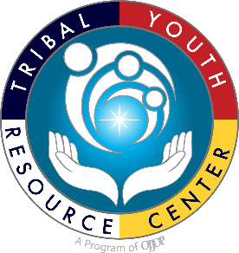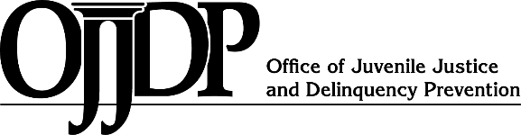

FY 2020

**CTAS Purpose Area 9: Tribal Youth Programs *Resource Guide with Planning Templates***

**FY 2020**

**Tribal Youth Resource Center**

Strategic Planning Resource Guide

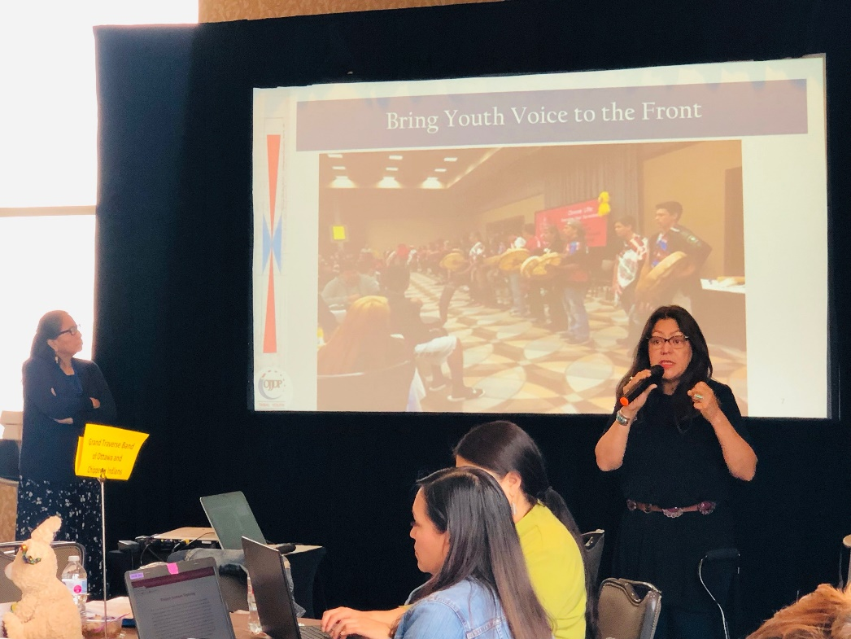

*This project was supported by Grant #2018-MU-MU-K001 awarded by the Office of Juvenile Justice and* *Delinquency Prevention, Office of Justice Programs, U.S. Department of Justice. The opinions, findings, and* *conclusions or recommendations expressed in this publication/program/exhibition are those of the author(s) and do not necessarily reflect those of the Department of Justice.*

|  |
| --- |
| **Introduction to the Strategic Planning Resource Tool (Strat Pak)** |
| Greetings from the Tribal Youth Resource Center (TYRC)!  We are honored to work with your Tribe and community to develop the plan to implement your OJJDP Tribal Youth Program grant. The Tribal Youth TTA team will launch the bi-weekly Tribal Youth peer learning lab sessions in April. Due to the pandemic we do not have any in person trainings scheduled but we will work with grantees via Zoom and conference calls to complete the strategic planning process by September 30, 2021.  This Strat Pak tool is intended as a *resource* for Tribal Youth Program grantees to develop a strategic plan which will serve as a road map for realizing the goals, objectives, outcomes, and sustainability of your Tribal Youth Program. While 2020 and part of 2021 has been challenging we can now take advantage of the resources made available to your Tribe to virtually engage with parents, caregivers, and youth to build the capacity for Tribal youth to define and realize their goals and strengthen their future.  As an experienced Tribal Training and Technical Assistance Center we have observed that a strategic plan that is developed by a group of people with a shared vision and a commitment to investing time in the goals of the program enriches the potential for effective implementation and sustainability. Each FY 2020 Tribal Youth grantee has an assigned TTA Specialist who will work with the TYP coordinator and advisory circle through each step of the strategic planning process. Please visit [www.TribalYouth.org](http://www.tribalyouth.org/) to learn more about the Tribal Youth Resource Center. |
| As a training and technical assistance provider for the [Office of Juvenile Justice and Delinquency Prevention](https://www.ojjdp.gov), the [Tribal Youth Resource Center](https://www.TribalYouth.org) as part of the [Tribal Law and Policy Institute](https://www.home.tlpi.org/) and its partner the [National Native Children’s Trauma Center](https://www.nnctc.org/) bring an in depth understanding and appreciation of American Indian and Alaska Native History, customs, Indigenous justice systems. **Native youth benefit from a value held by Native peoples: *Our Children are Sacred.***    *Tribal Youth Resource Center Email:* [*TribalYouth@TLPI.org*](mailto:TribalYouth@TLPI.org)  *Web:* [*www.TribalYouth.org*](http://www.TribalYouth.org) |

|  |  |
| --- | --- |
| Table of Contents | |
| Section | Page |
| * OJJDP FY 2020 Grant Program Timeline Snapshot | 4 |
| * Program Reporting Overview | 5 |
| * Tribal Youth Program Guiding Priorities | 6 |
| * Tribal Youth Program Planning Resources | 7 |
| * Program Contact Information | 9 |
| * Plan Core Components | 9 |
| * Community Advisory Circle | 10 |
| * Vision and Mission Statements | 12 |
| * Communication Plan | 13 |
| * Engaging Youth and Community Voice | 16 |
| * Data Collection Planning | 18 |
| * Program Logic Model | 20 |
| * Evaluation Planning and Implementation | 23 |
| * S.M.A.R.T. Goals | 27 |
| * Developing Supportive Objectives | 31 |
| * Sustainability Plan | 34 |
| Appendix |  |
| * Developing the Community Advisory Committee Guidance | 37 |
| * Community Engagement Planning Tools and Resources | 40 |
| * Resource Mapping Resources | 41 |
| * Summary Findings: Community Engagement Activities Worksheet | 42 |
| * Sustainability Planning Tools and Resources | 43 |
| * Action Planning Template | 44 |

**FY 2020 Tribal Grantee OJJDP Prescribed Objectives Overview**   
The FY 2020 CTAS Purpose Area 9 Grant Solicitation includes prescribed objectives for years one through three of the project period. A snapshot of the three-year timeline is included below. Note you can review the detailed list of objectives in the project solicitation link [here](https://files.constantcontact.com/9f76d4bb701/503fd801-4134-4db9-88ab-c814c81a1f29.pdf).

|  |
| --- |
| ***Program Reporting*** |
| Your progress reports are semi-annual and are due in the JustGrants system **no later than January 30 and July 30 of each year**. Please reference the below resources for guidance on reporting:   1. [OJJDP Progress Reporting Questions Training](https://files.constantcontact.com/9f76d4bb701/6c15534e-4409-4d51-8941-c3047fe80f2c.pdf) 2. [Office for Juvenile Justice and Delinquency Prevention (OJJDP) Progress Reporting Questions](https://files.constantcontact.com/9f76d4bb701/1d3fe250-ef2f-4497-bc2e-36689f10b859.pdf)   Online training is also available to support access to JustGrants: <https://justicegrants.usdoj.gov/>  For help with the JustGrants (including problems with passwords or finding information in the system) call the Helpdesk: 888-549-9901. You can request information related to:   * General requirements for receiving funds * Assistance with JustGrants * JustGrants user Id and password issues. |
| ***Financial Reporting*** |
| **Financial reports are due Quarterly**: **January 30/April 30/July 30/October 30**  The Office of Justice Programs provides Financial Training and Technical Assistance.  To access information on available training visit <https://www.ojp.gov/training/financial>  The Office of Justice Programs Financial Guide can be accessed by visiting: <https://www.ojp.gov/funding/apply/2014-ojp-financial-guide>  For support and to link to online financial management training visit: <https://onlinegfmt.training.ojp.gov/>  The Office of the Chief Financial Officer (OCFO) Customer Service Center provides assistance on the financial aspects of OJP awards. For help with drawing down funds or other issues related to finances contact the Office of the Chief Financial Officer (OCFO) Customer Service Center by email at [ASK.OCFO@USDOJ.GOV](mailto:ASK.OCFO@USDOJ.GOV) or by phone at 800-458-0786. |

|  |
| --- |
| **Tribal Youth Program Guiding Priorities** |
| 1. **Prevention**    1. Prevention services to impact risk factors for delinquency and ***promote protective factors***. Which may include:  * Mentoring * Youth Development * Anti-Gang Education * Truancy and Dropout Prevention * After School Programs * Anti-Bullying * Parenting Education   1. Prevention, intervention, and treatment for children exposed to violence. * Development and Implementation of ***trauma-informed practices*** in programs and services that address child abuse, neglect and the effects and issues of childhood trauma or exposure to violence   1. Development and implementation of ***tribal best practices*** and traditional healing methods to support tribal youth.  1. **Intervention**    1. Interventions for court-involved youth. Which may include:  * Therapeutic services * Mentoring * Graduated Sanctions * Restitution * Diversion * Home detention * Foster and Shelter Care * Other alternatives to detention   1. Intervention and treatment services for children exposed to sex trafficking and/or child exploitation. Which may include development of or implementation of programs and services for children who are victims of child exploitation and/or sex trafficking.  1. **Treatment**    1. Treatment services for at-risk and high-risk youth.   Which may include:   * Alcohol and drug abuse treatment and prevention programs * Mental health treatment * Development of comprehensive screening tools * Crisis intervention * Intake assessments * Treatment team planning * Therapeutic services for co-occurring mental health and substance abuse disorders  1. **Effective Use of Data**    1. Improvement or establishment of data collection system. Which may include efforts to create or improve abilities to track youth in detention, placement, or community-based programs with the goal of improving understanding of and responses to youth and community needs.   *Please see below for further information:   * <https://www.justice.gov/file/1223441/download> * <https://www.justice.gov/file/1251271/download>​ |

|  |
| --- |
| **Tribal Youth Program Planning Resources** |
| There are several resources your team may review to support planning and implementation of your Tribal Youth Program. This table is only a sampling of resources. Your training and technical assistance specialist can support your team and identify additional resources to support your program. |
| **Helpful Websites:** |
| * OJJDP Tribal Youth Resource Center: [www.TribalYouth.org](http://www.TribalYouth.org) * National Native Children’s Trauma Center: [www.NNCTC.org](http://www.NNCTC.org) * Center for Native American Youth: [www.CNAY.org](http://www.CNAY.org) * Native Wellness Institute: [www.NativeWellness.com](http://www.NativeWellness.com) * RurAL CAP - The Resource Basket: [www.ResourceBasket.org](http://www.ResourceBasket.org) * Northwest Portland Area Indian Health Board: [www.NPAIHB.org](http://www.NPAIHB.org) * We R Native: [www.WeRNative.org](http://www.WeRNative.org) * National Congress of American Indians: [www.NCAI.org](http://www.NCAI.org) |
| **Resources to Support Project Planning and Implementation:** |
| * BJA Tribal Strategic Planning Fact Sheet: <https://www.tribalyouthprogram.org/media/virtual_library/2018/06/27/ctas_pa2_factsheet.pdf> * Strategic Planning- A Ten Step Guide: <https://www.tribalyouthprogram.org/media/virtual_library/2018/06/27/mosaica_10_steps.pdf> * Developing an Effective Approach to Strategic Planning for Native American Indian Reservations, Space and Polity, Nicholas Christos Zaferatos (2004): <https://www.tribalyouthprogram.org/media/virtual_library/2018/06/27/Zaferatos_-_Space_and_Policy.pdf.pdf> * Healthy & Empowered Youth: A Positive Youth Development Program for Native Youth, Journal of Preventative Medicine (2017): <https://www.tribalyouthprogram.org/media/virtual_library/2018/06/26/1-s2.0-S0749379716305499-main.pdf> * Youth Power: a Guide to Community Organizing: <https://www.tribalyouthprogram.org/media/virtual_library/2018/06/26/youth_power_complete.pdf> * Core Principles for Engaging Young People in Community Change: <https://www.tribalyouthprogram.org/media/virtual_library/2018/06/26/FINALYouth_Engagment_8.15pdf.pdf> * Our Identities as Civic Power: 2017 State of Native Youth Report: <https://www.tribalyouthprogram.org/media/virtual_library/2018/06/26/CNAY_State_of_Native_Youth_Report_2017_web.pdf> * Native American Youth 101: <https://www.tribalyouthprogram.org/media/virtual_library/2018/06/26/Native-American-Youth-101.pdf> * Strengthening Indian Country Through Tribal Youth Programs: <https://www.tribalyouthprogram.org/media/virtual_library/2018/05/15/TYPReportfinal_000.pdf> |

FY 2020 CTAS Purpose Area 9: Tribal Youth Program

*Strategic Planning Resource Guide*

|  |  |
| --- | --- |
| **Tribe Name:** | Click or tap here to enter text. |
| **Grant Award Number:** | Click or tap here to enter text. |
| **Grantee Point of Contact:** | Click or tap here to enter text. |
| **Grantee Secondary**  **Point of Contact:** | Click or tap here to enter text. |
| **Phone Number:** | Click or tap here to enter text. |
| **Email Address:** | Click or tap here to enter text. |
| **OJJDP Program Specialist:** | Click or tap here to enter text. |
| **Technical Assistance Specialist:** | Click or tap here to enter text. |

|  |
| --- |
| **This Strategic Plan Addresses the Following Core Components:** |
| Community Advisory Circle |
| Vision and Mission |
| Communication Plan |
| Youth and Community Engagement |
| Data Collection, Logic Model, Evaluation Plan |
| Specific Measurable Achievable Relevant Time-bound (S.M.A.R.T.) Goals and Objectives |
| Sustainability Plan |

|  |
| --- |
| **Community Advisory Circle**  The Community Advisory Circle is considered a best practice for strategic planning, implementation, and sustainability. The purpose of a Community Advisory Circle is to contribute to the development of the overarching framework and program design from planning to sustainability. Community Advisory Circles are comprised of 6-12 members representing all facets of the community from elders, youth, formal and informal leaders in the community to health, education, justice, treatment and youth serving providers. |

|  |  |  |  |  |  |
| --- | --- | --- | --- | --- | --- |
| **Partner Name**  **& Title** | | **Role on Team** | **MOA**  **Yes or No** | **Preferred Method of Communication** | **Gifts/**  **Expertise** |
|  | Click or tap here to enter text. | Click or tap here to enter text. | Click or tap here to enter text. | Click or tap here to enter text. | Click or tap here to enter text. |
|  | Click or tap here to enter text. | Click or tap here to enter text. | Click or tap here to enter text. | Click or tap here to enter text. | Click or tap here to enter text. |
|  | Click or tap here to enter text. | Click or tap here to enter text. | Click or tap here to enter text. | Click or tap here to enter text. | Click or tap here to enter text. |
|  | Click or tap here to enter text. | Click or tap here to enter text. | Click or tap here to enter text. | Click or tap here to enter text. | Click or tap here to enter text. |
|  | Click or tap here to enter text. | Click or tap here to enter text. | Click or tap here to enter text. | Click or tap here to enter text. | Click or tap here to enter text. |
|  | Click or tap here to enter text. | Click or tap here to enter text. | Click or tap here to enter text. | Click or tap here to enter text. | Click or tap here to enter text. |
|  | Click or tap here to enter text. | Click or tap here to enter text. | Click or tap here to enter text. | Click or tap here to enter text. | Click or tap here to enter text. |

*Add rows as needed. While your cursor is in the last row, right click and then click “insert rows below.”

|  |
| --- |
| **Optional Team Exercise:** Create a picture collage of your advisory circle! |

|  |
| --- |
| **Advisory Circle Meeting Agreements** |
| Please provide a brief overview of the frequency of Community Advisory Circle meetings.  *Example: Bi-Weekly, Monthly, Quarterly.*  *Example Language: The Community Advisory Circle shall meet bi-weekly/monthly during the planning year of the grant, and then shall meet quarterly and as needed for program support.* |
| Click or tap here to enter text. |

|  |
| --- |
| **Community Advisory Circle Responsibilities** |
| Provide a brief overview of the responsibilities of your advisory circle. Program planning, support, implementation, and guidance are all roles that an advisory committee may support as part of the project activities.  *Example Language: The Community Advisory Circle meets monthly and assists in the development of the Strategic Plan. The Community Advisory Circle outreaches to community members and provides frequent updates on the program implementation progress.* |
| Click or tap here to enter text. |

|  |
| --- |
| **Vision and Mission Statements**  Developing effective vision (*your inspired dream*) and mission (*why your program exists*) statements are important first steps in your strategic planning process. These written declarations provide the program’s foundation while communicating the purpose and direction of work that will be launched during the next three years. |

|  |
| --- |
| **VISION STATEMENT**  Your dream/the desired end state, where you would like to be. Statement is generally inspirational, memorable and concise. *For example:* Restoration of our families and our communities. |
| Click or tap here to enter text. |

|  |
| --- |
| **MISSION STATEMENT**  A statement of why your strategic initiative/program exists and how you will realize the vision (explain) in 1-2 sentences that are brief & clear. *For example:* Our mission is to revitalize and reconnect our Tribal youth to their Culture so that they will have a strong foundational cultural identity. |
| Click or tap here to enter text. |
| **Communication Plan**  A communication plan will contribute to effective communication with fellow team members, partners, youth and families. Tribal and community leadership and other stakeholders should be included in communication plans and activities. A plan will assist in reducing communication barriers and strengthen your strategies to engage in consistent and on-going collaborative communication. |

|  |  |  |
| --- | --- | --- |
| **Communication Plan: Team Strengths/Needs** | | |
| **Core Service Providers** | **Team Member Name** | **Preferred Mode of Communication** |
| Click or tap here to enter text. | Click or tap here to enter text. |
| Click or tap here to enter text. | Click or tap here to enter text. |
| Click or tap here to enter text. | Click or tap here to enter text. |
| Click or tap here to enter text. | Click or tap here to enter text. |
| Click or tap here to enter text. | Click or tap here to enter text. |
| Click or tap here to enter text. | Click or tap here to enter text. |
| Click or tap here to enter text. | Click or tap here to enter text. |
| **Brainstorm Program Partners and their preferred methods of communication** | **Partner Program/Organization** | **Preferred Mode of Communication** |
| Click or tap here to enter text. | Click or tap here to enter text. |
| Click or tap here to enter text. | Click or tap here to enter text. |
| Click or tap here to enter text. | Click or tap here to enter text. |
| Click or tap here to enter text. | Click or tap here to enter text. |
| Click or tap here to enter text. | Click or tap here to enter text. |
| Click or tap here to enter text. | Click or tap here to enter text. |

|  |  |  |  |
| --- | --- | --- | --- |
| **Building a Communication Plan to Strengthen Community Engagement & Support** | | | |
| **Please list the materials you will be developing for your Tribal Youth Program.** | | | |
| **Print** | **Broadcast** | **Social Media** | **Digital Content Management** |
| *Example:*  *Program Brochures*  *Template for community flyer* | *Example:*  *Pre-recorded PSAs for local radio stations* | *Example:*  *YouTube account*  *Instagram account* | *Example:*  *\*Scheduling posts*  *\*Coordinating different platforms*  *\*Storing content online* |
| Click or tap here to enter text. | Click or tap here to enter text. | Click or tap here to enter text. | Click or tap here to enter text. |
| Click or tap here to enter text. | Click or tap here to enter text. | Click or tap here to enter text. | Click or tap here to enter text. |
| Click or tap here to enter text. | Click or tap here to enter text. | Click or tap here to enter text. | Click or tap here to enter text. |
| Click or tap here to enter text. | Click or tap here to enter text. | Click or tap here to enter text. | Click or tap here to enter text. |

|  |  |
| --- | --- |
| **Administrative Activities to Support Communication** | |
| Develop record keeping process and communicate with full team regarding notes, records, and minutes from meetings and communications. | Click or tap here to enter text. |
| Develop necessary MOU/MOA to engage program partners. | Click or tap here to enter text. |
| Develop necessary consents/waivers/ confidentiality agreements to address protected communications. | Click or tap here to enter text. |
| Assess communication processes ongoing to support quality improvement. | Click or tap here to enter text. |
| Identify modes of communication and venues to outreach to broader community (e.g., radio, television, tribal newsletter, social media). | Click or tap here to enter text. |

|  |
| --- |
| **Engaging Youth and Community Voice**  Incorporating youth and community voice in the development and implementation of the Tribal Youth Program provide youth and community an opportunity to learn about power dynamics, consensus making, planning and organizing, data collection and resource mapping. Most importantly, providing a “place and space” for youth and community in the strategic planning process will provide a sense of investment to the success of the program. |

|  |  |  |  |  |
| --- | --- | --- | --- | --- |
| **Activities/ Tasks** | **Person Responsible** | **Anticipated  Completion Date** | **Progress and Comments** | **Indigenous Value** |
| *Host open community meeting and invite youth* | *Program Coordinator,*  *TYP Community Advisory Circle* | *August 2021* | *Not Started. Requested Resources from TTA Specialist* | *Inclusion* |
| *Set up booth at Community Youth Event* | *Program Coordinator,*  *TYP Community Advisory Circle* | *September 2021* | *Requested booth from event organizer* | *Empowerment* |
| *Volunteer at Community Youth Events* | *Program Coordinator,*  *TYP Community Advisory Circle* | *Ongoing* | *Review community event calendars and outreach to key contacts* | *Generosity* |
| *Meet with other youth serving agencies* | *Program Coordinator,*  *TYP Community Advisory Circle* | *October 2021* | *Schedule meetings with the directors of other youth serving agencies in the community* | *Respect* |
| Click or tap here to enter text. | Click or tap here to enter text. | Click or tap here to enter text. | Click or tap here to enter text. | Click or tap here to enter text. |
| Click or tap here to enter text. | Click or tap here to enter text. | Click or tap here to enter text. | Click or tap here to enter text. | Click or tap here to enter text. |
| Click or tap here to enter text. | Click or tap here to enter text. | Click or tap here to enter text. | Click or tap here to enter text. | Click or tap here to enter text. |
| Click or tap here to enter text. | Click or tap here to enter text. | Click or tap here to enter text. | Click or tap here to enter text. | Click or tap here to enter text. |
| Click or tap here to enter text. | Click or tap here to enter text. | Click or tap here to enter text. | Click or tap here to enter text. | Click or tap here to enter text. |
| Click or tap here to enter text. | Click or tap here to enter text. | Click or tap here to enter text. | Click or tap here to enter text. | Click or tap here to enter text. |

*Add rows as needed. While your cursor is in the last row, right click and then click “insert rows below.”

|  |
| --- |
| **See Summary Findings: Community Engagement Activities Worksheet in appendix** |

|  |
| --- |
| **Data Collection Planning**  Local community members are the greatest asset in gathering and interpreting data for your Tribal Youth Program. Focus on collecting data that can be analyzed to improve the life of your youth and prevent or reduce their at risk behaviors. It is highly recommended to take a strengths based approach, gathering and interpreting data that exemplifies the resilience and positive things happening in your tribal community. Collecting this data will substantiate what is working in your community and allow you to enhance those interventions/approaches. The link below is a great resource for further understanding and approaching data collection.  **Resource:** <https://nij.ojp.gov/topics/articles/collecting-and-analyzing-tribal-data> |

|  |  |  |  |  |
| --- | --- | --- | --- | --- |
| **Local Level Data:** Work with the team to identify local level data. Data collection will support program goals, activities, quality improvement, and future sustainability planning. Developing a resource map may assist you with identifying key points for which data can be collected. | | | | |
| **Key Questions*:*** What methods will you use to collect the data? Where is the data? How often will the data be collected? Who will assist the program coordinator in collecting the data? How will you organize, manage, and store the data? | | | | |
| **Data to Collect** | **Where is data and**  **how will it be collected?** | **Who is Responsible for collecting data?** | **Target Date(s) for Data Collection and review** | **How will data be stored?** |
| *Example: Number of tribal youth school expulsions.* | *Example: School attendance and record keeping system. Data will be generated through electronic reports.* | *Example: Local County School.* | *Example: Monthly Review of student expulsion reports by program partners.* | *Example: Data received by program partners will be stored on shared electronic records sheet.* |

|  |  |  |  |  |
| --- | --- | --- | --- | --- |
| **Year 1: Planning Data to Collect** | | | | |
| **Data to Collect** | **Where is data and how will it be collected?** | **Who is responsible for collecting data?** | **Target date(s) for data collection** | **How will data be stored?** |
| Click or tap here to enter text. | Click or tap here to enter text. | Click or tap here to enter text. | Click or tap here to enter text. | Click or tap here to enter text. |
| Click or tap here to enter text. | Click or tap here to enter text. | Click or tap here to enter text. | Click or tap here to enter text. | Click or tap here to enter text. |
| Click or tap here to enter text. | Click or tap here to enter text. | Click or tap here to enter text. | Click or tap here to enter text. | Click or tap here to enter text. |
| Click or tap here to enter text. | Click or tap here to enter text. | Click or tap here to enter text. | Click or tap here to enter text. | Click or tap here to enter text. |
| Click or tap here to enter text. | Click or tap here to enter text. | Click or tap here to enter text. | Click or tap here to enter text. | Click or tap here to enter text. |
| Click or tap here to enter text. | Click or tap here to enter text. | Click or tap here to enter text. | Click or tap here to enter text. | Click or tap here to enter text. |
| Click or tap here to enter text. | Click or tap here to enter text. | Click or tap here to enter text. | Click or tap here to enter text. | Click or tap here to enter text. |
| Click or tap here to enter text. | Click or tap here to enter text. | Click or tap here to enter text. | Click or tap here to enter text. | Click or tap here to enter text. |
| Click or tap here to enter text. | Click or tap here to enter text. | Click or tap here to enter text. | Click or tap here to enter text. | Click or tap here to enter text. |
| Click or tap here to enter text. | Click or tap here to enter text. | Click or tap here to enter text. | Click or tap here to enter text. | Click or tap here to enter text. |

*Add rows as needed. While your cursor is in the last row, right click and then click “insert rows below.

|  |  |  |  |  |
| --- | --- | --- | --- | --- |
| **Identify Performance Measures that will be reported on**  *See sample Performance Measures included in the logic model on the following page: #1 under the column “What can we do today, Supporting our relatives” and #s 3-5 under column “Honoring our youth today.”* | | | | |
| **Performance measure to collect** | **Where is data and how will it be collected?** | **Person(s) responsible for collecting data** | **Target date(s) for data collection** | **How will data be stored?** |
| Click or tap here to enter text. | Click or tap here to enter text. | Click or tap here to enter text. | Click or tap here to enter text. | Click or tap here to enter text. |
| Click or tap here to enter text. | Click or tap here to enter text. | Click or tap here to enter text. | Click or tap here to enter text. | Click or tap here to enter text. |
| Click or tap here to enter text. | Click or tap here to enter text. | Click or tap here to enter text. | Click or tap here to enter text. | Click or tap here to enter text. |
| Click or tap here to enter text. | Click or tap here to enter text. | Click or tap here to enter text. | Click or tap here to enter text. | Click or tap here to enter text. |
| Click or tap here to enter text. | Click or tap here to enter text. | Click or tap here to enter text. | Click or tap here to enter text. | Click or tap here to enter text. |
| Click or tap here to enter text. | Click or tap here to enter text. | Click or tap here to enter text. | Click or tap here to enter text. | Click or tap here to enter text. |
| Click or tap here to enter text. | Click or tap here to enter text. | Click or tap here to enter text. | Click or tap here to enter text. | Click or tap here to enter text. |
| Click or tap here to enter text. | Click or tap here to enter text. | Click or tap here to enter text. | Click or tap here to enter text. | Click or tap here to enter text. |

*Add rows as needed. While your cursor is in the last row, right click and then click “insert rows below.”

|  |
| --- |
| **Program Logic Model**  **A logic model is a graphic depiction (road map) that presents the shared** relationships among the resources, activities, outputs, outcomes, and impact for your program. It depicts the relationship between your program’s activities and its intended effects. <https://www.cdc.gov/eval/logicmodels/index.htm> |

How are we going to work toward our Vision and implement our Mission Statement? Let us start with a developing a logic model, which is a depiction of your project – where you have been, where you are going, how you are going to get there and how you will know when you have arrived. For example, if we were to tell the story of our project in a one-page graphic, what would that look like? Here are a couple of examples:

**Example One (below):** In this example, note that the logic model starts with indicating the changes that we want to see, then it works to the right highlighting how those changes are going to happen and how they will be measured. Finally, the far right column shows how the resources invested and the activities engaged in have impacted the desired outcome. [Click here to view a larger version of the logic model.](https://files.constantcontact.com/9f76d4bb701/6cb1cb84-bbab-4876-baf8-28583d58cddc.docx) 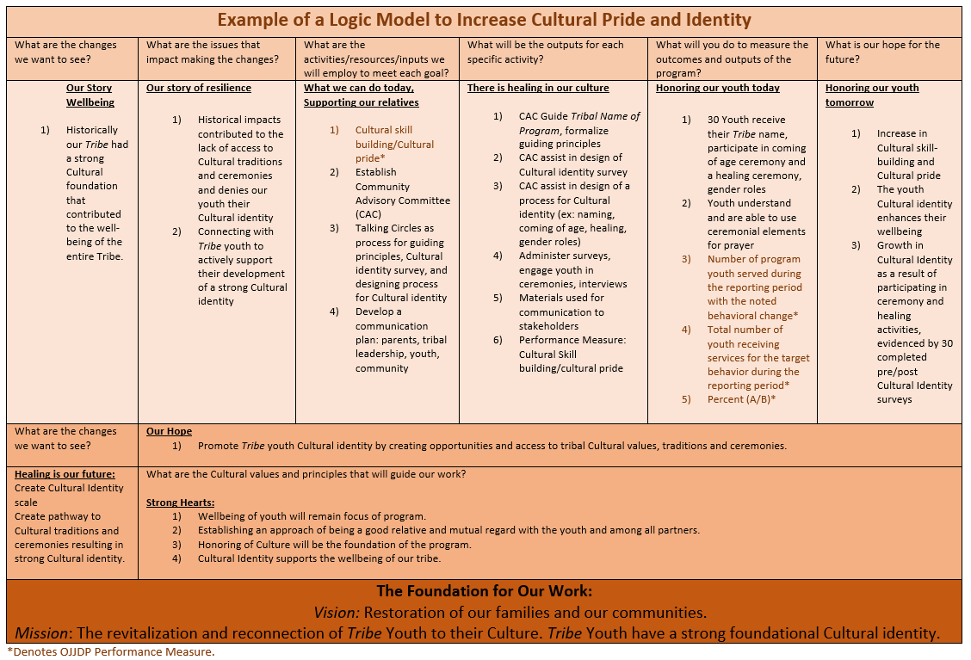

Let us look at another example below. In this example, where we have been is highlighted at the top, then the logic model proceeds to the right showing where we would like to be, then how we are going to get there and finally the outcome.

**Example Two:**

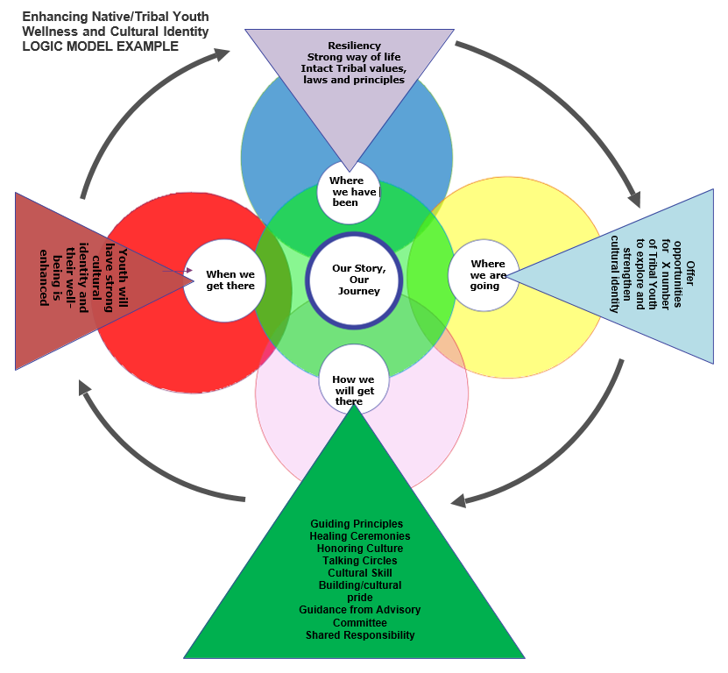

These two examples contain the same information but are depicted in different formats. There is no one “right” format, and you and your Advisory Committee can decide on what format to use; perhaps you’ll build your own format or use a different format. The point is the logic model provides a graphic depiction of your project, the issues or needs, how you are going to address the needs through available resources and activities, and what you are going to measure to determine if you are headed in the direction you want to go. Finally, the graphic shows the hoped for impact or outcome of your project.

**Example Three:**

This is another example of a format for a logic model that comes from OJJDP. As stated before, logic models can look different but they all have a central purpose: provide a one-page depiction of your program’s goals, objectives, activities and hoped for outcomes.

[Applicant/Program Name] Logic Model]

The italicized text in each logic model section describes the information to include and should be replaced with your responses. Enter the applicant or program name in the header, replacing the brackets.

|  |  |  |
| --- | --- | --- |
| **Date** | *MM/DD/YY* |  |
| **Desired Result** | | *State precisely what the program or initiative hopes to achieve. The result statement should reflect the purpose of the federal award and the Office of Juvenile Justice and Delinquency Prevention’s vision to support a nation where children are free from crime and violence and encounter a just and beneficial juvenile justice system.* | |
| **Goals** | | **Goal 1**: *Goals define how you know you have achieved your desired outcomes or the future condition your program or initiative hopes to achieve.* *The goals should align with your stated desired result and demonstrate how you intend to meet the purpose of the federal award*. *You may include an unlimited number of* *goals.* | |

|  |  |  |  |  |  |
| --- | --- | --- | --- | --- | --- |
| **Inputs** | **Activities** | **Outputs** | **Outcomes** | | |
| **Short-term** | **Intermediate** | **Long-term** |
| * *Inputs describe the resources needed to implement a program’s activities successfully.* | * *Activities describe the actions needed to achieve a program’s goals and objectives.* | * *Outputs identify what happens from a program’s intended activity. Outputs are generally represented as a number, such as the number of people trained.* | * *Outcomes describe the results of an activity, program, or initiative.* * *Short-term outcomes reflect the immediate result of an activity, such as a change in knowledge, or change in practice.* | * *Intermediate outcomes reflect the result that occurs after achieving the short-term outcome, such as a change in behavior or implementation of a new system.* | * *Long-term outcomes demonstrate the ultimate change in a population or system the activity, program, or initiative hopes to achieve, such as decreased youth recidivism or decreased child victimization.* |

So let’s jump into measurement which is an aspect of evaluation planning and is part of your data collection plan. For sure, the OJJDP performance indicators are data that you want to collect and in fact are required to collect as part of your grant. You may want to see if cultural identity of youth is increasing as a result of your activities so you would plan and implement activities designed to strengthen cultural identity and measure the outcomes of those activities.

|  |
| --- |
| **Evaluation Planning and Implementation**  Evaluation is not about judgment, evaluation is about telling your program’s story – where you have been, where you are going and how you are going to get there. Indigenous and Tribal people have always used evaluation. They needed to evaluate where the best hunting and fishing places were, where the best and safest place to camp and how they were going to ensure their teachings were passed on. Here is an opportunity to share your program’s story and ensure the teachings get passed on. |

“*Evaluation should be tailored to the cultural context of the community and responsive to cultural ways of life, including cultural values for parenting and child well-being*” (see pg. 23 in #4 “A Roadmap” in the resource list below). With this in mind, here are some resources that may help with your evaluation planning:

**RESOURCES FOR EVALUATION PLANNING AND IMPLEMENTATION**

1. Indigenous Evaluation Toolkit, <https://gptec.gptchb.org/indigenous-evaluation-toolkit/>
2. Indigenous Evaluation Framework: Telling Our Story in Our Place and Time. LaFrance, J., & Nichols, R. (2008). Alexandria, VA: American Indian Higher Education Consortium (AIHEC), <http://indigeval.aihec.org/Pages/Documents.aspx>
3. Using your logic model to plan for evaluation, Evaluation Planning, Chapter 4, W.K. Kellogg Foundation, <https://azprc.arizona.edu/sites/default/files/CHWtoolkit/PDFs/LOGICMOD/CHAPTER4.PDF>
4. A Roadmap for Collaborative and Effective Evaluation in Tribal Communities, <https://www.acf.hhs.gov/sites/default/files/cb/tribal_roadmap.pdf>
5. W.K. Kellogg Foundation Evaluation Handbook, <https://www.wkkf.org/resource-directory/resource/2010/w-k-kellogg-foundation-evaluation-handbook>
6. Evaluating Indigenous programs: a toolkit for change, S. Hudson, 2017, <https://www.cis.org.au/app/uploads/2017/06/rr28.pdf>

Key questions for evaluation planning include: *What is the culture of the community? What is the purpose of our evaluation? Who needs to know what, when? What outcome in our logic model do we want to focus on in our evaluation? How will we engage stakeholders in our evaluation plan? What resources do we have to commit to evaluation planning and implementation?* After considering these questions, your first step is to establish goals for your evaluation. Here’s a table to help guide your work:

|  |  |
| --- | --- |
| **Establish Goal(s) for evaluation:**  *Example: Team strives to implement ongoing internal team-led strengths-based evaluation to consistently evaluate project progress through an agreed upon data collection method, in order to determine needed improvements.* | |
| **Evaluation Goal(s)** | |
| **Goal 1** | Click or tap here to enter text. |
| **Goal 2** | Click or tap here to enter text. |
| **Goal 3** | Click or tap here to enter text. |

*Add rows as needed. While your cursor is in the last row, right click and then click “insert rows below.”

|  |  |  |
| --- | --- | --- |
| **Evaluation Working Group** | | |
| **Establish Working Group  Team Lead** | **Program Name** | **Role/Responsibilities** |
| **Evaluation Team Member(s)** | **Name(s)** | **Role(s)** |
| Click or tap here to enter text. | Click or tap here to enter text. | Click or tap here to enter text. |
| Click or tap here to enter text. | Click or tap here to enter text. | Click or tap here to enter text. |
| Click or tap here to enter text. | Click or tap here to enter text. | Click or tap here to enter text. |

*Add rows as needed. While your cursor is in the last row, right click and then click “insert rows below.”

|  |  |  |
| --- | --- | --- |
| **Stakeholders: How will the team engage stakeholders in the evaluation process?** | | |
| **Stakeholders to Engage** | **Stakeholder Interests/Perspectives** | **Stakeholder Engagement (When/How)** |
| *Example (Truancy Program): Engage local school partners* | *Example: Knowledge and awareness of population, program strengths, needs, and impacts* | *Example: Ongoing, but at least yearly, for program quality improvement. Survey will be generated and coordinator will host in-person meeting to review results.* |
| Click or tap here to enter text. | Click or tap here to enter text. | Click or tap here to enter text. |
| Click or tap here to enter text. | Click or tap here to enter text. | Click or tap here to enter text. |
| Click or tap here to enter text. | Click or tap here to enter text. | Click or tap here to enter text. |

*Add rows as needed. While your cursor is in the last row, right click and then click “insert rows below.”

|  |  |  |
| --- | --- | --- |
| **Evaluation Activities** | **Timing** | **Comments** |
| Review data collected from data collection plan. | *Example: Every 6 months through life of project*  Click or tap here to enter text. | Click or tap here to enter text. |
| Review logic model to track projected short-term and long-term outcomes. | Click or tap here to enter text. | Click or tap here to enter text. |
| Engage stakeholders/partners/team in planning evaluation activities. | Click or tap here to enter text. | Click or tap here to enter text. |
| Team development of evaluation method and processes. (Will team engage in internal evaluation or engage external evaluation supports? What types of evaluation will team engage in — process evaluation, outcome evaluation, or both?) | Click or tap here to enter text. | Click or tap here to enter text. |
| Develop evaluation outcome dissemination plan; How will you share the evaluation results? How will results improve program design/implementation? | Click or tap here to enter text. | Click or tap here to enter text. |
| Engage supportive TTA assistance when needed for analysis and interpretation. | Click or tap here to enter text. | Click or tap here to enter text. |
| Click or tap here to enter text. | Click or tap here to enter text. | Click or tap here to enter text. |
| Click or tap here to enter text. | Click or tap here to enter text. | Click or tap here to enter text. |
| Click or tap here to enter text. | Click or tap here to enter text. | Click or tap here to enter text. |
| Click or tap here to enter text. | Click or tap here to enter text. | Click or tap here to enter text. |

*Add rows as needed. While your cursor is in the last row, right click and then click “insert rows below.”

Logic models are tied directly to development of evaluation plans. The following is an example of how to use your logic model to plan for evaluation.

**Evaluation Planning Using Your Logic Model**

Identifying what area to focus on for evaluation, identifying the key audiences, identifying potential questions for evaluation and how to use the responses from those questions can all be helpful in evaluation planning. See below for examples.

1. *Evaluation Focus Area - What is going to be evaluated?* List those components from your logic model that you think are the most important aspects of your program. These areas will become the focus of your evaluation.
2. *Audience* – *Who are the key audiences will have questions about your focus areas?* For each focus area you have identified, list the audiences that are likely to be the most interested in that area.

Example of a Key Audience: *Parents of youth who have truancy issues.*

1. *Question* – *What questions will your key audience have about your program?* For each focus area and audience you have identified, list the questions they might have about your program.

Example question from key audience of parent community: *“How is this program going to help my child stay in school?”*

1. *Information Use* – *for responses to any given questions, what will that information be used for?* For each audience question you have identified, list the ways and extent to which you are going to make use of the evaluation information.

Example: *If we ask the school about availability of truancy prevention activities and the response is they don’t have any, then we use that information to engage the school and partners to develop truancy prevention activities.*

**The following is an example of how evaluation can be designed using information from your logic model:**

|  |  |  |  |
| --- | --- | --- | --- |
| **Logic Model Statements** | **Key evaluation questions** | **Indicators** | **Potential data sources** |
| *Ultimate outcome:*  Tribal youth cultural identity enhances their wellbeing | To what extent has the program contributed to Tribal youth well-being? | Number and percentage of program participants surveyed who report improvements in the quality of their life due to enhanced cultural identity | • Interviews with youth, their families and program staff  • Quality of life assessment/survey |
| *Longer term outcomes:*  Tribal youth have a foundational cultural identity | To what extent has the program contributed to youth identifying and establishing their cultural identity? | Level of improvement in youth’s confidence in cultural identity as reported by youth, their families and staff | • Interviews with youth, their families and program staff  • Quality of life assessment/survey |
| *Short term or Intermediate outcomes:*  Growth in cultural identity | To what extent has the youth participated in cultural teachings and ceremonies? | Number of Youth who receive their *tribal/spirit* name; participated in coming of age ceremony; participated in a healing ceremony | • Program data  • Population data |

|  |
| --- |
| **Setting Indigenous S.M.A.R.T. Goals**  Research shows that specific and challenging goals lead to better performance[1]. In this section, you will be creating SMART goals to help you obtain your desired results. Utilizing the SMART goals process will aid in establishing clear goals and objectives that will benefit the Tribal Youth Program and ultimately the entire tribal community.  I-SMART is keeping the Indigenous lens and perspective at the forefront of everything we do. When using the SMART goal and SMART objective process, continuously revisit whether these goals and objectives are in line with tribal culture and community values. |

A SMART goal is defined as one that is specific, measurable, achievable, realistic and time-bound. Below is a definition of each of the SMART goal criteria.

**S.M.A.R.T. Goal Guidance**

**Example**

**GOAL:** Increase partnerships within the Tribal Youth Program.

**SMART GOAL:** Increase Tribal and Local county partnerships from 4 to 7 (75% Increase) to support youth referral and services within the Tribal Youth Program.

The following steps will assist you in creating SMART goals. Conduct this activity with your planning team. If your team is already using the SMART or a similar process, ***you are on a good path***. Should you have any questions or require assistance, please contact your TTA Specialist.

**For each goal in your grant:**

1. Transcribe your goal as it is currently written.
2. Assess whether your current goals are crafted in a way that is specific, measurable, achievable, realistic and time bound. If they are, please fill them in below.
3. If your current goals would benefit from some additional editing, please use the list below to answer the questions for each letter of the S.M.A.R.T. acronym.
4. Use a separate sheet of paper for brainstorming as needed.
5. Conclude by revising your goal in the space allotted.

Review your work. Does your revised goal meet the SMART criteria and align with the Vison and Mission?

|  |
| --- |
| **Current goal:** Click or tap here to enter text. |
| **Specific –** What will the goal accomplish? How, why and by whom will it be accomplished? |
| **Measurable –** How will you quantify and measure whether or not the goal has been reached or progress is made? |
| **Achievable –** Do you have the necessary knowledge, skills, abilities, and resources to accomplish this goal? Are your goals attainable? |
| **Realistic –** Considers constraints such as resources, personnel, cost, and time. Is your goal realistic within these contexts? |
| **Time-Bound –** When will you attain this goal? What is the deadline? |
| **Revised goal:** Click or tap here to enter text. |

|  |
| --- |
| **Current goal:** Click or tap here to enter text. |
| **Specific –** What will the goal accomplish? How, why and by whom will it be accomplished? |
| **Measurable –** How will you quantify and measure whether or not the goal has been reached or progress is made? |
| **Achievable –** Do you have the necessary knowledge, skills, abilities, and resources to accomplish this goal? Are your goals attainable? |
| **Realistic –** Considers constraints such as resources, personnel, cost, and time. Is your goal realistic within these contexts? |
| **Time-Bound –** When will you attain this goal? What is the deadline? |
| **Revised goal:** Click or tap here to enter text. |

|  |
| --- |
| **Current goal:** Click or tap here to enter text. |
| **Specific –** What will the goal accomplish? How, why and by whom will it be accomplished? |
| **Measurable –** How will you quantify and measure whether or not the goal has been reached or progress is made? |
| **Achievable –** Do you have the necessary knowledge, skills, abilities, and resources to accomplish this goal? Are your goals attainable? |
| **Realistic –** Considers constraints such as resources, personnel, cost, and time. Is your goal realistic within these contexts? |
| **Time-Bound –** When will you attain this goal? What is the deadline? |
| **Revised goal:** Click or tap here to enter text. |

|  |
| --- |
| **Current goal:** Click or tap here to enter text. |
| **Specific –** What will the goal accomplish? How, why and by whom will it be accomplished? |
| **Measurable –** How will you quantify and measure whether or not the goal has been reached or progress is made? |
| **Achievable –** Do you have the necessary knowledge, skills, abilities, and resources to accomplish this goal? Are your goals attainable? |
| **Realistic –** Considers constraints such as resources, personnel, cost, and time. Is your goal realistic within these contexts? |
| **Time-Bound –** When will you attain this goal? What is the deadline? |
| **Revised goal:** Click or tap here to enter text. |

|  |
| --- |
| **Current goal:** Click or tap here to enter text. |
| **Specific –** What will the goal accomplish? How, why and by whom will it be accomplished? |
| **Measurable –** How will you quantify and measure whether or not the goal has been reached or progress is made? |
| **Achievable –** Do you have the necessary knowledge, skills, abilities, and resources to accomplish this goal? Are your goals attainable? |
| **Realistic –** Considers constraints such as resources, personnel, cost, and time. Is your goal realistic within these contexts? |
| **Time-Bound –** When will you attain this goal? What is the deadline? |
| **Revised goal:** Click or tap here to enter text. |

*Add additional tables as needed. Click the + at the top left of the table, right click and select “copy” and then right click again and select “paste” to add a new table below.

|  |
| --- |
| **Developing Supportive Objectives**  Objectives are focused, measurable, concrete and support the broader or long range goals that your team has set forth. It is important to set out clear objectives to support your goals and desired outcomes.  An example goal with supporting objectives is included below to help you get started. |

|  |  |
| --- | --- |
| **Example Project Goal:** *Increase Tribal and Local county partnerships by 75% to support youth referral and services within the Tribal Youth Program.* | |
| **Objectives to support reaching project goal.** | |
| **Objective a** | *Within 30-45 days the team will work with the advisory circle to identify a list of potential Tribal and local county partners.* |
| **Objective b** | *Within 120 days the program coordinator will arrange meetings with at least 5 local county/Tribal partners and discuss potential MOU development.* |
| **Objective c** | *Within 12 months, partnership agreements with at least 3 partners will be outlined to support youth referral to services and will be moving toward finalization.* |

|  |  |
| --- | --- |
| **Project Goal 1:**Click or tap here to enter text. | |
| **Objectives to support reaching project goal.** | |
| **Objective 1a** | Click or tap here to enter text. |
| **Objective 1b** | Click or tap here to enter text. |
| **Objective 1c** | Click or tap here to enter text. |

|  |  |
| --- | --- |
| **Project Goal 2:**Click or tap here to enter text. | |
| **Objectives to support reaching project goal.** | |
| **Objective 2a** | Click or tap here to enter text. |
| **Objective 2b** | Click or tap here to enter text. |
| **Objective 2c** | Click or tap here to enter text. |

|  |  |
| --- | --- |
| **Project Goal 3:**Click or tap here to enter text. | |
| **Objectives to support reaching project goal.** | |
| **Objective 3a** | Click or tap here to enter text. |
| **Objective 3b** | Click or tap here to enter text. |
| **Objective 3c** | Click or tap here to enter text. |

|  |  |
| --- | --- |
| **Project Goal 4:**Click or tap here to enter text. | |
| **Objectives to support reaching project goal.** | |
| **Objective 4a** | Click or tap here to enter text. |
| **Objective 4b** | Click or tap here to enter text. |
| **Objective 4c** | Click or tap here to enter text. |

|  |  |
| --- | --- |
| **Project Goal 5:**Click or tap here to enter text. | |
| **Objectives to support reaching project goal.** | |
| **Objective 5a** | Click or tap here to enter text. |
| **Objective 5b** | Click or tap here to enter text. |
| **Objective 5c** | Click or tap here to enter text. |

|  |
| --- |
| **Sustainability Plan**  Maintaining the program’s vision for the future will provide a base for a strong sustainability plan. Review and assess other portions of the strategic plan as you work through sustainability planning processes.  To begin sustainability planning, work with your Community Advisory Circle to establish a shared vision for sustainability. |

|  |
| --- |
| **Team Sustainability Vision**  *Type your shared vision for sustainability below.* |
| Click or tap here to enter text. |

|  |  |  |
| --- | --- | --- |
| **Sustainability Activities** | | |
| **Activities/Tasks** | **Person Responsible** | **By When** |
| Develop team processes to discuss program outcomes and data collected to make data-driven decisions. | *Example: Coordinator*  Click or tap here to enter text. | *Year/Quarter*  Click or tap here to enter text. |
| Review sustainability resources and tools to support project sustainability planning. Visit TribalYouth.org to engage in current and archived learning events to support project sustainability planning. Tools and resources for sustainability planning are also available on the “Planning Tools and Resources” supplement page. | Click or tap here to enter text. | Click or tap here to enter text. |
| Engage with TTA specialist to identify key partnerships that support project sustainability. Share results with team advisory circle. | Click or tap here to enter text. | Click or tap here to enter text. |
| Develop asset map to identify current project partnerships, resources, and program supports. Share results with advisory circle. | Click or tap here to enter text. | Click or tap here to enter text. |
| Develop team process to support identification of available funding sources. Engage with leadership to discuss application for available funding sources. | Click or tap here to enter text. | Click or tap here to enter text. |
| Develop funding availability review working group. | Click or tap here to enter text. | Click or tap here to enter text. |
| Click or tap here to enter text. | Click or tap here to enter text. | Click or tap here to enter text. |
| Click or tap here to enter text. | Click or tap here to enter text. | Click or tap here to enter text. |
| Click or tap here to enter text. | Click or tap here to enter text. | Click or tap here to enter text. |
| Click or tap here to enter text. | Click or tap here to enter text. | Click or tap here to enter text. |

*Add rows as needed. While your cursor is in the last row, right click and then click “insert rows below.”

|  |
| --- |
| **Please see appendix for the action planning template.** |

APPENDIX

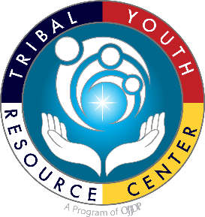**Tribal Youth Resource Center Technical Assistance Tools for Tribal Youth Programs**

**Tribal Youth Program Community Advisory Circle/Committee Development GUidance**

**What is the Community Advisory Circle/Committee?**

An advisory board is an effective method to garner meaningful input and support for programmatic activities and enhance the delivery of services to the community. The development of an advisory circle/committee is a recommended core component of the Strat Pak *(the project strategic plan that will be submitted to the Office of Juvenile Justice and Delinquency Prevention)* and is a practice that can assist with program strategic planning, implementation, and sustainability.

**Who should be on the Community Advisory Circle/Committee?**

Individuals who are identified as ***key stakeholders*** may then become members of your steering or tribal community advisory committee. “An effective steering committee is made up of key leaders in the community- people who are in the position to leverage resources, enlist the cooperation of other agencies, influence policy making, and build community awareness of your work” (Gurnell, 2014). It is imperative that the TYP coordinators identify key leaders to ensure support and participation within the TYP planning and implementation activities.

A Community Advisory Circle/Committee should be comprised of key stakeholders. Who are key stakeholders? Examples of Community Stakeholders:

|  |  |
| --- | --- |
| Restorative Justice Practitioners | Tribal Leadership/Elders |
| Cultural/Spiritual Leadership | Education Providers |
| Social Services Providers | Program/Tribal Evaluator |
| Tribal/County/State Law Enforcement | Primary Care/Medical Providers |
| Tribal Juvenile Court Staff | Probation/Law Enforcement |
| Behavioral Health Providers | Tribal Families |
| Local Non-Profit Partners | Tribal Youth |

 \**In the grant goals & objectives, key programs and services will be indicated; staff representation from those key programs and services should be considered for membership in the* Community Advisory Circle/Committee.

**How many members should be on the Community Advisory Circle/Committee?**

The Tribal Youth Program incorporates an interdisciplinary approach from a range of service areas. The advisory board/circle should reflect these areas in diversity of membership and size of the committee should be determined by the community. Commonly a board may consist of at least five or up to a dozen members. Consideration for the quality of interaction and contribution as opposed to the than quantity of membership may be helpful in determining total advisory committee membership.

**What are the primary roles and responsibilities of the Community Advisory Circle/Committee members?**

* A primary role is to provide helpful guidance and support.
* Model and commit to being an impartial and objective group in support of the TYP program coordinator and the Indigenous youth and their families that will be served by the grant.
* Willing to contribute to the development of the overarching framework/program design from planning to sustainability.
* Willing to work together to develop necessary infrastructural supports for the planning and operational components of the TYP.
* Knowledgeable about the TYP’s place in the community (willingness to experience training that will assist with knowledge) and/or trends in the community affecting the field of services, and a focused commitment to the long-range issues that impact Indigenous youth and their families.
* Commitment to contribute to developing asset/strengths-based solutions.
* Willing to build relationships and work together as a Community Advisory Circle/Committee to accomplish the goals and objectives of the TYP.
* Attend/Participate in Community Advisory Circle/Committee meetings.
* Support ongoing evaluation and processes improvement
* Provide supportive advice as the project develops and changes.

Planners can use six basic questions to assist with the format of the committee. *See: Center for Court Innovation, “How can Community Advisory Boards Assist the Work of the Justice System,” (Malangone and Facciolo, 2014)*

1.     Will meetings be open to the public?

2.     Where will meetings occur?

3.     When and how often will the board/circle meet?

4.     Who will lead the meetings?

5.     How will meetings be run?

6.     How will the board be publicized?

Establishing answers to these questions can assist with the format and contributions of the committee to the TYP.  Development of the committee should also consider any existing administrative rules within the respective Tribal community, as some Tribes may have established or existing administrative policies related to the development of advisory or local community boards.

**What are the benefits of forming an Advisory Circle/Committee**?

* Collaborative planning provides the opportunity to identify key programmatic and tribal community strengths.
* Gathering members of the community, justice system, treatment, health, social services, and partner agencies ensures that the community voice is at the center of the development of the TYP.
* Creates and strengthens interdepartmental relationships, promotes resource sharing, and knowledge of the community.
* Increases positive impact on youth and their families.

**What are the possible challenges involved with forming a Community Advisory Circle/Committee?**

Maintaining an effective advisory committee/circle can be challenging, but steps can be taken to support the usefulness of the committee. Below are some common challenges.

* Advisory Committee lacks purpose or direction.

o     Tip: Define the committee with a charter and set out a clear purpose statement and/or goals of the committee.

* Having no previous working relationship with potential members can be difficult for recruitment.

o     Tip: Request and invite potential members to an open discussion of the program, the vision for the program and how expertise can contribute to the program.

* Potential members are very busy people and may not be able to commit extensive time to the advisory board/circle.

o     Tip: Encourage buy-in for committee roles by expressing the value of the program and the long-term benefit derived by individual youth and community. Set clear timelines so that members can anticipate the amount of time that may be contributed as part of the advisory committee.

o     Tip: Define roles and responsibilities within the committee to assist with communication and effective planning/meeting processes.

**Community Engagement Planning Tools and Resources**

*Note it is integral to consider ways in which you can incorporate local tribal knowledge, traditions, and lifeways when utilizing these community engagement tools and resources.

**Gathering of Native Americans**

Gathering of Native Americans (GONA) is a culture-based planning process where community members gather to address community-identified issues. It uses an interactive approach that empowers and supports AI/AN tribes. The GONA approach reflects AI/AN cultural values, traditions, and spiritual practices.

GONA TOOLKIT

<https://www.samhsa.gov/sites/default/files/gona-goan-toolkit.pdf>

GONA Curriculum and Facilitator Guide

<https://www.samhsa.gov/sites/default/files/gona-goan-curriculum-facilitator-guide.pdf>

Fresno Indian Health Board- youth GONA Example

<https://www.youtube.com/watch?v=blHMHWaSpmA&feature=youtu.be>

**Community Readiness**

The Community Readiness Model (CRM) was developed at Colorado State University. The National Center for Community and Organizational Readiness at CSU was formed to assist communities and tribes in using the model. The CRM aids in assessing the readiness of a community to address specific problems (i.e. youth substance misuse). The CRM identifies dimensions, such as leadership involvement, knowledge of the problem, levels of community readiness and can be easily scored by the community.

National Center for Community and Organizational Readiness  
<https://nccr.colostate.edu>

Community Tool Box  
<https://ctb.ku.edu/en/table-of-contents/overview/models-for-community-health-and-development/community-readiness/main>

Community Readiness: A Handbook for Change  
<https://www.ndhealth.gov/injury/ND_Prevention_Tool_Kit/docs/Community_Readiness_Handbook.pdf>

**Community Workshops, Meetings, Assessments**

There are a variety of other avenues that can be utilized in working toward community engagement. Formal workshops, meetings and assessments can be very beneficial to the process. Also, utilizing community-specific traditional gatherings may provide an organic structure for community engagement activities. Please use your Technical Assistance Specialist as a resource to further explore and brainstorm community engagement processes and formats.

**Resource Mapping**

**National Center on Secondary Education and Transition:  Essential Tools-Community Resource Mapping**

This resource provides essential tools and steps to effective resource mapping. Mapping of youth services, supports, and programs within a community can have essentially three outcomes: 1) the identification of resources available to individual youth in a particular community—often referred to as “youth mapping,” 2) the identification of new or additional resources to sustain existing specific youth activities or initiatives within a community, and/or 3) the identification of resources to assist in creating and building capacity to support a more comprehensive community system for serving youth. The first outcome typically occurs at the local level while the second and third outcome can happen at any level—local, state, or federal.

*Link to resource:* <http://www.ncset.org/publications/essentialtools/mapping/overview.asp>

**NCAI First Kids-Every Child is Sacred, Tribal Tool Kit: Community Asset Mapping for Tribal Youth Well-being**

This resource provides a broad overview of the community asset mapping process. It addresses the overall purpose of gathering information, organizing and developing resources using a strength-based approach through identifying, collecting, and analyzing community assets.

*Link to resource:* <http://www.ncai.org/policy-research-center/initiatives/NCAI_CAM_presentation_2019_Mid-Year_Conference.pdf>

|  |
| --- |
| **Summary Findings: Community Engagement Activities**  Summarize outcomes from any community engagement processes that program staff or the advisory circle were a part of. |

|  |
| --- |
| **Activity:**Click or tap here to enter text. |
| **Outcomes/Benefits:** Click or tap here to enter text. |
| **Additional Comments/Resources Needed/Next Steps:** Click or tap here to enter text. |

**Sustainability Planning Tools and Resources**

Planning for sustainability should take place early on in the planning process. Your team should formulate a workgroup to design and plan for future sustainability and engage with program partners and stakeholders to identify opportunities for supportive funding and resources. Create a shared vision to sustain program services and meet regularly to discuss plans and activities. Remember, “sustainability is not synonymous with securing more funds, rather it refers to the capacity of a program to sustain the benefits that it provides” (Mancini and Marek, 2004). Some resources are included here to support team sustainability planning:

**OJJDP Tribal Youth Online Learning Resources:   
Strategic Action Planning Talking Circle 1: Sustainability**<https://www.youtube.com/watch?v=9nofME2bjqs&list=PLEYl_nJGyPlF23t4QVc2EnWb75qAouWCX&index=2>

**Strategic Planning Toolkit Session 9: Planning for Sustainability** <https://www.youtube.com/watch?v=iQWUqhnz88g&list=PLEYl_nJGyPlH6TQxvxbGW6QzKVt71xSjt&index=11>

**Community Toolbox, University of Kansas**A free online toolkit to support sustaining work and initiatives with an outline and examples.<https://ctb.ku.edu/en/sustaining-work-or-initiative>

**Program Sustainability Assessment Tool, Washington University in St. Louis**

An online tool and resource to understand, assess, plan, and review resources to support program sustainability.

<https://sustaintool.org/>

**Creating Sustainable and Effective Tribal Criminal Justice Systems**

National Institutes of Justice

<https://www.nij.gov/topics/tribal-justice/Pages/criminal-justice-system.aspx>

Sources:

1. Mancini et al., Sustaining Community Based Programs for Families: Conceptualization and Measurement, Family Relations Interdisciplinary Journal of Applied Family Science, 2004.

|  |
| --- |
| **Action Planning Template**  Maintaining the program’s vision for the future will provide a base for a strong sustainability plan. Review and assess other portions of the strategic plan as you work through  sustainability planning processes. An example goal, objectives and tasks are listed below to help you get started. |

|  |  |  |  |  |  |
| --- | --- | --- | --- | --- | --- |
| **Goal 1:** *Example: Develop a comprehensive, trauma-informed, culture-centered summer program for Tribal youth.* | | | | | |
| **Objective supported by task:** | **Tasks/Activities:** | **Community resources available to support activity:** | **Target date for completion:** | **Person-Workgroup responsible:** | **Status** |
| *Objective 1(a): Identify and engage stakeholders to develop advisory/ planning committee.* | *Host informal gathering to gain interest in advisory committee for trauma-informed, culture-centered summer program.*    *Engage in discussion that focuses on identifying resources available for the summer program* | *N/A* | *Year 1 Quarter 2* | *Coordinator* | *Completed* |
| *Objective 1(b): Hire staff to support program coordination.* | *Develop job posting.*  *Contact human resources for outreach support.*  *Explore venues to recruit qualified staff.* | *Link to Tribal Newspaper and Tribal Website.*  *Engage with employment services to see if any participants may qualify for position.* | *Year 1 Quarter 3* | *Coordinator* | *In Progress* |
|  |  |  |  |  |  |
|  |  |  |  |  |  |
|  |  |  |  |  |  |

*Add rows as needed. While your cursor is in the last row, right click and then click “insert rows below.”

1. Locke, E. A. (1968). Toward a theory of task motivation and incentives. *Organizational Behavior and Human Performance,3*(2), 157-189. doi:10.1016/0030-5073(68)90004-4