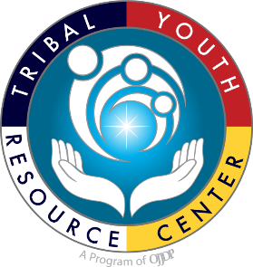
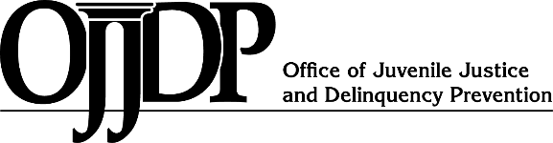
FY 2022
CTAS Purpose Area 9: Tribal Youth Programs Resource Guide with Planning Templates
FY 2022
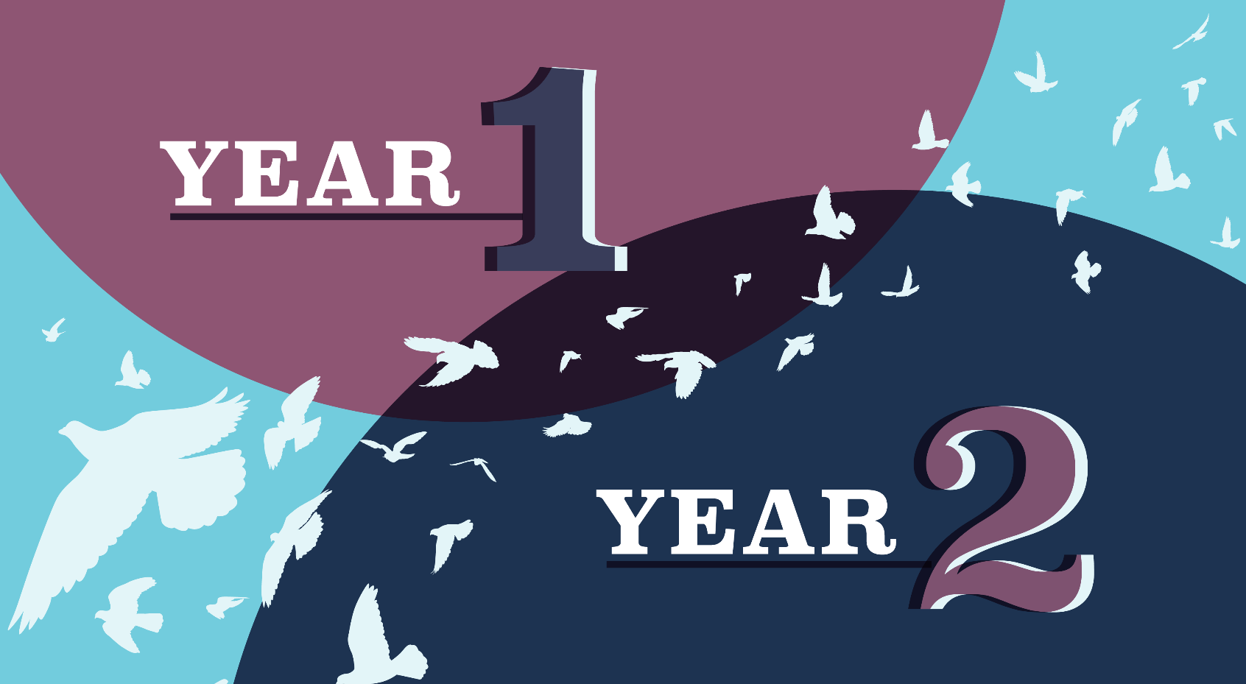
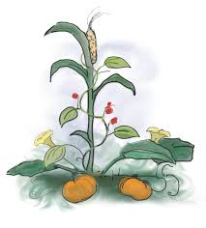
This project was supported by Grant #15PJDP-21-GK-04048-MUMU awarded by the Office of Juvenile Justice and Delinquency Prevention, Office of Justice Programs, U.S. Department of Justice. The opinions, findings, and conclusions or recommendations expressed in this publication/program/exhibition are those of the author(s) and do not necessarily reflect those of the Department of Justice.
MAPPING THE JOURNEY A Strategic Planning Resource Guide Seeding Change (Category 1)
Tribal Youth Resource Center
Introduction to the Mapping the Journey Tool (A strategic planning resource guide)

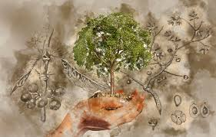
Greetings from the Tribal Youth Resource Center (TYRC)!

A DREAM,
Written down with a date,
Becomes a GOAL.
A GOAL, broken down into
steps, becomes a PLAN.
A PLAN backed by
ACTION
Becomes REALITY.

And so it is with the Tribal Youth Resource Center’s training and technical assistance delivery. We work diligently with OJJDP Juvenile Healing to Wellness Court and Tribal Youth Program grantees, Federally Recognized Tribes, and Tribal organizations to Indigenize successful approaches and evidence-based practices, while innovating and encouraging culturally grounded responses that can contribute to promoting the strengths of youth, families, and community. We are honored and humbled to serve Tribal youth, their families, and their communities.

We are grateful for the opportunity to work with your Tribe and community to assist in the development of a plan to conceptualize expanded services and programs for the youth in your community. The Tribal Youth Training and Technical Assistance Specialist (TTAS) team provides online learning events and both individual and group learning opportunities, and will work with your staff to plan an onsite visit between April - May 2023 to support the completion of the planning process by September 30, 2024, utilizing the “Mapping the Journey Resource Guide” as a planning tool.

Mapping the Journey is a process our people engaged in for thousands of years as they strategized where to go, when to go, and which tools they needed to ensure that they would reach their destination. This guide includes examples of tools that are intended as resources for “Seeding Change,” Category 1 Tribal Youth Program grantees, to develop a “Seeding Change” plan, with the help of your respective stakeholders and partners. Ultimately, the “Seeding Change” plan will serve as a road map for the journey your Tribe is undertaking to seed and develop a Tribal Youth Program to support Native youth, families, and community. Each Tribal Youth grantee will have an assigned TTA Specialist who will work with your TYP Coordinator and planning team through each step of your Journey to develop a “Seeding Change” plan. Please visit www.TribalYouth.org to learn more about the Tribal Youth Resource Center.
Respectfully,
The Tribal Youth Resource Team
As a training and technical assistance provider for the Office of Juvenile Justice and Delinquency Prevention, the Tribal Youth Resource Center, administered by the Tribal Law and Policy Institute and in partnership with the National Native Children’s Trauma Center, we bring an in-depth understanding and appreciation of American Indian and Alaska Native history, customs, and Indigenous justice systems.
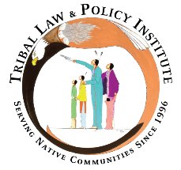
Native youth benefit from our value that:
Our Children are Sacred.

Tribal Youth Resource Center
Email: TribalYouth@TLPI.org
Website: www.TribalYouth.org

Table of Contents
Section | Page
I. OJJDP FY 2022 Tribal Youth Program Mapping the Journey Timeline | 4
II. Program Contact Information | 5
III. Strategic Plan Core Components | 6
- Planning Team | 7
- Vision and Purpose Statement | 8
- Communication Plan | 9
- Engaging and Empowering Youth Voice | 10
- Specific Measurable Achievable Realistic Time-bound (S.M.A.R.T.) Goals | 11
- Logic Model | 15
- Building a Plan to Document Our Journey and Tell Our Story: Data Collection and Evaluation Planning | 19
- Creating a Sustainability Plan to Equip Our Youth to Thrive | 24
Appendix
- Community Engagement Planning Tools and Resources | 28
- Youth Engagement and Empowerment | 30
- Developing the Community Advisory Committee Guidance | 31
- Memorandums of Understanding | 34
- Resource Mapping Resources | 35
- Strategic Planning Tools | 36
- Data Collection & Evaluation Planning Resources | 37
- Program Reporting Overview | 38
- Sustainability Planning Tools and Resources: Continuing Our Journey | 39
- Tribal Youth Program Guiding Priorities | 40
- Resource Websites for Tribal Youth Program Planning | 43

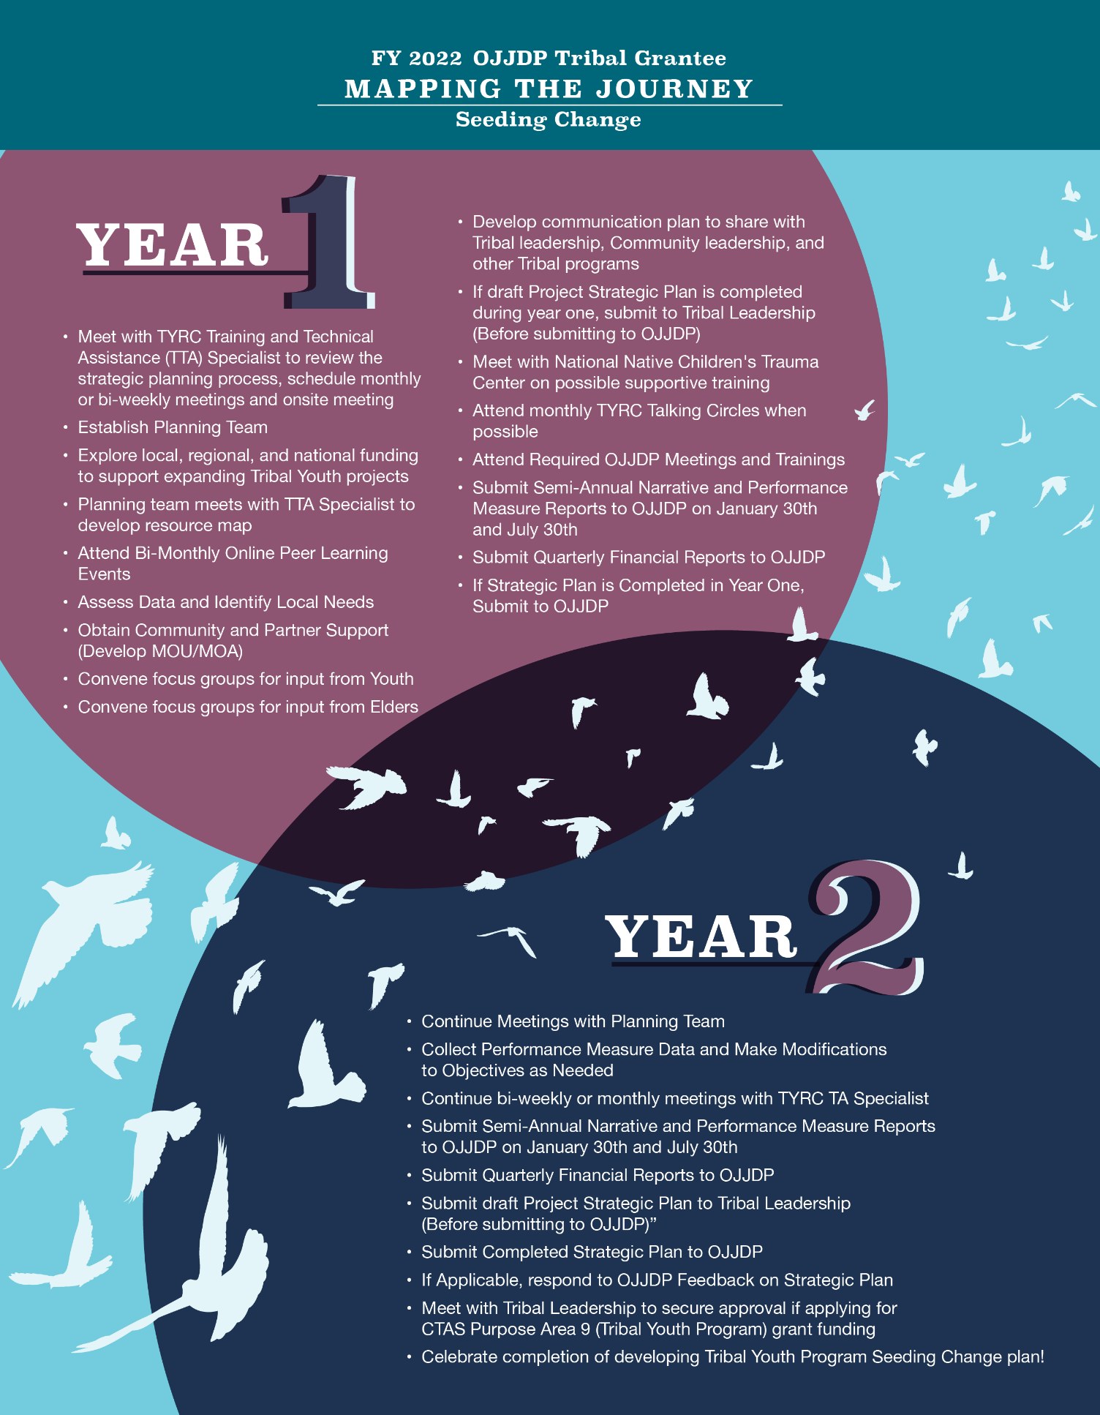
FY 2022 CTAS Purpose Area 9: Tribal Youth Program


Strategic Planning Resource Guide

Tribe Name: | Click or tap here to enter text.
Grant Award Number: | Click or tap here to enter text.
Grantee Point of Contact (Name, Phone, Email): | Click or tap here to enter text.
Grantee Secondary  Point of Contact (Name, Phone, Email): | Click or tap here to enter text.
OJJDP Grants Management Specialist: | Click or tap here to enter text.
TYRC Training and Technical Assistance Specialist: | Click or tap here to enter text.

This Strategic Plan Guide Addresses the Following Core Components:

☐ Planning Team
☐ Vision & Purpose Statements
☐ Communication Plan
☐ Engaging Youth Voice and Empowerment
☐ Specific Measurable Achievable Realistic Time-bound (S.M.A.R.T.) Goals
☐ Logic Model
☐ Building a Plan to Document Our Journey and Tell Our Story: Data Collection and Evaluation Planning
☐ Creating a Sustainability Plan to Equip Our Youth to Thrive

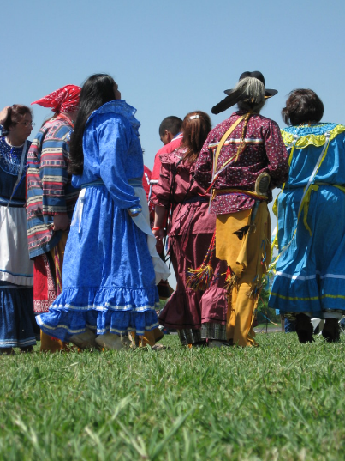
Tribal Youth Planning Team

Engaging a Planning Team is considered a best practice for ensuring sustainability when developing new resources and services for a program. The purpose of a Planning Team is to contribute to the development of the overarching framework and program design from planning to implementation. Planning Teams are comprised of 6-12 members representing all facets of the community ranging from elders, youth, formal and informal leaders in the community, to health, education, justice, treatment/healing and youth serving providers. For more information and resources to complete this section, see appendix section “Tribal Youth Program Community Advisory Circle/Committee Development Guidance.”

Partner Name  & Title |  | Role on Team | Gifts/  Expertise
 | Click or tap here to enter text. | Click or tap here to enter text. | Click or tap here to enter text.
 | Click or tap here to enter text. | Click or tap here to enter text. | Click or tap here to enter text.
 | Click or tap here to enter text. | Click or tap here to enter text. | Click or tap here to enter text.
 | Click or tap here to enter text. | Click or tap here to enter text. | Click or tap here to enter text.
 | Click or tap here to enter text. | Click or tap here to enter text. | Click or tap here to enter text.
 | Click or tap here to enter text. | Click or tap here to enter text. | Click or tap here to enter text.
 | Click or tap here to enter text. | Click or tap here to enter text. | Click or tap here to enter text.
Add rows as needed. While your cursor is in the last row, right click and then click “insert rows below.”


Vision and Purpose Statements

Developing effective vision (your collective inspired dream) and purpose (why your program exists) statements are important first steps in your strategic planning process. These written declarations provide the foundation for the program while communicating the purpose and direction of work that will be launched during the life of the project.

VISION STATEMENT
Your dream/the desired end state, where you would like to be. Statement is generally inspirational, memorable, and concise. For example: Restoration of our families and our communities to be strong and healthy.
Click or tap here to enter text.

PURPOSE STATEMENT
A statement of the purpose of your strategic initiative/program and how your vision will be realized. For example: Our purpose is to revitalize and reconnect our Tribal youth to their Culture through activities and support that strengthen their cultural identity.
Click or tap here to enter text.

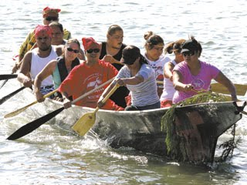
Tribal Youth
Communication Plan

A communication plan among the Tribal Youth Planning Team and Tribal leadership can strengthen collaboration and support for the program. The more informed everyone is about the status of your program, the greater their ability to contribute, lend support, and invest in your program.
*Add rows as needed. While your cursor is in the last row, right click and then click “insert rows below.
Activities to Support Communication

Example: Develop record keeping process and communicate with Planning Team and Tribal leadership. | Example: Develop listserv, share bi-weekly updates on planning progress, and ask for input. Set up a shared virtual folder accessible to the Planning Team and archive all meeting notes and planning-related documents.
Example: Create process for sharing draft sections of Mapping the Journey Resource Guide with Planning Team and Tribal leadership. | Example: Request reviews of draft documents as needed from Planning Team and Tribal leadership, as well as youth leaders. Schedule bi-monthly (or even more frequent) meetings with youth leaders for their input.
Example: Identify modes of communication and avenues to meet bi-weekly with Planning Team and youth leaders. | Example: Outreach to Planning Team and youth leaders to determine preference for virtual or in-person meetings. Set up and send out recurring meeting invitation to all participants.

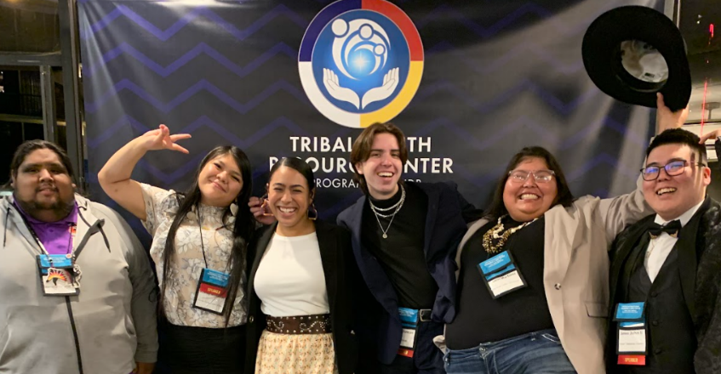
Engaging and Empowering Youth Voice

Incorporating youth voice in the development and implementation of the Tribal Youth Program provides youth an opportunity to learn about power dynamics, consensus decision-making, planning and organizing, data collection, and resource mapping. Most importantly, providing a “voice, place, and space” for youth in the strategic planning process provides youth with a sense of investment in the success of the program and supports the philosophy of “nothing about us without us.”

The Tribal youth program’s focus is Tribal youth, so they should be included and involved every step of the way. One method to ensure youth inclusion and involvement is having youth representation on the Planning Team. Other suggested activities for youth engagement and empowerment are listed below. For more information and resources to complete this section, see appendix section “Youth Engagement and Empowerment.”
Activities/  Tasks (examples) | Person Responsible | Anticipated  Completion Date
Create Sign-up process for youth Focus group to gather youth input | Planning Coordinator | May-June 2023
Schedule bi-monthly youth focus groups to gather youth input | Planning Coordinator | June 2023 ongoing
Plan celebration to honor the youths’ ideas and input | Planning Coordinator | Summer 2024
*Add rows as needed. While your cursor is in the last row, right click and then click “insert rows below.”


Setting Indigenous S.M.A.R.T. (I-SMART) Goals

Research shows that establishing specific and challenging goals can lead to better performance. In this section, you will be creating Indigenous SMART goals to help you obtain your desired results. Utilizing the SMART goals process will aid in establishing clear goals and objectives that will benefit the Tribal Youth Program and ultimately the entire Tribal community.
I-SMART is keeping the Indigenous lens and perspective at the forefront of everything we do. When using the SMART goal and SMART objective process, continuously revisit whether these goals and objectives are aligned with Tribal culture and community values.

A SMART goal is defined as one that is specific, measurable, achievable, relevant, and time-bound. Below is a definition of each of the SMART goal criteria.

S.M.A.R.T. Goal Guidance
Example
GOAL: Increase partnerships within the Tribal Youth Program.
SMART GOAL: Establish partnerships with schools on the reservation to increase academic success for middle school and high school students within the next three years.
The following steps will assist you in creating SMART goals. Conduct this activity with your planning team. If your team is already using the SMART or a similar process, great! Should you have any questions or require assistance, please contact your TTA Specialist.

For each goal in your grant:
- Use a separate sheet of paper for brainstorming as needed.
- List your goals in the boxes below.
- Assess your goals to ensure they are written in a way that is specific, measurable, achievable, relevant, and time-bound.
- Review your work. Does your revised goal meet the SMART criteria and align with the Vision and Purpose? If not, please work with your team and TA specialist to revise them to be I-SMART.

Goal #1: Click or tap here to enter text.

Goal #2: Click or tap here to enter text.

Goal #3: Click or tap here to enter text.

Goal #4: Click or tap here to enter text.

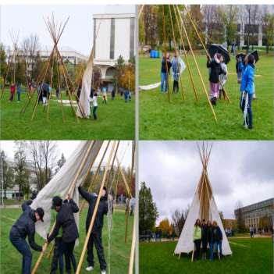
Developing Supportive Objectives

Objectives are focused, measurable, concrete and support the broader or long-range goals that your team has set forth. It is important to set out clear objectives to support your goals and desired outcomes.
An example goal with supporting objectives is included below to help you get started.

Example Project Goal 1: Establish partnerships with schools on the reservation to increase academic success for middle school and high school students within the next three years.
Objectives to support reaching project goal.
Objective a | Create a spreadsheet that lists all school leadership and counselors. Outreach and schedule meeting with school leadership within 60 days.
Objective b | Within 90 days, draft fact sheet which includes information on current social, emotional, and academic learning outcomes through public county, state, and local data available online. The vision and purpose of the program would be included in the document.
Objective c | Share fact sheet with school leadership, parent groups within the school, and the tribal education department, and develop a work plan for supporting students and families. Attend school board meetings to share progress and to network.

Project Goal 1: Click or tap here to enter text.
Objectives to support reaching project goal.
Objective 1a | Click or tap here to enter text.
Objective 1b | Click or tap here to enter text.
Objective 1c | Click or tap here to enter text.

Project Goal 2: Click or tap here to enter text.
Objectives to support reaching project goal.
Objective 2a | Click or tap here to enter text.
Objective 2b | Click or tap here to enter text.
Objective 2c | Click or tap here to enter text.

Project Goal 3: Click or tap here to enter text.
Objectives to support reaching project goal.
Objective 3a | Click or tap here to enter text.
Objective 3b | Click or tap here to enter text.
Objective 3c | Click or tap here to enter text.

Project Goal 4: Click or tap here to enter text.
Objectives to support reaching project goal.
Objective 4a | Click or tap here to enter text.
Objective 4b | Click or tap here to enter text.
Objective 4c | Click or tap here to enter text.

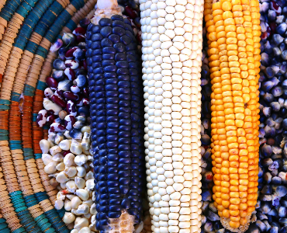
Logic Model

A logic model is a one-page depiction (road map) that outlines the shared relationships among the resources, activities, outputs, outcomes, and impacts for your program. It depicts the relationship between your program’s activities and its intended effects. https://www.cdc.gov/eval/logicmodels/index.htm
How are we going to work toward realizing our Vision and honoring our Purpose? Let us start with developing a logic model, which is a depiction of your proposed project. If we were to tell the story of our project in a one-page graphic, what would that look like? Below are a couple of examples, which are also available as blank templates. After viewing the templates, please select a template and meet with your TA Specialist to begin the process of creating your logic model.
Example One (below): In this example, note that the logic model starts on the left, indicating the changes that we want to see. Then, moving towards the right, the graphic highlights how those changes are going to happen and how they will be measured. Finally, the far-right column shows how the resources invested and the activities engaged in have impacted the desired outcome. Click here to view a larger version of the logic model.

Example of a Logic Model to Increase Cultural Pride and Identity
What are the changes we want to see? | What are the issues that impact making the changes? | Which activities/resources/inputs will we  employ to meet each goal? | What will be the outputs for each specific activity? | How will you measure the outcomes and outputs of the  program? | What is our hope for the future?
Our Story Wellbeing  - Historically our XYZ Tribe had a strong Cultural foundation that contributed to the well-being of the entire Tribe. | Our story of resilience  - Historical impacts contributed to the lack of access to Cultural traditions and ceremonies and denies our youth their Cultural identity.  - Connecting with XYZ Tribe youth to actively support their development of a strong Cultural identity. | What we can do today, Supporting our relatives  - Cultural skill-building/Cultural pride  - Establish Community Advisory Committee (CAC)  - Talking Circles as process for guiding principles, Cultural identity survey, and designing process for Cultural identity  - Develop a communication plan: parents, Tribal leadership, youth, community | There is healing in our culture  - CAC Guide Tribal Name of Program, formalize guiding principles  - CAC assist in design of Cultural identity survey  - CAC assist in design of a process for Cultural identity (ex: naming, coming of age, healing, gender roles)  - Administer surveys, engage youth in ceremonies, interviews  - Materials used for communication to stakeholders  - Performance Measure: Cultural Skill building/cultural pride | Honoring our youth today  - 30 Youth receive their XYZ Tribe name, participate in coming of age ceremony and a healing ceremony, gender roles  - Youth understand and are able to use ceremonial elements for prayer  - Number of program youth served during the reporting period with the noted behavioral change  - Total number of youth receiving services for the target behavior during the reporting period | Honoring our youth tomorrow  - Increase in Cultural skill-building and Cultural pride  - The youth Cultural identity enhances their well-being  - Growth in Cultural Identity as a result of participating in ceremony and healing activities, evidenced by 30 completed pre/post-Cultural Identity surveys
What are the changes we want to see? | Our Hope  - Promote XYZ Tribe youth Cultural identity by creating opportunities and access to Tribal Cultural values, traditions and ceremonies.
Healing is our future: | What are the Cultural values and principles that will guide our work?  Strong Hearts:  - Wellbeing of youth will remain focus of program.  - Establishing an approach of being a good relative and mutual regard with the youth and among all partners.  - Honoring of Culture will be the foundation of the program.  - Cultural Identity supports the wellbeing of our Tribe.
The Foundation for Our Work:
Vision: Restoration of our families and our communities.
Purpose: The revitalization and reconnection of Tribal Youth to their Culture. Tribal Youth will have a strong cultural identity as a foundation for healing, skill building and pride.

Let us look at another example below. In this example, where we have been is highlighted at the top, then the logic model proceeds to the right showing where we would like to be, how we are going to get there, and, finally, the outcome.
Example Two:
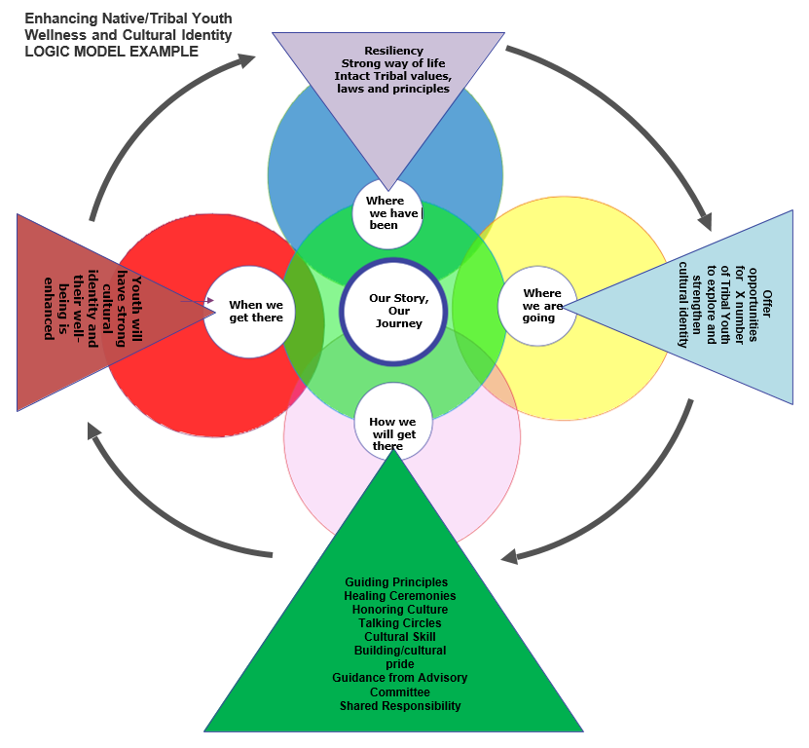
These two examples contain the same information but are depicted in different formats. There is no one “right” format, and you and your Planning Team can decide on which format to use. You are also encouraged to design your own logic model or use a different format if that better suits your team. The intent of the logic model is to provide a graphic depiction of your project that includes the issues or needs, the available resources and activities to address the needs, and how you will measure if you are headed in the direction you want to go. Finally, the graphic shows the hoped-for impact or outcome of your project.
Example Three:
This is another example of a format for a logic model that comes from OJJDP. As stated before, logic models can look different, but they all have a central purpose: provide a one-page depiction of your program’s goals, objectives, activities, and hoped-for outcomes.
[Applicant/Program Name] Logic Model]
The italicized text in each logic model section describes the information to include and should be replaced with your responses. Enter the applicant or program name in the header, replacing the brackets.
Date | MM/DD/YY
Desired Result |  | State precisely what the program or initiative hopes to achieve. The result statement should reflect the purpose of the federal award and the Office of Juvenile Justice and Delinquency Prevention’s vision to support a nation where children are free from crime and violence and encounter a just and beneficial juvenile justice system.
Goals |  | Goal 1: Goals define how you know you have achieved your desired outcomes or the future condition your program or initiative hopes to achieve. The goals should align with your stated desired result and demonstrate how you intend to meet the purpose of the federal award. You may include an unlimited number of goals.

Inputs | Activities | Outputs | Outcomes
Inputs | Activities | Outputs | Short-term | Intermediate | Long-term
- Inputs describe the resources needed to implement a program’s activities successfully. | - Activities describe the actions needed to achieve a program’s goals and objectives. | - Outputs identify what happens from a program’s intended activity. Outputs are generally represented as a number, such as the number of people trained. | - Outcomes describe the results of an activity, program, or initiative.  - Short-term outcomes reflect the immediate result of an activity, such as a change in knowledge, or change in practice. | - Intermediate outcomes reflect the result that occurs after achieving the short-term outcome, such as a change in behavior or implementation of a new system. | - Long-term outcomes demonstrate the ultimate change in a population or system the activity, program, or initiative hopes to achieve, such as decreased youth recidivism or decreased child victimization.

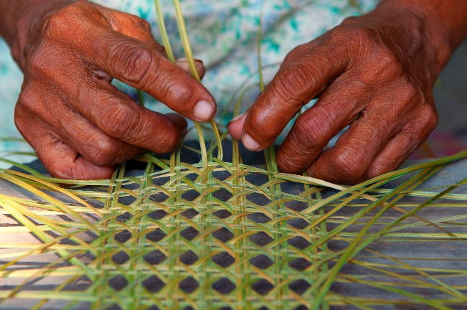
Documenting Our Journey:
Data Collection Planning
Local community members are excellent resources for gathering and interpreting data for your Tribal Youth Program because they know and live in the community. Please review the goals of your program and discuss with the Planning Team how you will know if your goals are met. For example, if the program goal is to increase school attendance, how will you know if that goal is met? You will know it is met if school attendance improves. Therefore, you will need school attendance data in order to assess if the goal is being met. Taking a strengths-based approach in gathering and interpreting data can highlight the resiliency of and positive things happening in your Tribal community. This data can show what is working in your community and will help you to enhance interventions/approaches that are linked to positive outcomes for youth. Please see the appendix “Data Collection & Evaluation Planning Resources” section for additional resources to support your data collection planning.

Key Questions

Note: These are examples related to promoting academic success.
What information do we need in order to know if our program is having the effect we desire? | Example: school attendance data by semester, number of students advancing to the next grade, number of students working with a tutor, number of students graduating from middle school and high school  Insert response: Click or tap here to enter text.
What information does the Tribal Youth Program currently have access to that would help us assess the effect our program is having? | Insert response: Click or tap here to enter text.
What information would we like to have access to that does not currently exist? | Insert response: Click or tap here to enter text.
Who can help us find or create the data we need to make good decisions for our program and youth? | Example: Middle school social workers and counselors, attendance liaisons  Insert response: Click or tap here to enter text.

Local Level Data: Work with the Planning Team to identify local level data. Data collection will support program goals, activities, quality improvement, and future sustainability planning. Your Training and Technical Assistance Specialist can virtually facilitate resource mapping with the Planning Team, which may assist you with identifying key points for which data can be collected.
Key Questions:
- What methods will you use to collect the data?
- How often will the data be collected?
- Who will assist the Planning Team coordinator in collecting the data?
- How will you organize, manage, and store the data? Will your program have access to a database, or will you track data in a spreadsheet?
Data to Collect | Where is the data and  how will it be collected? | Who is responsible for collecting the data? | Target Date(s) for Data Collection and review | Why would we collect this data?
Example: School attendance records | Example: School can share information through a MOU | Example: Planning Team coordinator will coordinate with local schools to collect agreed upon data | Example: Monthly review | Example: To celebrate youth who are experiencing academic success and provide support for those youth who are not experiencing academic success
Example: School attendance records | Example: School can share information through a MOU | Example: Planning Team coordinator will coordinate with local schools to collect agreed upon data | Example: Monthly review | Example: To celebrate youth who are experiencing academic success and provide support for those youth who are not experiencing academic success
Example: # youth in elementary, middle, and high school in the school districts that serve your community | Example: Tribal census; school census will be requested | Example: Planning Team coordinator or designated partners | Example: By December 2023 | Example: To inform the development of your Tribal Youth Program
Example: Feedback from youth and families on program services | Example: Create youth and adult focus groups and circles | Example: Planning Team | Example: Monthly, July-October 2023 | Example: To ensure youth and family voice is included in planning
Example: Identify service gaps impacting youth in the community | Example: Interviews with youth, families, systems providers | Example: Planning Team coordinator | Example: Monthly July-October 2023 | Example: To ensure that lessening system gaps for youth and families is incorporated into the program design
Click or tap here to enter text. | Click or tap here to enter text. | Click or tap here to enter text. | Click or tap here to enter text. | Click or tap here to enter text.
Click or tap here to enter text. | Click or tap here to enter text. | Click or tap here to enter text. | Click or tap here to enter text. | Click or tap here to enter text.
Click or tap here to enter text. | Click or tap here to enter text. | Click or tap here to enter text. | Click or tap here to enter text. | Click or tap here to enter text.
Click or tap here to enter text. | Click or tap here to enter text. | Click or tap here to enter text. | Click or tap here to enter text. | Click or tap here to enter text.
*Add rows as needed. While your cursor is in the last row, right click and then click “insert rows below.

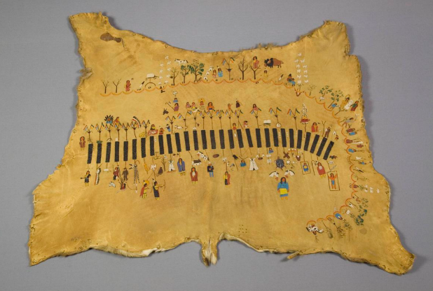
Telling Our Story:
Designing an Evaluation Plan
Evaluation is not a judgement of your program, it is about telling your program’s story – where you have been, where you are going, and how you are going to get there. Indigenous and Tribal people have always used evaluation. They needed to evaluate where the best hunting and fishing places were, where the best and safest places to camp were, and how they were going to ensure that their teachings were passed on. Here is an opportunity to share your program’s story and ensure the teachings get passed on. For additional resources to support evaluation planning, please see appendix section “Data Collection & Evaluation Planning Resources.”

Key questions for evaluation:
Key questions for evaluation planning are included in the table below. After considering these questions, your first step is to establish goals for your evaluation. Here is a table to help guide your work:
Key questions
What is the purpose of our evaluation? | Click or tap here to enter text.
Who needs to know what, when, and why? | Click or tap here to enter text.
What outcome in our logic model do we want to focus on in our evaluation? | Click or tap here to enter text.
How will we engage stakeholders in our evaluation plan? | Click or tap here to enter text.
What resources do we have to commit to evaluation planning and implementation? | Click or tap here to enter text.

Establish Goal(s) for evaluation:
Example: In a planning grant, there are two pathways to exploring evaluation. The first is to develop an evaluation plan regarding the accomplishments and challenges experienced as part of the planning process. The second is to create an evaluation plan for your proposed Tribal Youth Program.
Evaluation Goal(s)
Goal 1 | Click or tap here to enter text.
Goal 2 | Click or tap here to enter text.
Goal 3 | Click or tap here to enter text.
*Add rows as needed. While your cursor is in the last row, right click and then click “insert rows below.”

How will the team engage partners and those most impacted in the evaluation process?
Partners to Engage | Disseminating Data/Information | Gathering Feedback
Example: Planning Team | Example: Tribal leadership, community, and youth-serving programs | Example: Engage in self-evaluation quarterly to reflect on accomplishments and challenges
Example (proposed Tribal Youth Program that focuses on academic success): Local school partners | Example: Tribal leadership, youth-serving programs, schools, parents, community | Example: Assessing what we are learning and identifying changes that need to be made to the program based on feedback  Example: Tribal Youth Program coordinator will make necessary changes to objectives based on data and feedback received
*Add rows as needed. While your cursor is in the last row, right click and then click “insert rows below.

Creating a Sustainability Plan to Equip Our Youth to Thrive

“Native Americans, Alaska Natives, and other Indigenous peoples have a long tradition of living sustainably with the natural world by understanding the importance of preserving natural resources and respecting the interdependence of all living things.” — Native American Rights Fund (NARF)

Sustainability is the process of effectively achieving and maintaining desired long-term results. Maintaining and continuing the program’s vision for the future will provide a base for a strong sustainability plan. Review and assess other portions of the strategic plan as you work through sustainability planning processes. For additional resources to support evaluation planning, please see appendix section “Sustainability Planning Tools and Resources.”

Team Sustainability Vision

Type your shared vision for sustainability drawing from the key elements below. Will the tribe apply for funding from OJJDP or other federal and state funding sources or non-profit giving organizations, or partner with other youth-serving agencies?

Click or tap here to enter text.

Key Elements to Sustainability:
Building community support
Enhancing organizational capacity
Ensuring effectiveness

Build Community Support: Cultivating community support for prevention and behavioral health promotion and the positive outcomes they achieve is built on the success of organizational efforts to collaborate.
Community support can be built by:
• Encouraging community ownership through positive relationship building and collaboration
• Celebrating promotion/prevention successes and accomplishments in public and through social media
• Developing community promotion/prevention leaders and champions and connecting to other prevention efforts locally, across Tribal/County/State lines
Enhance Organizational Capacity: Ensuring that community agencies, organizations, and institutions have adequate internal organizational capacity to achieve positive outcomes involves exploring the answers to a number of questions:
• Does the Tribe/Agency have strong administrative structures that will allow them to be competitive for grants and other opportunities?
• Are there formal linkages, such as memoranda of understanding, with key partners? Do partners share equal responsibility for addressing community issues?
• Do partnering organizations have resources and expertise that they are willing to share?
Ensure Effectiveness: An effective program requires more than just using evidence-based interventions; effectiveness depends on making sure the strategic plan lines up in the following ways:
• Interventions are aligned with the problem and risk factors and have sufficient reach.
• Evidence-based and practice-based programs/services that are a good fit conceptually, culturally and practically.
• The implementation is high quality and includes buy-in from the community, administrative support, and adequate training for staff.
• The evaluation plan provides ongoing process and outcome data so improvements can be made as needed.
The Key Elements to Sustainability come from the Substance Abuse and Mental Health Services Administration, Center for the Application of Prevention Technologies. (n.d.). Keys to sustainability [slide presentation, Native American Substance Abuse Prevention Skills Training]. Rockville, MD: Author. Unpublished.

Sustainability Activities
Based on the element(s) selected for your sustainability vision,
map out supportive activities for the duration of the planning grant.

Activities/Tasks | Person Responsible | By When
Example for Enhancing Organizational Capacity: Identify partners for the proposed Tribal Youth Program and discuss if Memorandums of Understandings (MOUs) will be necessary. If yes, identify the binding expectations and elements of the MOUs. | Example: Planning Team  Click or tap here to enter text. | Year/Quarter  Click or tap here to enter text.
Coordinate with your Training and Technical Assistance Specialist to network with other Tribal Youth Program grantees to discuss applicable sustainability strategies. | Example: Planning Team coordinator | Click or tap here to enter text.
Click or tap here to enter text. | Click or tap here to enter text. | Click or tap here to enter text.
Click or tap here to enter text. | Click or tap here to enter text. | Click or tap here to enter text.
Click or tap here to enter text. | Click or tap here to enter text. | Click or tap here to enter text.
*Add rows as needed. While your cursor is in the last row, right click and then click “insert rows below.”

APPENDIX

Community Engagement Planning Tools and Resources
*Note: it is critical that local Tribal knowledge, traditions, and lifeways guide the adaptation and/or utilization of any community engagement tools and resources.
Gathering of Native Americans

Gathering of Native Americans (GONA) is a culture-based planning process where community members gather to address community-identified issues. It uses an interactive approach that empowers and supports AI/AN tribes. The GONA approach reflects AI/AN cultural values, traditions, and spiritual practices.

GONA TOOLKIT
https://www.samhsa.gov/sites/default/files/gona-goan-toolkit.pdf

GONA Curriculum and Facilitator Guide
https://www.samhsa.gov/sites/default/files/gona-goan-curriculum-facilitator-guide.pdf

Fresno Indian Health Board- youth GONA Example
https://www.youtube.com/watch?v=blHMHWaSpmA&feature=youtu.be

Community Readiness Model
The Community Readiness Model (CRM) was developed at Colorado State University to aid in assessing the readiness of a community to address specific problems (e.g., youth substance misuse). The CRM identifies dimensions including leadership involvement, knowledge of the problem, levels of community readiness and can be easily scored by the community. The National Center for Community and Organizational Readiness at CSU was formed to assist communities and tribes in using the model.
National Center for Community and Organizational Readiness
https://nccr.colostate.edu
Community Tool Box
https://ctb.ku.edu/en/table-of-contents/overview/models-for-community-health-and-development/community-readiness/main
Community Readiness: A Handbook for Change
https://www.ndhealth.gov/injury/ND_Prevention_Tool_Kit/docs/Community_Readiness_Handbook.pdf
Community Workshops, Meetings, Assessments
There are other avenues that can be utilized in working toward community engagement. Formal workshops, meetings and assessments can be very beneficial to the process. Also, utilizing community-specific traditional gatherings may provide an organic structure for community engagement activities. Please engage your Technical Assistance Specialist as a resource to further explore and brainstorm community engagement processes and formats.

Youth Engagement and Empowerment
- Healthy & Empowered Youth: A Positive Youth Development Program for Native Youth, Journal of Preventative Medicine (2016): https://www.tribalyouth.org/wp-content/uploads/2021/08/1-s2.0-S0749379716305499-main.pdf

- Youth Power: a Guide to Community Organizing: https://www.tribalyouth.org/wp-content/uploads/2021/08/youth_power_complete.pdf

- Core Principles for Engaging Young People in Community Change: https://www.tribalyouth.org/wp-content/uploads/2021/08/FINALYouth_Engagment_8.15pdf.pdf

- Our Identities as Civic Power: 2017 State of Native Youth Report: https://www.tribalyouth.org/wp-content/uploads/2021/08/CNAY_State_of_Native_Youth_Report_2017_web.pdf

- Native American Youth 101: https://www.tribalyouth.org/wp-content/uploads/2021/08/Native-American-Youth-101.pdf

- Strengthening Indian Country Through Tribal Youth Programs: https://www.tribalyouth.org/wp-content/uploads/2021/08/TYPReportfinal_000.pdf

- A Sweetgrass Method of Bullying Prevention for Native American Youth: A Sweetgrass Method of Bullying Prevention for Native American Youth (usu.edu)

- UNITY Report, Healing Indigenous Lives Native Youth Town Halls: https://ojjdp.ojp.gov/library/publications/healing-indigenous-lives-native-youth-town-halls?utm_source=govdelivery&utm_medium=email&utm_campaign=publications

Tribal Youth Program Community Advisory Circle/Committee Development Guidance
Note: this section is most applicable for Tribes that have received Tribal Youth Program funding and are in the planning and implementation phases of their grant.
What is the Community Advisory Circle/Committee (CAC) and what is their Role?
A Community advisory circle/committee is a group of collaborative key stakeholders who provide critical voice, input and support for programmatic activities to enhance the delivery of services to the community. The development of an advisory circle/committee is a recommended core component of the Mapping the Journey Strategic Plan (to be submitted to the Office of Juvenile Justice and Delinquency Prevention).
What are the primary roles and responsibilities of the Community Advisory Circle/Committee members?
- A primary role is to provide helpful guidance and support throughout the life of the project.
- Model and commit to being an impartial and objective group in support of the TYP program coordinator and the Indigenous youth and their families that will be served by the grant.
- Willing to contribute to the development of the overarching framework/program design from planning to sustainability.
- Willing to work together to develop necessary infrastructural supports for the planning and operational components of the TYP.
- Knowledgeable about the TYP’s place in the community (willingness to engage in training that can assist with increasing knowledge) and/or trends in the community affecting the field of services, and a focused commitment to the long-range issues that impact Indigenous youth and their families.
- Commitment to contribute to developing asset/strengths-based solutions.
- Willing to build relationships and work together as a Community Advisory Circle/Committee to accomplish the goals and objectives of the TYP.
- Attend/Participate in Community Advisory Circle/Committee meetings.
- Support ongoing evaluation and processes improvement.

Planners can use six basic questions to assist with the development of the operations of the Community Advisory Circle/Committee. See: Center for Court Innovation, “How can Community Advisory Boards Assist the Work of the Justice System,” (Malangone and Facciolo, 2014).
1. Will meetings be open to the public?
2. Where will meetings occur?
3. When and how often will the board/circle meet?
4. Who will lead the meetings?
5. How will meetings be conducted?
6. How will the board meetings be publicized?
Establishing answers to these questions can assist with the format and contributions of the committee to the TYP. Development of the committee should also consider any existing administrative rules within the respective Tribal community, as some Tribes may have established or existing administrative policies related to the development of advisory or local community boards.

Who should be on the Community Advisory Circle/Committee?
Individuals who are identified as key stakeholders may then become members of your Tribal community advisory committee. “An effective steering committee is made up of key leaders in the community- people who are in the position to leverage resources, enlist the cooperation of other agencies, influence policy making, and build community awareness of your work” (Gurnell, 2014). It is imperative that the TYP coordinators identify key leaders to ensure support and participation within the TYP planning and implementation activities.
A Community Advisory Circle/Committee should be comprised of key stakeholders. Who are key stakeholders? Here are some examples:
Restorative Justice Practitioners | Tribal Leadership/Elders
Cultural/Spiritual Leadership | Education Providers
Social Services Providers | Program/Tribal Evaluator
Tribal/County/State Law Enforcement | Primary Care/Medical Providers
Tribal Juvenile Court Staff | Probation/Law Enforcement
Behavioral Health Providers | Tribal Families
Local Non-Profit Partners | Tribal Youth

*In the grant goals and objectives, staff representation from those key programs and services listed in the narrative should be recruited for membership in the Community Advisory Circle/Committee.
How many members should be on the Community Advisory Circle/Committee?
The Tribal Youth Program incorporates an interdisciplinary approach from a range of service areas. The advisory circle/committee should reflect these areas in diversity of membership and size of the committee should be determined by the community. Usually, a CAC may consist of at least five or up to a dozen members. Consideration for the quality of interaction and contribution as opposed to the number of members may be helpful in determining total advisory circle/committee membership.

What are the possible challenges involved with implementing a Community Advisory Circle/Committee (CAC)?
Here are some common challenges in maintaining a strong CAC, and steps that can help:
- Advisory Committee lacks purpose or direction.
o Tip: Define the committee with a charter and set out a clear purpose statement and goals of the committee.
- Having no previous working relationship with potential members can be difficult for recruitment.
o Tip: Request and invite potential members to an open discussion of the program, the vision for the program and how their expertise can contribute to the program.
- Potential members can be very busy people and may not be able to commit extensive time to the advisory board/circle.
  - Tip: Encourage buy-in for committee roles by expressing the value of the program and the long-term benefit derived by individual youth and community. Set clear timelines so that members can anticipate the amount of time that may be contributed as part of the advisory committee.
  - Tip: Define roles and responsibilities within the committee to assist with communication and effective planning/meeting processes.
  - Tip: Consider how reciprocity can help with keeping members engaged, e.g., what is their program doing that your project can support, offer that support.

Memorandum of Understanding (MOU) Resources
Sample Memorandum of Understandings are included below:
- Tribal Youth Program Memorandum of Understanding Template
- Tribal Youth Program Memorandum of Understanding Regarding Information Sharing Template
- Developing Agreements between Local Education Agencies and American Indian Nations and Tribal Communities: A WISCONSIN PERSPECTIVE
- MOU Example: Ho Chunk Nation and Black River Falls School District

Resource Mapping
National Center on Secondary Education and Transition: Essential Tools-Community Resource Mapping
This resource provides essential tools and steps to effective resource mapping. Mapping of youth services, supports, and programs within a community can have essentially three outcomes: 1) the identification of resources available to individual youth in a particular community—often referred to as “youth mapping,” 2) the identification of new or additional resources to sustain existing specific youth activities or initiatives within a community, and/or 3) the identification of resources to assist in creating and building capacity to support a more comprehensive community system for serving youth. The first outcome typically occurs at the local level while the second and third outcome can happen at any level—local, state, or federal.
Link to resource: http://www.ncset.org/publications/essentialtools/mapping/overview.asp

NCAI First Kids-Every Child is Sacred, Tribal Tool Kit: Community Asset Mapping for Tribal Youth Well-being
This resource provides a broad overview of the community asset mapping process. It addresses the overall purpose of gathering information, organizing and developing resources using a strength-based approach through identifying, collecting, and analyzing community assets.
Link to resource: http://www.ncai.org/policy-research-center/initiatives/NCAI_CAM_presentation_2019_Mid-Year_Conference.pdf

Wellness Resources for your Team
Your team and partners are key resources of the community and team wellness and strengthening are critical to effectively addressing needs of the youth, families and community. There are tools and support that can help including the Native Wellness Institute (nativewellness.com) and the Professional Quality of Life (ProQOL) websites. These websites (and there are many other resources) have information and tools related to self-care and wellness. Feel free to reach out to your assigned Technical Assistance Specialist for more information.

Strategic Planning Tools

- Strategic Planning Tool Example: National Minority AIDs Council: https://files.constantcontact.com/9f76d4bb701/df8d307d-08dd-48b6-bd90-44e104549780.pdf

- BJA Tribal Strategic Planning Fact Sheet: https://www.tribalyouth.org/wp-content/uploads/2021/08/ctas_pa2_factsheet.pdf

- Strategic Planning- A Ten Step Guide: https://www.tribalyouth.org/wp-content/uploads/2021/08/mosaica_10_steps.pdf

- Developing an Effective Approach to Strategic Planning for Native American Indian Reservations, Nicholas Christos Zaferatos (2004): https://www.tribalyouth.org/wp-content/uploads/2021/08/Zaferatos_-_Space_and_Policy.pdf.pdf

Data Collection & Evaluation Planning Resources
RESOURCES FOR DATA COLLECTION PLANNING
- Collecting and Analyzing Tribal Data (National Institute of Justice)
https://nij.ojp.gov/topics/articles/collecting-and-analyzing-Tribal-data
- Making Excel Work for Your Community Learning Series (Capacity Building Center for Tribes) https://www.youtube.com/watch?v=3ouvz-tvNdE&list=PLR4JDLysJ7WOs9RVN9VecX5ApzmN1OO-e
- Using Data to help our Communities Thrive (Capacity Building Center for Tribes) https://tribalinformationexchange.org/index.php/2018/04/24/data-overview-using-data-to-help-our-communities-thrive

RESOURCES FOR EVALUATION PLANNING AND IMPLEMENTATION
- Indigenous Evaluation Toolkit, https://gptec.gptchb.org/indigenous-evaluation-toolkit/
- Indigenous Evaluation Framework: Telling Our Story in Our Place and Time. LaFrance, J., & Nichols, R. (2008). Alexandria, VA: American Indian Higher Education Consortium (AIHEC), http://www.aihec.org/our-stories/nativeKnowledge.htm
- Using your logic model to plan for evaluation, Evaluation Planning, Chapter 4, W.K. Kellogg Foundation, https://azprc.arizona.edu/sites/default/files/CHWtoolkit/PDFs/LOGICMOD/CHAPTER4.PDF
- A Roadmap for Collaborative and Effective Evaluation in Tribal Communities, https://www.acf.hhs.gov/cb/training-technical-assistance/roadmap-collaborative-and-effective-evaluation-tribal-communities
- W.K. Kellogg Foundation Evaluation Handbook, file:///C:/Users/smith/Downloads/EvaluationHandbook.pdf
- Evaluating Indigenous programs: a toolkit for change, S. Hudson, https://www.cis.org.au/wp-content/uploads/2017/06/rr28.pdf
- Sample Cultural Identity Survey, https://www.dropbox.com/s/a8c11ppqtkyrp0y/Sample%20Cultural%20Identity%20Survey.docx
- Sample Data Collection Tool (Excel Spreadsheet), https://www.dropbox.com/s/tvet5i3vb1ssbil/Sample%20Data%20Collection.xlsx?dl=0
- Indigenous Evaluation Models (US Department of Health & Human Services, Administration for Native Americans Program Office), https://www.youtube.com/watch?v=EousrydpdyY
- Indigenous Evaluation Models (US Department of Health & Human Services, Administration for Native Americans Program Office), https://www.youtube.com/watch?v=EousrydpdyY
- Resilience-Based Program Resources for Tribal Communities (Center for Native Child and Family Resilience), https://cncfr.jbsinternational.com/resources#inform
Program Reporting Overview
Please confer with your assigned OJJDP Grants Management Specialist regarding questions about project reporting.

A narrative report about the progress of your program is due two times per year in JustGrants. Due dates are January 30 and July 30 of each year.

JustGrants training is available through a series of self-guided eLearning videos, job aid reference guides, and infographics. The training resources provide users with an overview of the JustGrants processes, as well as detailed instructions on how to navigate through the various features and functionalities of the system. Visit https://justicegrants.usdoj.gov/training-resources to learn more.
Required Performance Measures for Tribal Youth Programs can be found at: https://ojjdp.ojp.gov/funding/performance-measures/performance-measures-Tribal-youth-program.pdf

Grant Management Support
- For assistance with JustGrants: JustGrants.Support@usdoj.gov or 833–872–5175, Monday through Friday, between the hours of 5:00 a.m. and 9:00 p.m. Eastern Time (ET); and Saturday, Sunday, and federal holidays from 9:00 a.m. to 5:00 p.m. ET. Self-service support is available at: https://justicegrants.usdoj.gov/user-support

- For assistance with Program Reports: contact the OJJDP PMT Helpdesk 866–487–0512 or ojjdppmt@ojp.usdoj.gov. The Helpdesk is available Monday – Friday, 8:30 A.M. – 5:00 P.M. Eastern Time, excluding federal holidays.

Financial Reporting
Please confer with your assigned OJJDP Grants Management Specialist regarding questions about financial reporting.

SF425 (Financial Status Report and Office Management & Budget
Standard Form) reports are due Quarterly: January 30/April 30/July 30/October 30

Notes:
- Report actual expenditures for the period, not drawdowns or expected expenditures.
- Can be revised up until the end of the next quarter.
Review Financial Reporting Guidance by visiting https://justicegrants.usdoj.gov/training-resources/justgrants-training/financial-reporting

The Office of the Chief Financial Officer (OCFO) Customer Service Center provides assistance on the financial aspects of OJP awards. For help with drawing down funds or other issues related to finances contact the Office of the Chief Financial Officer (OCFO) Customer Service Center by email at ASK.OCFO@USDOJ.GOV or by phone at 800-458-0786.

Sustainability Planning Tools and Resources

Planning for sustainability should take place early in the planning process. Your team should formulate a workgroup to design and plan for future sustainability and engage with program partners and stakeholders to identify opportunities for supportive funding and resources. Create a shared vision to sustain program services and meet regularly to discuss plans and activities. Remember, “sustainability is not synonymous with securing more funds, rather it refers to the capacity of a program to sustain the benefits that it provides” (Mancini and Marek, 2004). Here are examples of resources to support team sustainability planning:
OJJDP Tribal Youth Online Learning Resources:
Strategic Action Planning Talking Circle 1: Sustainability
https://www.youtube.com/watch?v=9nofME2bjqs&list=PLEYl_nJGyPlF23t4QVc2EnWb75qAouWCX&index=2
Strategic Planning Toolkit Session 9: Planning for Sustainability https://www.youtube.com/watch?v=iQWUqhnz88g&list=PLEYl_nJGyPlH6TQxvxbGW6QzKVt71xSjt&index=11
Community Toolbox, University of Kansas
A free online toolkit to support sustaining work and initiatives with an outline and examples. https://ctb.ku.edu/en/sustaining-work-or-initiative

Program Sustainability Assessment Tool, Washington University in St. Louis
An online tool and resource to understand, assess, plan, and review resources to support program sustainability.
https://sustaintool.org/

Creating Sustainable and Effective Tribal Criminal Justice Systems
National Institutes of Justice
https://www.nij.gov/topics/Tribal-justice/Pages/criminal-justice-system.aspx

Sources:
- Mancini et al., Sustaining Community Based Programs for Families: Conceptualization and Measurement, Family Relations Interdisciplinary Journal of Applied Family Science, 2004.

Tribal Youth Program Planning and Implementation Terminology
The references and terminology listed below can assist in the development of your strategic plan and provide resources for program goals that are developed.

- Prevention
  - “The term "prevention" is typically used to represent activities that stop an action or behavior. It can also be used to represent activities that promote a positive action or behavior. Research has found that successful interventions must both reduce risk factors and promote protective factors to ensure the well-being of youth and families.” (See: What Is Prevention and Why Is It Important? - Child Welfare Information Gateway.)

  - Prevention services to impact risk factors for delinquency and promote protective factors. Which may include:

- Mentoring
- Youth Development
- Gang Education
- Supporting Academic Success
- After School Programs
- Bullying Education
- Parenting Education
- Healing-Informed Practices
- Indigenous Culture and Language
- Gather of Native Americans
- Indigenous Model of Restorative Practices
- Promotion of Science Technology Engineering Arts & Mathematics (STEAM)
- Coming of Age Ceremonies

  - Prevention, intervention, and treatment for children exposed to violence.

- Development and implementation of trauma-informed/healing-informed practices in programs and services that address the needs of unsheltered, runaway, Two-Spirit and Native LGBTQ+ youth.

  - Development and implementation of Tribal best practices and traditional healing methods to support Tribal youth.

- Intervention
  - Interventions for youth not experiencing success in schools, with family, or in their community, or for youth who may be justice-involved. These may include:

- Indigenous Culture and Language
- Supporting Youth through an Asset-based Lens
- Connecting Youth with Mentors and Wisdom Keepers
- Therapeutic Services
- Mentoring
- Indigenous Model of Restorative Practices
- Project Venture
- Coming of Age Ceremonies
- Seasonal Camps (Hunting, Fishing, Trapping, Maple Syrup)
- Alternatives to Detention

  - Intervention and treatment services for children exposed to sex trafficking and/or child exploitation may include the development and implementation of programs and services including healing-informed practices and services, as well as Restorative Practices.
  - Development and implementation of trauma-informed/healing-informed practices in programs and services that address the needs of unsheltered, runaway, Two-Spirit and Native LGBTQ+ youth.

- Healing/Treatment
  - Healing/Treatment services for at-risk and high-risk youth may include:

- Substance misuse/abuse treatment and prevention programs
- Healing-informed practices and services, e.g., equine assisted therapeutic activities
- Mental health treatment and healing
- Use of trauma-informed/healing-informed, culturally grounded and comprehensive intake, assessment, and screening tools
- Wraparound Model of Care
- Healing-informed services and supports for Two-Spirit and Native LGBTQ+ youth
- Therapeutic services for co-occurring mental health and substance abuse disorders

- Effective Use of Data
  - Development, establishment and/or improvement of data collection system. This may include efforts to create or improve abilities to track youth in detention, placement, or community-based programs with the goal of strengthening responses to youth and understanding community needs.

Resource Websites for Tribal Youth Program Planning
The programs/organizations have a specific Native/Tribal youth focus and may be helpful to your project development and implementation.
- OJJDP Tribal Youth Resource Center: www.TribalYouth.org
- National Native Children’s Trauma Center: www.NNCTC.org

- Center for Native American Youth: www.CNAY.org

- Native Wellness Institute: www.NativeWellness.com

- Rural Alaska Community Action Program (RurAL CAP) - The Resource Basket: www.ResourceBasket.org

- Northwest Portland Area Indian Health Board: www.npaihb.org

- We R Native: www.WeRNative.org

- National Congress of American Indians: www.NCAI.org

- Capacity Building Center for Tribes: www.capacity.childwelfare.gov/tribes

- Project Venture: National Indian Youth Leadership Project: www.projectventure.org

Locke, E. A. (1968). Toward a theory of task motivation and incentives. Organizational Behavior and Human Performance,3(2), 157-189. doi:10.1016/0030-5073(68)90004-4

