***A planning template to support project plan revision***

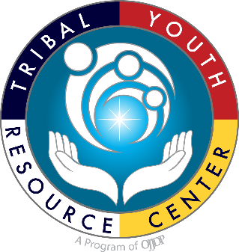

**Tribal Youth Resource Center**

Strategic Planning Template

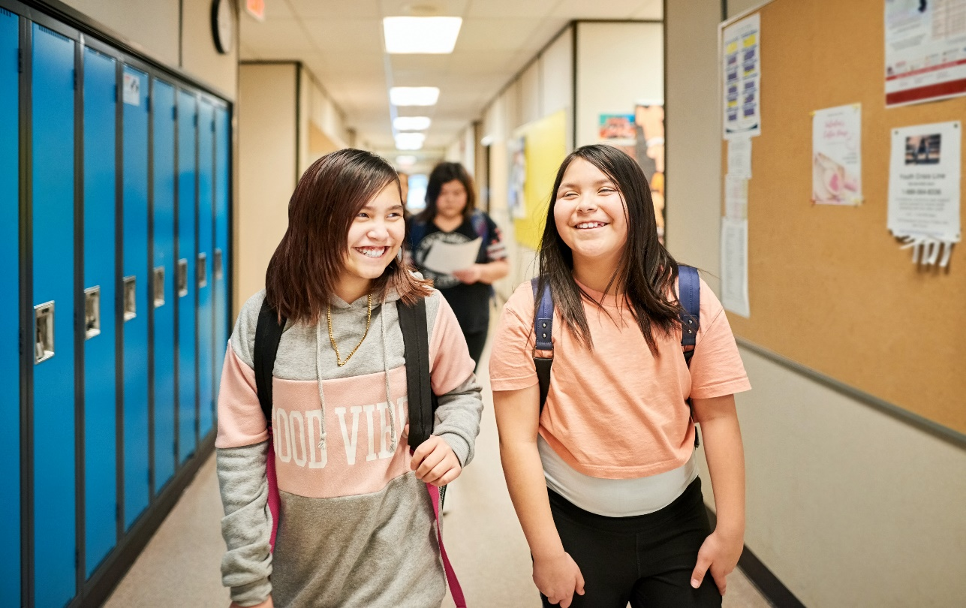

*This project was supported by Grant #15PJDP-21-GK-04048-MUMU awarded by the Office of Juvenile Justice and* *Delinquency Prevention, Office of Justice Programs, U.S. Department of Justice.  
 The opinions, findings, and* *conclusions or recommendations expressed in this publication/program/exhibition are those of the author(s) and do not necessarily reflect those of the Department of Justice.  
Revised April 2022*

**INSERT TRIBE NAME**

**PROJECT STRATEGIC PLAN**

**INSERT TRIBAL SEAL/LOGO**

**Project Vision Statement:**

**Project Purpose (Mission) Statement:**

|  |  |
| --- | --- |
| **Contact Information and Project Summary** | |
| Tribe or Village Name |  |
| Grant Award Number |  |
| Program Mailing Address |  |
| Grant Primary Point of Contact |  |
| Primary Point of Contact Email |  |
| Primary Contact Phone Number |  |
| Grant Financial Point of Contact |  |
| Additional Point of Contact and Role |  |
| OJJDP Grants Management Specialist |  |
| Technical Assistance Specialist |  |

|  |
| --- |
| **Overview** |
| **Project Abstract:**  **Areas of Project Growth and Expansion:**  **Community and program strengths that will be carried forward into this project:**  **Challenges that will be addressed as part of this project:** |

|  |  |  |
| --- | --- | --- |
| **Community Advisory Committee** | | |
| Member Name | Role/Title | Agency/Organization and Contact Information |
|  |  |  |
|  |  |  |
|  |  |  |
|  |  |  |
|  |  |  |
|  |  |  |
|  |  |  |
|  |  |  |
|  |  |  |
|  |  |  |

|  |
| --- |
| **Community Advisory Committee- Meeting Frequency**  Please provide a brief overview of the frequency of Community Advisory Circle meetings. |
| *Example: Bi-Weekly, Monthly, Quarterly* |

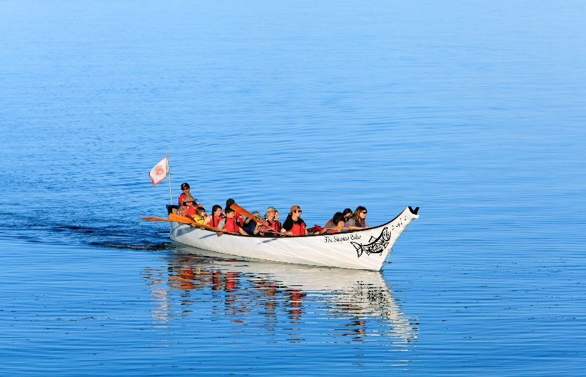

|  |
| --- |
| **Community Advisory Circle Responsibilities**  Please provide a brief overview of the responsibilities of the Advisory Circle |
| *Example:* |

|  |  |  |
| --- | --- | --- |
| **Project Service Team (Day-to-Day Services)** | | |
| Member Name | Role on Team | Department/Organization |
|  |  |  |
|  |  |  |
|  |  |  |
|  |  |  |
|  |  |  |
|  |  |  |
|  |  |  |
|  |  |  |

|  |
| --- |
| **Meeting Frequency** |
| Please provide a brief overview of the frequency of Multidisciplinary team meetings.  *Example: Team shall meet weekly or bi-weekly to staff and review and discuss participant progress. Team shall meet monthly regarding policy or business pertinent to the JHWC team.* |
|  |

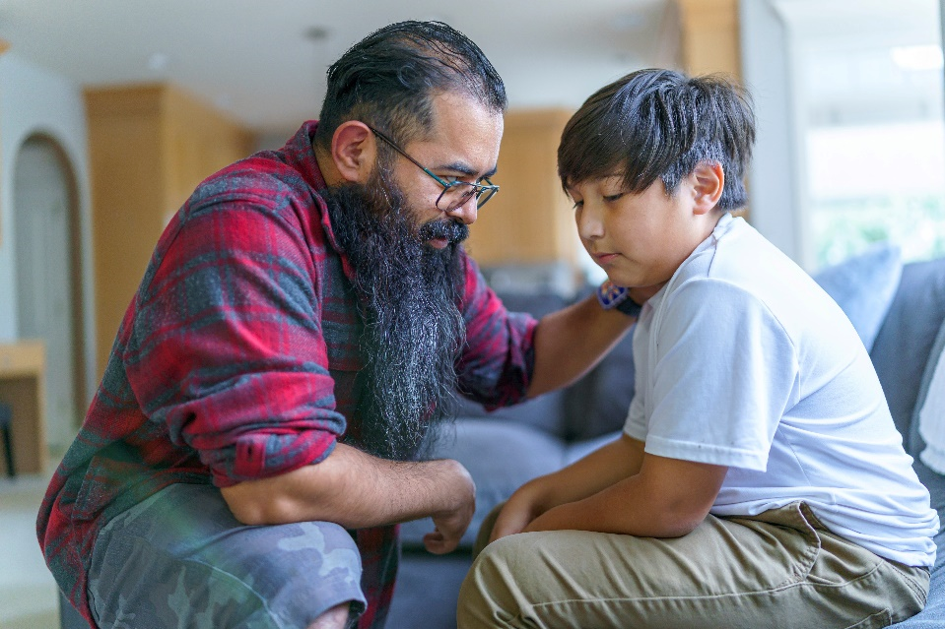

|  |  |
| --- | --- |
| **Interdisciplinary Team Responsibilities** | |
| **Team Member- The roles listed below are an example, you may insert or delete any roles that exist in your community.** | **Responsibilities** |
| **Judicial Leader** |  |
| **Program Coordinator/Case Manager** |  |
| **Behavioral Health/Treatment Provider** |  |
| **Probation/Supervision/Law Enforcement** |  |
| **Cultural Mentor** |  |
| **Other Team Member (Include Title/Role)** |  |
| **Other Team Member (Include Title/Role)** |  |
| **Other Team Member (Include Title/Role)** |  |

|  |
| --- |
| **Project Goals and Objectives** |
| **Goal One: Insert the project goal and any supporting objectives. Tasks and activities that support the project goal should be inserted below.** |
| *Tasks/Actions to support Goal:* |
| **Goal Two:** |
| *Tasks/Actions to support Goal:* |
| **Goal Three:** |
| *Tasks/Actions to support Goal:* |
| **Goal Four:** |
| *Tasks/Actions to support Goal:* |

* Add or delete rows as needed.

**Are these goals a continuation or an expansion of prior program services?**

|  |  |
| --- | --- |
| **Accomplishments** | |
| What have we accomplished so far? |  |
| What were our setbacks? |  |
| Did our staffing change? |  |

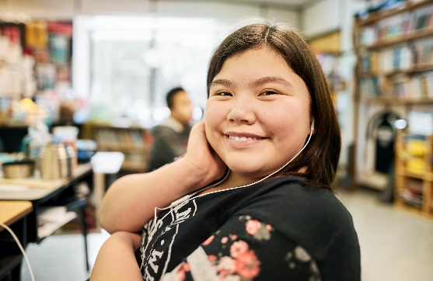

“The lesson learned here is that you have to keep the same staff. And if you can’t, and all tribes have turnover, have a policy and procedures of each role specific on what their role is, so a person can come in and just pick up.” –*Lessons Learned in Implementing the First Four Tribal Wellness Courts*, 2010

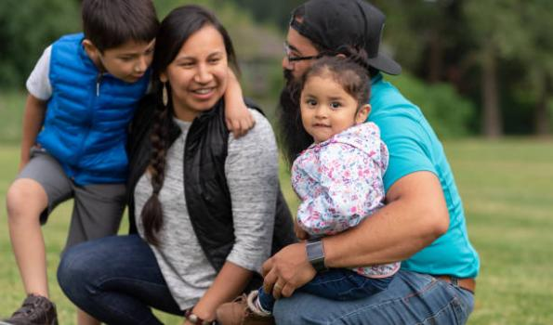“The lesson learned here is that you have to keep the same staff. And if you can’t, and all tribes have turnover, have a policy and procedures of each role specific on what their role is, so a person can come in and just pick up.” –*Lessons Learned in Implementing the First Four Tribal Wellness Courts*, 2010

|  |  |
| --- | --- |
| **Maintaining Momentum** | |
| What areas of our program can we expand? |  |
| What goals can we accomplish as a result of expansion? |  |

Engagement and Communication

“Similar to youth engagement strategies, family engagement strategies focus on strengths the family unit can bring to the process, not just the family’s deficits, and seek to access and leverage a family’s willingness to solve problems with professional guidance.”   
 -*National Standards for the Care and Youth Charged with Status Offenses, Section 1.7*

The Annie E. Casey Foundation defined family engagement as “a meaningful partnership with families and youth at every level of the agency and system.” The Foundation further notes that families can be engaged at both the Case and System Level- these operations listed below with some suggested strategies to promote strength-based family engagement. See, *Cross-Cutting Value: Family Engagement, The Annie E. Casey Foundation,* [*https://assets.aecf.org/m/privy/Deep-End-Resource-Guide-5a-Cross-Cutting-Value-Family-Engagement.pdf*](https://assets.aecf.org/m/privy/Deep-End-Resource-Guide-5a-Cross-Cutting-Value-Family-Engagement.pdf)

|  |  |
| --- | --- |
| **Family Case Level-Engagement** | **Strategy:** |
| Understand the process | * Provide a comprehensive orientation process and explain the programs case management process with the family. * Explain all program documents and provide an opportunity for the family/caregiver to ask questions about the process. |
| Are part of making all key decisions | * Provide parents/caregivers with an opportunity to provide updates and feedback. * Discuss both case progress, incentives, and consequences/sanctions with the family as decisions are made in the case. |
| Have access to an advocate that has personal and lived experience with the juvenile justice system | * Work on partnership development with youth or adults who have previously been in contact with the juvenile justice system. Develop activities that increase mentorship opportunities and family support. |
| Have the ability to have regular and routine contact with their children | * Provide opportunities for parents and youth to participate in group activities. * Support parents as they work on decision-making and positive skill development for youth participants. |
| Are given the opportunity to draw on their strengths and assets | * Implement assessment processes that allow parents and youth to identify areas of strength. * Develop case plans and activities that support these areas, (home-skills, arts, job, community events, leadership opportunities, etc.) |
| Are not made to feel shame, fault, or guilt | * Work with the team to implement a trauma-informed approach and building a strengths-based supportive environment. * Support the implementation a healing focused approach and reduce shaming practices. * Develop processes to support the identification of barriers to phased progress. |

**RESOURCES FOR FAMILY ENGAGEMENT**

1. [Family Engagement in Juvenile Justice, Office of Juvenile Justice Delinquency Prevention.](https://ojjdp.ojp.gov/model-programs-guide/literature-reviews/family_engagement_in_juvenile_justice.pdf)
2. [National Standards for the Care of Youth Charged with Status Offenses, Coalition for Juvenile Justice.](http://juvjustice.org/sites/default/files/resource-files/National%20Standards%202015%20WEB.pdf)
3. [Status Offenses and Family Engagement, Coalition for Juvenile Justice.](https://www.juvjustice.org/sites/default/files/resource-files/Family%20Engagement%20and%20SO.pdf)
4. [Identifying, Engaging, and Empowering Families: A Charge for Juvenile Justice Agencies](https://www.vera.org/downloads/publications/family-engagement-for-juvenile-justice-agencies.pdf)

|  |  |
| --- | --- |
| **Engaging Parents and Caregivers** | |
| *How are we engaging with family members?* |  |
| *Have we received feedback from family members regarding court processes?* |  |
| *Which family members are we engaging?* |  |
| *What are the local challenges that we have experienced in engaging families?* |  |
| *How do we anticipate our engagement strategy changing?* |  |
| *Are we sharing resources and/or providing education for family members?* |  |

|  |  |  |  |
| --- | --- | --- | --- |
| Communication Plan *A communication plan will contribute to increasing knowledge among your team, your community, the youth, and their families. It can assist in reducing informational barriers and strengthen engagement toward on-going collaboration.* | | | |
| **Communication Objectives:** | | | |
| **Youth Participants** | **JHWC Team** | **Program Partners** | **Community** |
|  |  |  |  |
| **Current Communication Methods:** | | | |
| **Youth Participants** | **JHWC Team** | **Program Partners** | **Community** |
|  |  |  |  |
| **What are ways we plan to increase our outreach and strengthen our communication methods?** | | | |
| **Youth Participants** | **JHWC Team** | **Program Partners** | **Community** |
|  |  |  |  |
| **Community Messaging- Who We Want To Reach:** | | | |
| * We will share our vision statement with the community through the following activities: * We will share our purpose/mission statement with the community through the following activities: * We are providing community education and awareness about the program’s services by: * These are some of the community and/or partner events, activities, functions, or locations, or information sharing methods that support extended awareness about our program services:   *“Our tribal ceremonies and rituals require planning, communication, collaboration, commitment, and clearly defined roles and responsibilities from everyone involved in order to realize a successful outcome. This is also true in the planning, implementation and enhancement of Tribal Healing to Wellness Courts.”*  *- Donna Humetewa, Consultant, Tribal Law and Policy Institute* | | | |

|  |  |  |  |  |
| --- | --- | --- | --- | --- |
| **Program Logic Model** | | | | |
| **Priority Statement:** | | | | |
| **External Factors:** | | | | |
| **Assumptions:** | | | | |
| **Project Goals and Who We Reach** | | | | |
| **Who do we serve?** | | | | |
| **Goal(s):** | | | | |
| ***What makes our program happen?*** | ***What we do.*** | ***The result of what we do.*** | ***Impact (More immediate)*** | ***Impact (Future)*** |
| **Program Inputs** | **Program Activities** | **Program Outputs** | **Short Term Outcomes (1-5 years)** | **Long Term Impact (8+ years)** |
|  |  |  |  |  |
|  |  |  |  |  |
|  |  |  |  |  |

|  |  |  |  |  |
| --- | --- | --- | --- | --- |
| **DATA COLLECTION TABLE 1**  **Local Level Data** Work with the team to identify local level data. Developing a program flow chart may assist you with identifying key points for which data can be collected.  Areas Concerning Juveniles to Consider:   * *Arrest Rates;* * *Types of Offenses;* * *Incarceration Rates;* * *Recidivism Rates;* * *Truancy Rates;* * *Referral to Treatment Rates;* * *Graduation Rates;* * *Community Crime Data.* | | | | |
| **Key Questions*:*** What methods will you use to collect the data? How often will the data be collected? Who will assist program coordinator in collecting the data? Where will you organize, manage, and store the data? | | | | |
| **Data to collect:** | **Where is data and how will it be collected?** | **Who is responsible for collecting data?** | **Target date(s) for data collection** | **How will data be stored?** |
|  | Click or tap here to enter text. | Click or tap here to enter text. | Click or tap here to enter text. | Click or tap here to enter text. |
|  |  |  |  |  |
|  |  |  |  |  |
|  |  |  |  |  |
|  |  |  |  |  |
|  |  |  |  |  |

*Add rows as needed. While your cursor is in the last row, right click and then click “insert rows below.

|  |  |  |  |  |
| --- | --- | --- | --- | --- |
| **Program Operational Data to Collect**  [**https://ojjdp.ojp.gov/funding/performance-measures/performance-measures-tribal-healing-wellness-program.pdf**](https://ojjdp.ojp.gov/funding/performance-measures/performance-measures-tribal-healing-wellness-program.pdf) | | | | |
| **Data to collect** | **Where is data and how will it be collected?** | **Person(s) responsible for collecting data** | **Target date(s) for data collection** | **How will data be stored?** |
|  | Click or tap here to enter text. | Click or tap here to enter text. | Click or tap here to enter text. | Click or tap here to enter text. |
|  |  |  |  |  |
|  |  |  |  |  |
|  |  |  |  |  |
|  |  |  |  |  |

*For demonstration purposes only- Communities should choose the performance measures that best apply to their program. There are additional performance measure indicators that may be selected as part of [OJJDP Tribal Grantee Reporting Measures](https://ojjdp.ojp.gov/funding/performance-measures/performance-measures-tribal-healing-wellness-program.pdf).   
Add rows as needed. While your cursor is in the last row, right click and then click “insert rows below.”

|  |
| --- |
| **Evaluation Plan**  “*Evaluation should be tailored to the cultural context of the community and responsive to cultural ways of life, including cultural values for parenting and child well-being*”. (<https://www.acf.hhs.gov/sites/default/files/cb/tribal_roadmap.pdf>)  Key questions for evaluation planning include:   * *What is the culture of the community?* * *What is the purpose of our evaluation?* * *Who needs to know what when?* * *What outcome in our logic model do we want to focus on in our evaluation?* * *How will we engage stakeholders in our evaluation plan?* * *What resources do we have to commit to evaluation planning and implementation?*   **RESOURCES FOR EVALUATION PLANNING AND IMPLEMENTATION**   1. Indigenous Evaluation Toolkit, <https://gptec.gptchb.org/indigenous-evaluation-toolkit/> 2. Indigenous Evaluation Framework: Telling Our Story in Our Place and Time. LaFrance, J., & Nichols, R. (2008). Alexandria, VA: American Indian Higher Education Consortium (AIHEC) <http://indigeval.aihec.org/Pages/Documents.aspx> 3. Using your logic model to plan for evaluation, Evaluation Planning, Chapter 4, W.K. Kellogg Foundation, <https://azprc.arizona.edu/sites/default/files/CHWtoolkit/PDFs/LOGICMOD/CHAPTER4.PDF> 4. A Roadmap for Collaborative and Effective Evaluation in Tribal Communities, <https://www.acf.hhs.gov/sites/default/files/cb/tribal_roadmap.pdf> 5. W.K. Kellogg Foundation Evaluation Handbook, <https://www.wkkf.org/resource-directory/resource/2010/w-k-kellogg-foundation-evaluation-handbook> 6. Evaluating Indigenous programs: a toolkit for change, S. Hudson, 2017, https://www.cis.org.au/app/uploads/2017/06/rr28.pdf |

|  |  |
| --- | --- |
| **Establish Goal(s) for evaluation:**  Click or tap here to enter text. | |
| **Evaluation Goal(s)** Click or tap here to enter text. | |
| **Goal 2** | Click or tap here to enter text. |
| **Goal 3** | Click or tap here to enter text. |

|  |  |  |
| --- | --- | --- |
| **Evaluation Working Group** | | |
| **Establish Working Group  Team Lead** | **Individual Name** | **Role/Responsibilities** |
|  | Click or tap here to enter text. | Click or tap here to enter text. |
|  |  |  |
|  |  |  |

|  |  |  |
| --- | --- | --- |
| **Stakeholders: How will the team engage stakeholders in the evaluation process?** | | |
| **Stakeholders to Engage** | **Stakeholder interests/Perspectives** | **Stakeholder Engagement (When/How)** |
|  |  |  |
|  |  |  |
|  |  |  |
|  |  |  |

*Add rows as needed. While your cursor is in the last row, right click and then click “insert rows below.”

|  |  |  |
| --- | --- | --- |
| Evaluation Activities | Timing | Additional Notes |
| Review data collected from data collection plan. |  | Click or tap here to enter text. |
| Review logic model to track projected short term and long-term outcomes | Click or tap here to enter text. | Click or tap here to enter text. |
| Engage stakeholders/partners/team in planning evaluation activities | Click or tap here to enter text. | Click or tap here to enter text. |
| Team development of evaluation methodology and processes | Click or tap here to enter text. | Click or tap here to enter text. |
| Develop evaluation outcome dissemination plan How will you share the evaluation results? How will results improve program design/implementation? | Click or tap here to enter text. | Click or tap here to enter text. |

**For CTAS PA8 Tribal Grantees:**

**Program Criteria:**

**Ages : X to X  
Post-Adjudication Program  
Delinquency Citation  
History or Evidence of Substance Misuse**

**Demonstrated Need for Services.**

**Participant Case Flow Diagram:**

**Screening Process**

**Entry Point**

**Ineligible**

**Eligible**

**Traditional Juvenile Justice System- Delinquency Petition & Adjudication**

**Juvenile Wellness Court (Option or Ordered to Participate)**

**Initial Steps: Intake/Orientation**

**Chooses not to participate**

**Unsuccessful Completion**

**Phased Process   
Team Contact  
Supervision  
Treatment Services  
Other Elements of Program:**

**Cultural Activities  
Education Support  
Youth-Development**

**Program Partners:**

**INSERT TRIBAL AND EXTERNAL PARTNERS**

**Post-Graduation/Release Services**

**Graduation/Release**

**Successful Completion**

**Dismiss Citation**